

**Reading Manual**

Computer Hardware and Maintenance

**Academic Year 2023 - 2024**

B.Tech Integrated Computer Engineering/ Data Science

Year II Semester III

**Syllabus:**

| **Unit** | **Description** | | | | | | | **Duration** | **Page no.** |
| --- | --- | --- | --- | --- | --- | --- | --- | --- | --- |
| **1** | **PC Hardware and Components**  Introduction to computer hardware, components of motherboards, CPU, various ports, slots, connectors, addon cards Primary and secondary memory and their installation, Cabinet types | | | | | | | **06** | 3 - 25 |
| **2** | **Diagnose & repair problems of Desktop and Laptop**  General Troubleshooting rules, Preventive Maintenance. BIOS Features, BIOS & Boot Sequences, BIOS Shortcoming & Compatible Issues, BIOS Troubleshooting. POST, Error Code: Beep Code, Post Code, preventive maintenance of latest gadgets | | | | | | | **06** | 26 - 49 |
| **3** | **Input-Output devices and their troubleshooting**  Troubleshoot Input-Output devices: keyboard, switches, mouse, scanners, webcam, monitors, printers, speaker and mike, LCD projector.  I/O Cables: specification of I/O Cables, types of I/O cables, types of I/O ports, internal and external modem | | | | | | | **06** | 50 - 70 |
| **4** | **Power Supply**  Switched Mode Power supply block diagram, working principles, testing and troubleshooting, power rating, requirement of SMPS wattage depending parameters like type of processors and HDDs | | | | | | | **06** | 71 - 83 |
| **5** | **Transmission Media and Networking Connectivity Hardware**  Network interface cards–Ethernet, Cabling Concepts (designing, installing, and maintaining modern communications infrastructures and electronic physical security systems. Fiber optics, wireless networks), various networking devices like routers, repeaters, switches, bridges | | | | | | | **06** | 84 - 99 |
| **Total** | | | | | | | | **30** |  |

**Video Links:**

| **Unit** | **Description and Video Links** | | | | | | |
| --- | --- | --- | --- | --- | --- | --- | --- |
| **1** | **PC Hardware and Components**   * Introduction to computer hardware - [Computer Hardware Basics Explained with Parts | Exploring My Computer |](https://youtu.be/3vSnVvtv_PQ) * Components of motherboards - [Motherboards Explained](https://www.youtube.com/watch?v=b2pd3Y6aBag) * CPU - [What Is CPU ? | How CPU Works ? | Functions Of Central Processing Unit](https://www.youtube.com/watch?v=lmDsCo6uV24) * Various ports, slots, connectors - [Computer Ports Explained](https://www.youtube.com/watch?v=FD9GMJxs7ZQ) * Addon cards - [Installing Expansion Cards](https://www.youtube.com/watch?v=IbBxB5AOoOI) * Primary and secondary memory and their installation - [Primary & Secondary Storage - GCSE Computer Science](https://www.youtube.com/watch?v=W_xAsLPFYwA) | | | | | | |
| **2** | **Diagnose & repair problems of Desktop and Laptop**   * General Troubleshooting rules - [Top 30 🔥 Desktop PC Troubleshooting Problems with Solutions](https://www.youtube.com/watch?v=kJ4KiUk-HuY) * BIOS - [Computer Stuck at BIOS Screen? [Solved!]](https://www.youtube.com/watch?v=swHGEuZ5fWw), [How To - What is BIOS?](https://www.youtube.com/watch?v=ncUmWthHrU0) * POST - [What is POST (Power On Self Test ) and what are the duties of POST?](https://www.youtube.com/watch?v=F78v7edrNeA) * Error Code: Beep Code, Post Code - [PC beeps and No Display? Computer beep codes. Fix it yourself](https://www.youtube.com/watch?v=BEmpQZztnZU) | | | | | | |
| **3** | **Input-Output devices and their troubleshooting**  Troubleshoot   * Keyboard - [How to Fix Laptop Keyboard Not Working | Windows 11, 10, 8, 7](https://www.youtube.com/watch?v=HFgNbJl7gSo) * Mouse - [How To Fix USB Mouse Not Working on Windows 10](https://www.youtube.com/watch?v=_DPIAuWxVLk) * Scanners - [No Scanners Were Detected Error on Windows 10 FIX 2021](https://www.youtube.com/watch?v=j3WN1X9uLQY) * Webcam -<https://www.youtube.com/watch?v=jFnTt0UJ_Ms> * Monitors - <https://www.youtube.com/watch?v=GltCCHhRTvs> * Printers - [Basic Printing Troubleshooting Steps - I still hate printing](https://www.youtube.com/watch?v=DkGrTEpDkGM) * Speaker , Mike - [How to Fix Sound or Audio Problems on Windows 10](https://www.youtube.com/watch?v=ncO8vekrfao) * LCD projector - [How To Fix "Projecting to This PC" Feature Disabled Problem in Windows 10](https://www.youtube.com/watch?v=apBgMWwlGuk) * Barcode scanner - [https://www.youtube.com/watch?v=yssnGacoTN](https://www.youtube.com/watch?v=yssnGacoTNA)A * Fingerprint scanner - [https://www.youtube.com/watch?v=2q2jwROLHN](https://www.youtube.com/watch?v=2q2jwROLHNI)I * Bluetooth Headphones - [https://www.youtube.com/watch?v=Ac2KETythU](https://www.youtube.com/watch?v=Ac2KETythUE)E * Different Headsets - [https://www.youtube.com/watch?v=36mVcrM3Pg](https://www.youtube.com/watch?v=36mVcrM3Pg0)0 | | | | | | |
| **4** | **Power Supply**  Switched Mode Power supply block diagram - [SMPS Basics | Switch Mode Power Supply Explained | Basics Guru](https://www.youtube.com/watch?v=IIcO_L9oGzM) | | | | | | |
| **5** | **Transmission Media and Networking Connectivity Hardware**  Network interface cards–Ethernet - [NIC (Network Interface Card)](https://www.youtube.com/watch?v=oo-tn17rUBo)  Fiber optics - [Fiber optic cables: How they work](https://www.youtube.com/watch?v=0MwMkBET_5I&t=4s)  Wireless networks - [What is Wireless Network? | Types of Wireless Network | Computer Science Engineering](https://www.youtube.com/watch?v=YpWWqa6PTME)  Routers - [What is a Router and What Does it Do?](https://www.youtube.com/watch?v=lyIUgr9JOLs)  Repeaters - [What is a Repeater | Computer & Networking Basics for Beginners | Computer Technology Course](https://www.youtube.com/watch?v=vrhb179CiiQ)  Switches - [What is a Switch in Networking - How does a Network Switch Work?](https://www.youtube.com/watch?v=NDVImep5UBI)  Bridges - [Basics of Bridge](https://www.youtube.com/watch?v=NSDAYnixdgc) | | | | | | |

**Chapter 1: PC Hardware and Components**

| **Contents:**   * Introduction to computer hardware * Components of motherboards * CPU * Ports * Slots * Connectors * Addon cards * Primary and secondary memory and their installation * Cabinet types | | | | | | |
| --- | --- | --- | --- | --- | --- | --- |

A Computer is an electronic device that has two essential parts including hardware and software to perform various operations. That means without hardware parts in a computer, software is of no work and vice versa. So, we need both hardware and software to run a Computer and can perform multiple operations. Software is nothing but a piece of code or set of instructions written in a chip to run a hardware device on the Computer. Now the question is what is hardware? Yes, like other machines physical parts are known as hardware. Hardware is a physical component that is attached to the PC that can neither be modified nor be changed as it is fixed into that place. There are different types and models of hardware components being manufactured by big companies available in the market.

**Definition of Hardware:**

Hardware is the collection of physical parts of a Computer system that has shape and size and can be felt. The most essential hardware components are Motherboard, CPU, RAM memory, IO system, power supply, video display controller, Bus and hard disk drive. Some of the normal hardware parts you see like a mouse, keyboard, monitor and CPU are the basic components of a computer. But inside the CPU box there is hard disk, motherboard, and RAM, video card, CPU Fan, sound card, server components, CD/DVD drive and many more. The hardware components do change in shape and size as in a desktop computer the CPU integrates all the components that are connected by wires but in laptop computers the components are integrated into a single portable unit. Basically the hardware components in a Computer system are connected through wires in order to function properly. From power supply to network connection all are connected through wires.

**Hardware Components:**

The most important hardware component is the MotherBoard that holds all the important components of a Computer including CPU, memory and various connectors for input/output devices. Some of the input devices like keyboard, mouse, microphone, modem, joystick, USB devices, joystick and many more are connected for better functioning. Similarly the output devices like the computer monitor, modem, projectors, printers etc are connected to the available connectors of the motherboard. It is the main mother board that includes graphic processors for a better display screen on your monitor. There is CPU socket, CPU fan memory connector, super IO chip, DIMM memory slots, IDE connector, SATA connector, BIOS flash chip that are the most essential components to run a Computer system. It also integrates audio codec chip for sound and gigabit Ethernet chip for network connection on a computer

The components that makeup hardware can be categorized as being either internal or external.

* **Internal components** are those installed inside the computer, typical examples being the motherboard, power supply, and central processing unit (CPU).
* **External components** are connected to the outside of the computer, these can also be referred to as peripherals, or peripheral devices, common examples being the monitor, keyboard, and mouse.

**Internal Components**

* Motherboard
* Central Processing Unit (CPU)
* Power Supply
* Random Access Memory (RAM)
* Hard Disk Drive (HDD)
* Video Card
* Solid-State Drive (SSD)
* Optical Disc Drive (e.g. BD drive, DVD drive, CD drive)

**External Components**

* Monitor
* Keyboard
* Mouse
* Printer
* Speakers
* External Hard Drive
* Desktop Image Scanner
* Projector
* Joystick
* Headphones

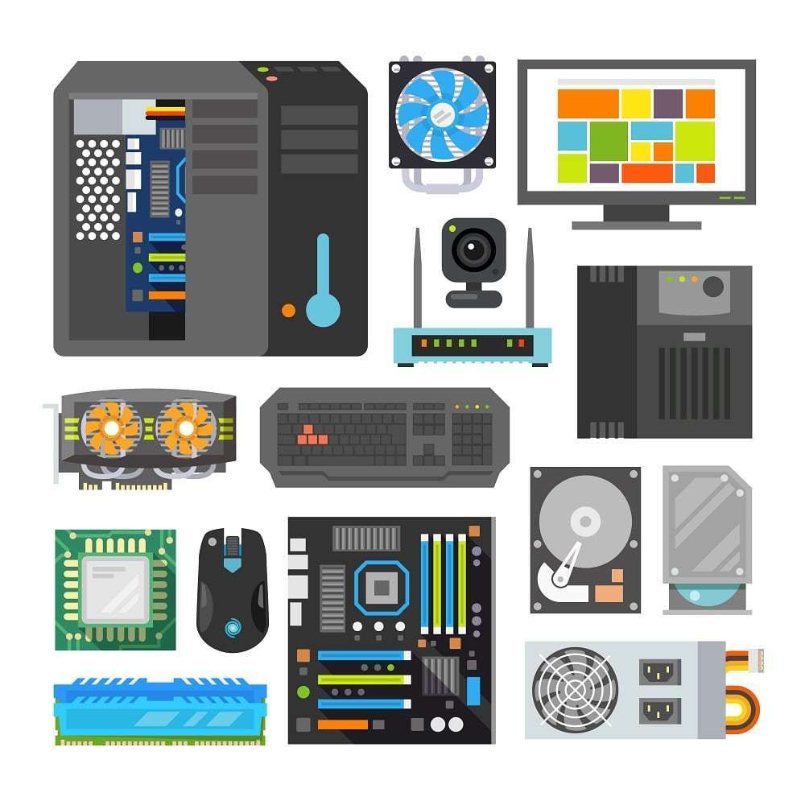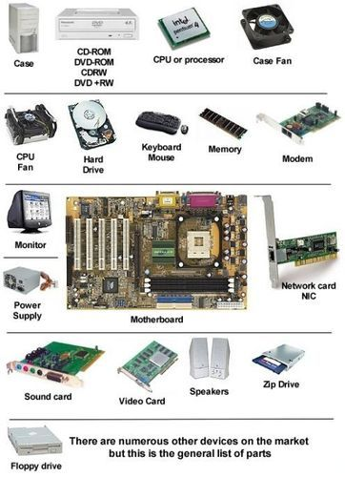

**Motherboard:**

The motherboard is a printed [circuit board](https://www.computerhope.com/jargon/p/pcb.htm) and foundation of a computer that is the biggest board in a computer [chassis](https://www.computerhope.com/jargon/c/chassis.htm). It allocates power and allows communication to and between the [CPU](https://www.computerhope.com/jargon/c/cpu.htm), [RAM](https://www.computerhope.com/jargon/r/ram.htm), and all other computer [hardware](https://www.computerhope.com/jargon/h/hardware.htm) components.

A motherboard provides connectivity between the hardware components of a computer, like the processor ([CPU](https://www.computerhope.com/jargon/c/cpu.htm)), memory ([RAM](https://www.computerhope.com/jargon/r/ram.htm)), [hard drive](https://www.computerhope.com/jargon/h/harddriv.htm), and [video card](https://www.computerhope.com/jargon/v/video-card.htm). There are multiple types of motherboards, designed to fit different types and sizes of computers.

Each type of motherboard is designed to work with specific types of processors and memory, so they don't work with every processor and type of memory. However, hard drives are mostly universal and work with the majority of motherboards, regardless of the type or brand.

Below is a picture of the [ASUS](https://www.computerhope.com/comp/asus.htm) P5AD2-E motherboard with labels next to each of its major components. Clicking the image directs you to a larger and more detailed version.

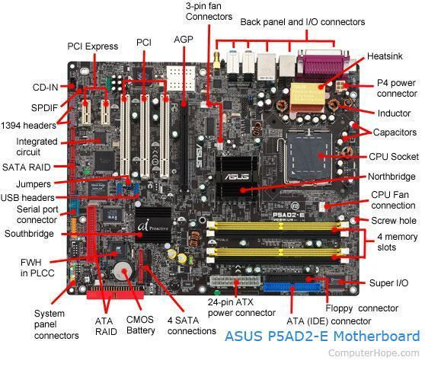

**Where is the motherboard located?**

A computer motherboard is located inside the [computer case](https://www.computerhope.com/jargon/c/chassis.htm) and is where most of the parts and computer [peripherals](https://www.computerhope.com/jargon/p/peripher.htm) connect. With [tower computers](https://www.computerhope.com/jargon/t/tower.htm), the motherboard is on the left or right side of the tower and is the biggest [circuit board](https://www.computerhope.com/jargon/p/pcb.htm).

**Motherboard components:**

Below are links to pages with more details for each of the motherboard components mentioned in the previous section. The links are listed in clockwise order starting from the top-left corner of the image. Components not labeled on the image above are found in sections later on this page.

* [Expansion slots](https://www.computerhope.com/jargon/e/expaslot.htm) ([PCI Express](https://www.computerhope.com/jargon/p/pciexpre.htm), [PCI](https://www.computerhope.com/jargon/p/pci.htm), and [AGP](https://www.computerhope.com/jargon/a/agp.htm))
* [3-pin case fan connectors](https://www.computerhope.com/jargon/c/casefan.htm)
* [Back pane connectors](https://www.computerhope.com/jargon/c/connect.htm)
* [Heat sink](https://www.computerhope.com/jargon/h/heatsink.htm)
* [4-pin (P4) power connector](https://www.computerhope.com/jargon/p/p4.htm)
* [Inductor](https://www.computerhope.com/jargon/c/coil.htm)
* [Capacitor](https://www.computerhope.com/jargon/c/capacito.htm)
* [CPU socket](https://www.computerhope.com/jargon/s/socket.htm)
* [Northbridge](https://www.computerhope.com/jargon/n/northbri.htm)
* [Screw hole](https://www.computerhope.com/jargon/s/standout.htm)
* [Memory slot](https://www.computerhope.com/jargon/m/memoslot.htm)
* [Super I/O](https://www.computerhope.com/jargon/s/sio.htm)
* [ATA / IDE disk drive primary connection](https://www.computerhope.com/jargon/i/ide.htm)
* [24-pin ATX power supply connector](https://www.computerhope.com/jargon/a/atxstyle.htm)
* [Serial ATA connections](https://www.computerhope.com/jargon/s/sata.htm)
* [Coin cell battery (CMOS backup battery)](https://www.computerhope.com/jargon/c/cmos.htm)
* [RAID](https://www.computerhope.com/jargon/r/raid.htm)
* [System panel connectors](https://www.computerhope.com/jargon/s/spc.htm)
* [FWH](https://www.computerhope.com/jargon/f/fwh.htm)
* [Southbridge](https://www.computerhope.com/jargon/s/soutbrid.htm)
* [Serial port connector](https://www.computerhope.com/jargon/s/seriport.htm)
* [USB headers](https://www.computerhope.com/jargon/u/usbhead.htm)
* [Jumpers](https://www.computerhope.com/jargon/j/jumper.htm)
* [Integrated circuit](https://www.computerhope.com/jargon/i/ic.htm)
* [1394 headers](https://www.computerhope.com/jargon/u/usbhead.htm)
* [SPDIF](https://www.computerhope.com/jargon/s/spdif.htm)
* [CD-IN](https://www.computerhope.com/jargon/c/cdin.htm)

**Older motherboard components**

The following list contains links to components that are not shown in the picture above or were part of older computer motherboards.

* [BIOS](https://www.computerhope.com/jargon/b/bios.htm)
* [Bus](https://www.computerhope.com/jargon/b/bus.htm)
* [Cache memory](https://www.computerhope.com/jargon/c/cache.htm)
* [Chipset](https://www.computerhope.com/jargon/c/chipset.htm)
* [Diode](https://www.computerhope.com/jargon/d/diode.htm)
* [Dip switches](https://www.computerhope.com/jargon/d/dipswitc.htm)
* [Electrolytic](https://www.computerhope.com/jargon/c/capacito.htm)
* [Floppy connection](https://www.computerhope.com/jargon/f/flopcabl.htm)
* [Fuse](https://www.computerhope.com/jargon/f/fuse.htm)
* [Game port and MIDI header](https://www.computerhope.com/jargon/u/usbhead.htm).
* [Internal speaker](https://www.computerhope.com/jargon/i/intespea.htm)
* [Keyboard controller](https://www.computerhope.com/jargon/k/keybcont.htm)
* [LCC](https://www.computerhope.com/jargon/l/lcc.htm)
* [Network header](https://www.computerhope.com/jargon/u/usbhead.htm)
* Obsolete expansion slots: [AMR](https://www.computerhope.com/jargon/a/amr.htm), [CNR](https://www.computerhope.com/jargon/c/cnr.htm), [EISA](https://www.computerhope.com/jargon/e/eisa.htm), [ISA](https://www.computerhope.com/jargon/i/isa.htm), and [VESA](https://www.computerhope.com/jargon/v/vesa.htm).
* Obsolete memory slots: [SIMM](https://www.computerhope.com/jargon/s/simm.htm).
* Onboard [LED](https://www.computerhope.com/jargon/l/led.htm)
* [Parallel port header](https://www.computerhope.com/jargon/u/usbhead.htm)
* [PS/2 header](https://www.computerhope.com/jargon/u/usbhead.htm)
* [Resistor](https://www.computerhope.com/jargon/r/resistor.htm)
* [RTC](https://www.computerhope.com/jargon/r/rtc.htm)
* [Serial port header](https://www.computerhope.com/jargon/u/usbhead.htm)
* [SCSI](https://www.computerhope.com/jargon/s/scsi.htm)
* [Solenoid](https://www.computerhope.com/jargon/s/solenoid.htm)
* [Voltage regulator](https://www.computerhope.com/jargon/v/voltregu.htm)
* [VRM (voltage regulator module)](https://www.computerhope.com/jargon/v/vrm.htm).

**Motherboard form factors and types:**

As computers advanced, so have motherboards. Below is a list of the various motherboard [form factors](https://www.computerhope.com/jargon/f/formfact.htm) and additional information about each, including ATX, which is the most common.

* [AT](https://www.computerhope.com/jargon/f/fullat.htm)
* [ATX](https://www.computerhope.com/jargon/a/atx.htm)
* [Baby AT](https://www.computerhope.com/jargon/b/babyat.htm)
* [BTX](https://www.computerhope.com/jargon/b/btx.htm)
* [DTX](https://www.computerhope.com/jargon/d/dtx.htm)
* [LPX](https://www.computerhope.com/jargon/l/lpx.htm)
* [Full AT](https://www.computerhope.com/jargon/f/fullat.htm)
* [Full ATX](https://www.computerhope.com/jargon/a/atx.htm)
* [microATX](https://www.computerhope.com/jargon/m/microatx.htm)
* [NLX](https://www.computerhope.com/jargon/n/nlx.htm)

**How many connections, ports, or slots are on a motherboard?**

There's no set standard to how many [connections](https://www.computerhope.com/jargon/c/connect.htm), [ports](https://www.computerhope.com/jargon/p/port.htm), or [expansion slots](https://www.computerhope.com/jargon/e/expaslot.htm) are on a motherboard. The best method of determining how many connections, ports, or slots are available for your motherboard is to look up the specifications contained in its documentation. If you've lost or discarded your motherboard's documentation, you can often download a free [PDF](https://www.computerhope.com/jargon/p/pdf.htm) version from the manufacturer's website.

**Why are the slots and connections different colors?**

The slots, ports, and connections on a motherboard may be color-coded to help identify the type of slot, port, or connector. For example, with our motherboard picture, the [IDE connectors](https://www.computerhope.com/jargon/i/ide.htm) are different colors to help identify the primary and secondary connectors. When the [memory slots](https://www.computerhope.com/jargon/m/memoslot.htm) are different colors, it indicates the memory slots are dual-channel, and pairs of memory should be installed on the same channel (color). For example, in our picture, the yellow memory slots are Channel A, and Channel B are the black slots. If you were only installing two memory sticks, you'd want to install both of them in Channel A (yellow slots) for optimal performance.

**How does a motherboard connect to a computer case?**

A computer motherboard connects to a desktop computer case using [standouts](https://www.computerhope.com/jargon/s/standout.htm). Once the motherboard is attached to the case, all other devices connect to the motherboard itself or an [expansion card](https://www.computerhope.com/jargon/e/expacard.htm).

**Central Processing Unit (CPU)**

Alternately referred to as a processor, central processor, or microprocessor, the CPU (pronounced sea-pea-you) is the central processing unit of the computer. A computer's CPU handles all [instructions](https://www.computerhope.com/jargon/c/compinst.htm) it receives from [hardware](https://www.computerhope.com/jargon/h/hardware.htm) and [software](https://www.computerhope.com/jargon/s/software.htm) running on the computer. For example, the CPU processes the instructions to use a [web browser](https://www.computerhope.com/jargon/b/browser.htm) to open and display this web page on your computer.

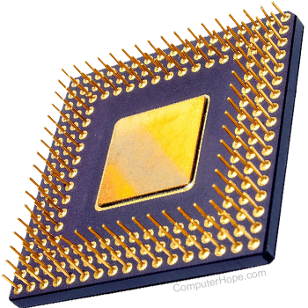

The picture below is an example of what the bottom and top of an [AMD](https://www.computerhope.com/jargon/a/amd.htm) [RYZEN](https://www.computerhope.com/jargon/r/ryzen.htm) processor may look like. The processor is placed and secured into a compatible CPU [socket](https://www.computerhope.com/jargon/s/socket.htm) found on the [motherboard](https://www.computerhope.com/jargon/m/mothboar.htm). Processors produce heat, so they are covered with a [heat sink](https://www.computerhope.com/jargon/h/heatsink.htm) to keep them cool and running smoothly. To help transfer the heat between the CPU and the heat sink.

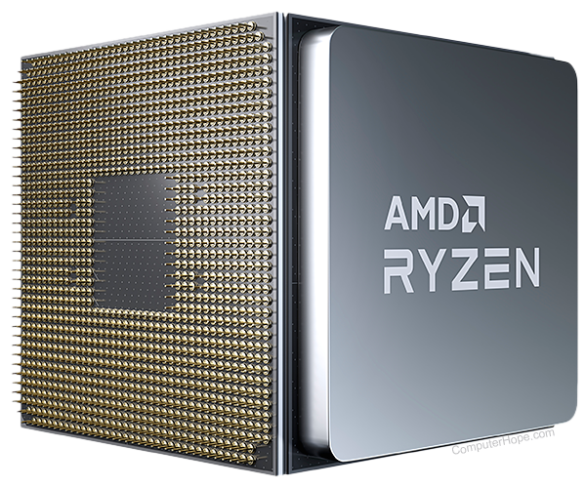

As seen in the picture above, the CPU chip is usually square with one notched corner to help make sure it's properly inserted into the CPU [socket](https://www.computerhope.com/jargon/s/socket.htm). On the bottom of the chip are hundreds of connector pins that correspond to the socket holes. Today, most CPU's resemble the picture shown above. However, [Intel](https://www.computerhope.com/comp/intel.htm) and [AMD](https://www.computerhope.com/comp/amd.htm) have also experimented with [slot processors](https://www.computerhope.com/jargon/s/slot.htm). They were much larger and slid into a slot on the motherboard. Also, over the years, there were several types of [sockets](https://www.computerhope.com/jargon/s/socket.htm) on motherboards. Each socket only supports specific types of processors and each has its own pin layout.

**What does the CPU do?**

The CPU's main function is to take input from a [peripheral](https://www.computerhope.com/jargon/p/peripher.htm) (keyboard, mouse, printer, etc) or computer program, and interpret what it needs. The CPU then either outputs information to your monitor or performs the peripheral's requested task.

CPU history

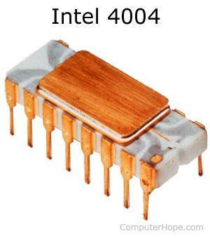

The CPU was first invented and developed at [Intel](https://www.computerhope.com/comp/intel.htm) with the help of [Ted Hoff](https://www.computerhope.com/people/marcian_hoff.htm) and others in the early 1970s. The first processor released by Intel was the [4004](https://www.computerhope.com/jargon/num/4004.htm) processor, shown in the picture.

**Components of the CPU**

In the CPU, there are two primary components.

1. [ALU](https://www.computerhope.com/jargon/a/alu.htm) (arithmetic logic unit) - performs mathematical, logical, and decision operations.
2. [CU](https://www.computerhope.com/jargon/c/contunit.htm) (control unit) - directs all the processor's operations.

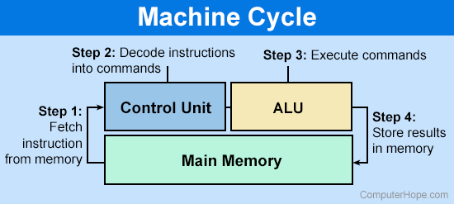

Over the history of computer processors, the speed ([clock speed](https://www.computerhope.com/jargon/c/clockspe.htm)) and capabilities of the processor have dramatically improved. For example, the first microprocessor was the Intel [4004](https://www.computerhope.com/jargon/num/4004.htm) that was released on November 15, [1971](https://www.computerhope.com/history/1971.htm), and had 2,300 [transistors](https://www.computerhope.com/jargon/t/transist.htm) and performed 60,000 operations per second. The Intel Pentium processor has 3,300,000 transistors and performs around 188,000,000 instructions per second.

Types of CPUs

In the past, computer processors used numbers to identify the processor and help identify faster processors. For example, the Intel [80486 (486)](https://www.computerhope.com/jargon/num/80486.htm) processor is faster than the [80386 (386)](https://www.computerhope.com/jargon/num/80386.htm) processor. After the introduction of the Intel Pentium processor (which would technically be the 80586), all computer processors started using names like Athlon, Duron, Pentium, and Celeron.

Today, in addition to the different names of computer processors, there are different architectures ([32-bit](https://www.computerhope.com/jargon/num/32bit.htm) and [64-bit](https://www.computerhope.com/jargon/num/64bit.htm)), speeds, and capabilities. Below is a list of the more common types of CPUs for home or business computers.

**AMD processors**

| K6-2  K6-III  [Athlon](https://www.computerhope.com/jargon/a/athlon.htm)  [Duron](https://www.computerhope.com/jargon/d/duron.htm)  Athlon XP | Sempron  Athlon 64  Mobile Athlon 64  Athlon XP-M  Athlon 64 FX | Turion 64  Athlon 64 X2  Turion 64 X2  Phenom FX  Phenom X4 | Phenom X3  Athlon 6-series  Athlon 4-series  Athlon X2  Phenom II | Athlon II  E2 series  A4 series  A6 series  A8 series  A10 series |
| --- | --- | --- | --- | --- |

**Intel processors**

| [4004](https://www.computerhope.com/jargon/num/4004.htm)  [8080](https://www.computerhope.com/jargon/num/8080.htm)  [8086](https://www.computerhope.com/jargon/num/8086.htm)  [8087](https://www.computerhope.com/jargon/num/8087.htm)  [8088](https://www.computerhope.com/jargon/num/8088.htm)  [80286 (286)](https://www.computerhope.com/jargon/num/80286.htm)  [80386 (386)](https://www.computerhope.com/jargon/num/80386.htm)  [80486 (486)](https://www.computerhope.com/jargon/num/80486.htm) | [Pentium](https://www.computerhope.com/jargon/p/pentium.htm)  Pentium w/ [MMX](https://www.computerhope.com/jargon/m/mmx.htm)  [Pentium Pro](https://www.computerhope.com/jargon/p/pentpro.htm)  [Pentium II](https://www.computerhope.com/jargon/p/p2.htm)  [Celeron](https://www.computerhope.com/jargon/c/celeron.htm)  [Pentium III](https://www.computerhope.com/jargon/p/p3.htm)  [Pentium M](https://www.computerhope.com/jargon/p/pentiumm.htm)  Celeron M | [Pentium 4](https://www.computerhope.com/jargon/p/pentium_4.htm)  Mobile Pentium 4-M  Pentium D | Pentium Extreme Edition  [Core Duo](https://www.computerhope.com/jargon/c/coreduo.htm)  [Core 2 Duo](https://www.computerhope.com/jargon/c/core2.htm) | [Core i3](https://www.computerhope.com/jargon/c/core-i3.htm)  [Core i5](https://www.computerhope.com/jargon/c/core-i5.htm)  [Core i7](https://www.computerhope.com/jargon/i/i7.htm)  [Core i9](https://www.computerhope.com/jargon/i/intel-core-i9.htm) |
| --- | --- | --- | --- | --- |

The AMD Opteron series and Intel Itanium and [Xeon](https://www.computerhope.com/jargon/x/xeon.htm) series are CPUs used in servers and high-end workstation computers. Some mobile devices, like smartphones and tablets, use [ARM](https://www.computerhope.com/jargon/a/arm.htm) CPUs. These CPUs are smaller in size, require less power, and generate less heat.

**How fast does a CPU transfer data?**

As with any device that utilizes electrical signals, the data travels very near the speed of light, which is 299,792,458 m/s. How close to the speed of light a signal can get depends on the medium (metal in wire) through which it's traveling. Most electrical signals are traveling at about 75 to 90% the speed of light.

**Could a computer work without a CPU?**

No. All computers require some type of CPU.

**Ports:**

A port may refer to any of the following:

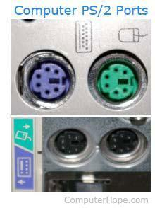

When referring to a physical [device](https://www.computerhope.com/jargon/d/device.htm), a hardware port or peripheral port is a hole or connection found on the front or back of a computer. Ports allow computers to [access](https://www.computerhope.com/jargon/a/access.htm) [external](https://www.computerhope.com/jargon/e/external.htm) devices such as [printers](https://www.computerhope.com/jargon/p/printer.htm). Below is a short listing of the different computer ports you may find on a computer. The picture shows an example of a type of port on the back of a computer.

Computer port examples:

* [AT port (old keyboard port)](https://www.computerhope.com/jargon/a/atkey.htm)
* [Displayport](https://www.computerhope.com/jargon/d/displayport.htm)
* [DVI port](https://www.computerhope.com/jargon/d/dvi.htm)
* [Firewire port (IEEE-1394)](https://www.computerhope.com/jargon/f/firewire.htm)
* [Gamepad / Joystick port](https://www.computerhope.com/jargon/g/gameca.htm)
* [HDMI port](https://www.computerhope.com/jargon/h/hdmi.htm)
* [LAN or network port (RJ-45)](https://www.computerhope.com/jargon/r/rj45.htm)
* [LPT port (printer port)](https://www.computerhope.com/jargon/l/lpt.htm)
* [Modem or phone port (RJ-11)](https://www.computerhope.com/jargon/r/rj11.htm)
* [Power port](https://www.computerhope.com/jargon/p/power-port.htm)
* [PS/2 port (keyboard port and mouse port)](https://www.computerhope.com/jargon/p/ps2.htm)
* [Serial port (DB9)](https://www.computerhope.com/jargon/s/seriport.htm)
* [USB port](https://www.computerhope.com/jargon/u/usb.htm)
* [VGA port](https://www.computerhope.com/jargon/v/vga.htm)

A port is a term used to describe the process of taking a program that has been written for specific [operating systems](https://www.computerhope.com/jargon/o/os.htm) and moving it to another operating system. For example, taking a program written for [Microsoft](https://www.computerhope.com/comp/msoft.htm) [Windows](https://www.computerhope.com/jargon/w/windows.htm) and moving it to [Linux](https://www.computerhope.com/jargon/l/linux.htm).

When referring to a network or the [Internet](https://www.computerhope.com/jargon/i/internet.htm), a software or network port is a location where information is sent. For example, port 80 is the [http](https://www.computerhope.com/jargon/h/http.htm) network port. A listing of commonly known and used ports can also be found on the below listing. Users running [Microsoft](https://www.computerhope.com/comp/msoft.htm) [Windows](https://www.computerhope.com/jargon/w/windows.htm) can utilize the [netstat command](https://www.computerhope.com/netstat.htm) to view currently active connections that include ports currently being used.

Users who want to block ports on their computer or network can use a software or hardware [firewall](https://www.computerhope.com/jargon/f/firewall.htm). If you cannot get access to a particular port it's likely that a firewall is already present on the Network or other network settings set by the administrators have been set up.

**Detailed list of all ports**: <https://www.computerhope.com/jargon/p/port.htm>

**Slots:**

A slot may refer to any of the following:

A slot is a computer processor connection designed to make upgrading the processor easier, where the user would only have to slide a processor into a slot. The original slot, or [Slot 1](https://www.computerhope.com/jargon/s/slot1.htm) , was first released by the [Intel Corporation](https://www.computerhope.com/comp/intel.htm) in [1997](https://www.computerhope.com/history/1997.htm) as a successor to the Socket 8. Later, [AMD](https://www.computerhope.com/comp/amd.htm) released another slot processor known as the Slot A in [1999](https://www.computerhope.com/history/1999.htm). Both slots look similar but are not compatible. Later, Intel released the Slot 2, which was a bigger slot used with the later versions of the Pentium II processors. Today, slot processors are no longer found in new computers and are replaced by [sockets](https://www.computerhope.com/jargon/s/socket.htm).

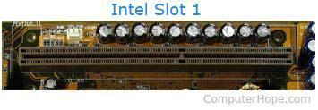

A slot is another name for an [expansion slot](https://www.computerhope.com/jargon/e/expaslot.htm) such as an [ISA](https://www.computerhope.com/jargon/i/isa.htm), [PCI](https://www.computerhope.com/jargon/p/pci.htm), [AGP](https://www.computerhope.com/jargon/a/agp.htm) slot, or [memory slots](https://www.computerhope.com/jargon/m/memoslot.htm).

**RAM Slot**

Random access memory (RAM) is data storage hardware on your computer's motherboard. Despite the name, RAM does not actually "remember" anything when a computer is turned off. Programs must be saved on the hard drive or another storage device. In practical terms, RAM determines how many programs can run at once and how large the programs can be. Computers cannot run without RAM installed. They often come packaged with multiple strips located in RAM slots on the motherboard that are easily removable and replaceable. Upgrading RAM will improve the speed of your computer.

**PCI Slot**

The Peripheral Component Interconnect (PCI) slot is a slot for expansion devices. Most desktop computers come with several PCI expansion slots. PCI slots are used for a variety of devices: modems, network cards, television tuners, radio tuners, video cards and sound cards, among others. Most computers today have several of these cards already built in. For computers that do not, these expansion devices provide additional functionality to a computer, making it possible for essential functions in a business such as wireless Internet connectivity.

**PCI Express Slot**

The PCI Express slot, like the PCI slot, is used for expansion cards. PCI Express allows for higher transfer speeds than PCI and is therefore preferred for graphics cards. The PCI Express has replaced the Accelerated Graphics Port (AGP) in most computers as the primary slot for graphics cards. Many newer programs, such as Adobe's popular photo and video editors, rely more on an advanced graphics card to process data. Upgrading your graphics card can improve performance markedly.

**Hard Drive Slot**

To connect hard drives to your computer, you might find a group of small rectangular slots, called serial advanced technology attachment slots. Some SATA slots might be capable of higher speeds and are usually colored differently. Connect solid-state drives to the high-speed SATA slots and mechanical disk drives to the lower-speed slots. Older motherboards might have parallel advanced technology attachment slots. PATA slots resemble PCI and PCIe slots more than they resemble SATA slots. PATA slots connect to disk drives as well as CD and DVD recorders and players using a ribbon cable.

**Connectors:**

A connection is a term that describes the link between a plug or connector into a [port](https://www.computerhope.com/jargon/p/port.htm) or [jack](https://www.computerhope.com/jargon/j/jack.htm). For example, your [monitor](https://www.computerhope.com/jargon/m/monitor.htm), [mouse](https://www.computerhope.com/jargon/m/mouse.htm), and [keyboard](https://www.computerhope.com/jargon/k/keyboard.htm) all must connect to the computer before they work.

**Connector** - The description of the end of the cable that joins a cable to a port. [Centronics](https://www.computerhope.com/jargon/p/paraport.htm), [DB](https://www.computerhope.com/jargon/d/dbconnec.htm), [DIN](https://www.computerhope.com/jargon/d/din.htm), [mini-plug](https://www.computerhope.com/jargon/m/mini-plug.htm), and [USB](https://www.computerhope.com/jargon/u/usb.htm) are all examples of types of connectors.

Below is a picture of the back of a desktop computer and each of the connections and ports. Although your desktop computer's layout may be different, this diagram gives you a better understanding of where everything connects.

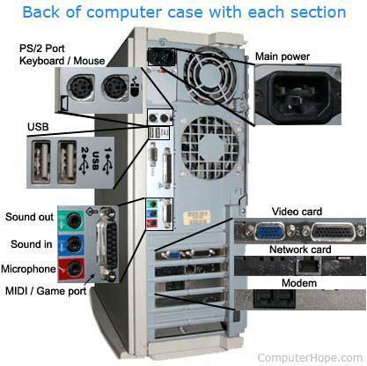

Connections on the back of the computer

* [AT](https://www.computerhope.com/jargon/a/at.htm)
* [BNC](https://www.computerhope.com/jargon/b/bnc.htm)
* [Composite](https://www.computerhope.com/jargon/c/composit.htm)
* [DisplayPort](https://www.computerhope.com/jargon/d/displayport.htm)
* [DVI](https://www.computerhope.com/jargon/d/dvi.htm)
* [eSATA](https://www.computerhope.com/jargon/s/sata.htm)
* [FireWire (IEEE-1394)](https://www.computerhope.com/jargon/f/firewire.htm)
* [HDMI](https://www.computerhope.com/jargon/h/hdmi.htm)
* [MIDI](https://www.computerhope.com/jargon/m/midi.htm)
* [Modem](https://www.computerhope.com/jargon/m/modem.htm) ([RJ-11](https://www.computerhope.com/jargon/r/rj11.htm) aka telephone)
* [Network](https://www.computerhope.com/jargon/n/nic.htm) ([RJ-45](https://www.computerhope.com/jargon/r/rj45.htm))
* [Parallel port](https://www.computerhope.com/jargon/p/paraport.htm)
* [PS/2 port](https://www.computerhope.com/jargon/p/ps2.htm)
* [RCA](https://www.computerhope.com/jargon/c/composit.htm)
* [S-Video](https://www.computerhope.com/jargon/s/svideo.htm)
* [S/PDIF](https://www.computerhope.com/jargon/s/spdif.htm)
* [SCSI](https://www.computerhope.com/jargon/s/scsi.htm)
* [Serial port (RS-232)](https://www.computerhope.com/jargon/s/serial.htm)
* [Sound card](https://www.computerhope.com/jargon/s/souncard.htm) ([sound out or line out](https://www.computerhope.com/jargon/l/lineout.htm), [sound in or line in](https://www.computerhope.com/jargon/l/linein.htm), [microphone](https://www.computerhope.com/jargon/m/microphone.htm), and [MIDI](https://www.computerhope.com/jargon/m/midi.htm) ([joystick](https://www.computerhope.com/jargon/j/joystick.htm)).
* [USB](https://www.computerhope.com/jargon/u/usb.htm)
* [VGA/SVGA](https://www.computerhope.com/jargon/v/vga.htm)

**Why are the colors on connections different?**

Connections on the back of a computer may be [color-coded](https://www.computerhope.com/jargon/c/color-coded.htm) to help locate the appropriate port for a [peripheral device](https://www.computerhope.com/jargon/p/peripher.htm).

The list below includes many ports and their associated colors.

* Keyboard (PS/2) - Purple
* Mouse (PS/2) - Green
* Serial - Cyan
* Printer - Violet
* Monitor ([VGA](https://www.computerhope.com/jargon/v/vga.htm)) - Blue
* Monitor ([DVI](https://www.computerhope.com/jargon/d/dvi.htm)) - White
* Line out (headphones) - Lime Green
* Line in (microphone) - Pink
* Audio in - Grey
* Joystick - Yellow

**Internal connections:**

* [ATA](https://www.computerhope.com/jargon/i/ide.htm)
* [Expansion slots](https://www.computerhope.com/jargon/e/expaslot.htm)
* [IDE/EIDE](https://www.computerhope.com/jargon/i/ide.htm)
* [SATA](https://www.computerhope.com/jargon/s/sata.htm)
* [SCSI](https://www.computerhope.com/jargon/s/scsi.htm)

**How do I check connections?**

Computer Hope or another technician may tell you to "check your connections" when [troubleshooting](https://www.computerhope.com/jargon/t/troushoo.htm) a problem. This suggestion refers to verifying a [cable](https://www.computerhope.com/jargon/c/cable.htm) is connected correctly on both ends of the cable. For example, with [monitor](https://www.computerhope.com/jargon/m/monitor.htm) troubleshooting, verify the cables on the back of the monitor, back of the computer, and the power cable are connected correctly. If all cables are firmly connected, it's also a good idea to disconnect a cable, verify nothing looks wrong with the cable or port, and reconnect the cable.

**What connection connects computers?**

Today, the most common method of connecting computers to each other is over a [network](https://www.computerhope.com/jargon/n/network.htm). To connect to a network, a computer uses a [network interface card](https://www.computerhope.com/jargon/n/nic.htm) to either connect using a cable like a [Cat 5](https://www.computerhope.com/jargon/c/cat5.htm) cable or wirelessly using [Wi-Fi](https://www.computerhope.com/jargon/w/wifi.htm).

**Addon Cards:**

A computer add-on card is an electronic card/board that is used to add extra functionality to a computer. It is inserted into an expansion slot on the motherboard of a computer. Add-on cards contain edge connectors that are used to create an electronic link between motherboard and card, thus enabling these two to communicate. Add-on cards are also known as expansion cards or interface cards. Many different classes of add-on cards are available, including sound cards, video graphics cards, network cards and so on. All add-on cards are used to enhance the quality of their specific function. For example, video graphics cards are used to enhance the video quality on a computer. The basic purpose of add-on cards is to enhance the existing abilities of the motherboard. The adoption of add-on cards occurred rapidly in the computing world because of the ability for users to customize performance.

Giving a computer additional capabilities requires fitting the computer with an add-on card, also called an expansion card, interface card or just plain card. Expansion controller cards have sockets that connect to conductors carrying data within the system. The connector you use depends on the card and computer. Cards provide communications interfaces, extra memory, video sound I/O capabilities, system interfaces for discs or tape backup devices and additional processors in general. Controller cards are an excellent example of an add-on card because the card acts as an interface for the motherboard, and other computer components like HDD, optical drives and keyboards. Add-on cards are suitable for use with printers and other devices in office environments.

1. **Graphics Card:**

As the name suggests, a graphics card deals with processing “everything graphics-related”. While most modern motherboards these days already come with a built-in graphics card, they are only good enough for conventional use.

So when it comes to demanding applications such as gaming and video editing, having a powerful dedicated graphics card is still a must. This is why some people still prefer to buy a graphics card, and why they are still thriving in today’s market.

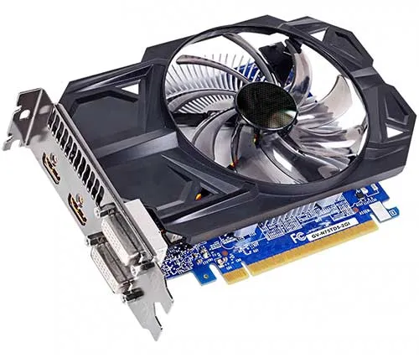

1. **Sound Card**

Once upon a time in the dark ages of computing, we had to buy and install a “separate sound card” just to play music with the computer. But times have changed, and nearly all modern motherboards these days will come with built-in audio. Sound cards are pretty much obsolete, less the specialized ones for audio production.

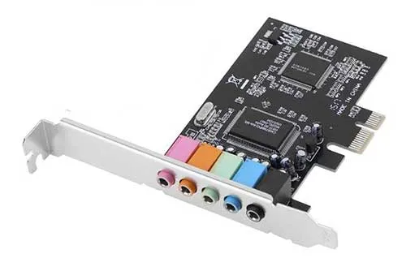

1. **Network Interface Card (NIC)**

The network interface card (NIC) comes in 2 flavors – Wired and wireless. Again, some modern motherboards already come with a built-in wired network port and even wireless. The “normal” network cards have pretty much become obsolete, less the specialized ones that offer insanely fast speeds.

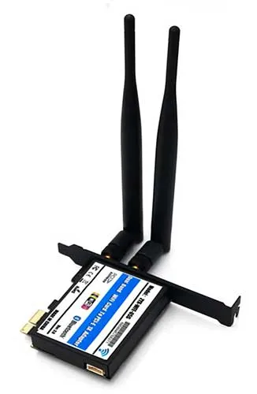

1. **TV Tuner Card**

Want to turn your computer into a TV? Yes, we can. Install one of these TV tuner cards, use their application, and that will enable the computer to tune into local TV channels.

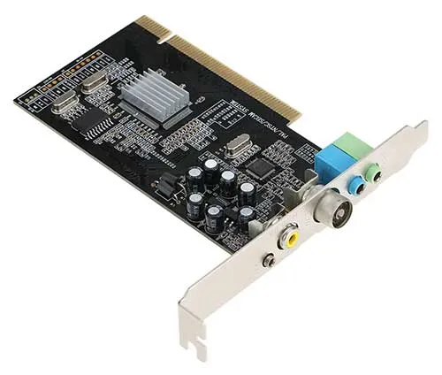

1. **FM Tuner Card**

There also used to be FM tuner cards that we can install on computers, allowing the computer to tune into the local radio stations. But FM tuner cards have gone extinct with the rise of the Internet, online videos, Internet radio, and smartphones.

1. **Modem Card**

Back in the stone age of the Internet, we had to connect a phone line to a dial-up modem, and “call” the Internet service provider (ISP) to get an Internet connection. These dial-up modems come in the shape of either an external device or an expansion card. Today, these cards are not as useful, but can still be used to send out faxes.

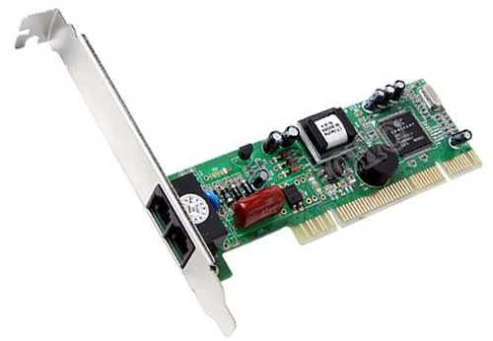

1. **Video Capture Card**

With the correct software, we can record and stream videos onto the Internet. But having a dedicated video capture card will just take that load off the CPU and GPU; The video capture card will do all the video encoding and thus free up more of the processing juice for the games/video editing/live stream sessions.

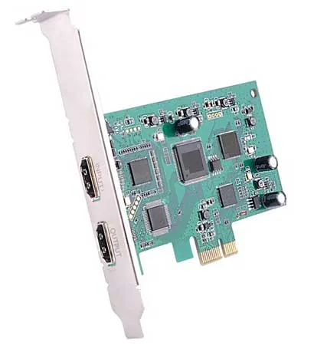

1. **Interface Card**

Interface cards add more ports of your choice to the computer

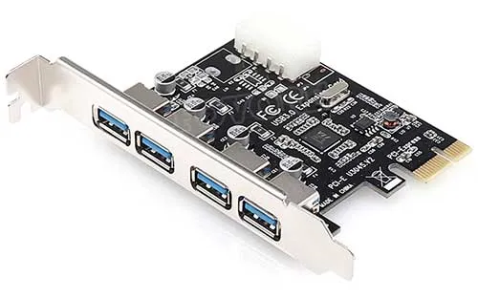

**Primary and secondary memory and their installation:**

Memory is very much like our brain as it is used to store data and instructions. Computer memory is the storage space where data is to be processed, and instructions needed for processing are stored. The memory is divided into a large number of smaller portions called the cell. Every cell/ location has a unique address and a size.

Two types of memories are:

* Primary Memory
* Secondary Memory

**Primary Memory** is the main memory of the computer system. Accessing data from primary memory is faster because it is an internal memory of the computer. The primary memory is most volatile, meaning data in primary memory does not exist if it is not saved when a power failure occurs.

The primary memory is a semiconductor memory. It is costlier compared with secondary memory. The capacity of primary memory is very much limited and is always smaller compares to secondary memory.

Two types of Primary Memory are:

* RAM
* ROM

**RAM (Random Access Memory)**

Random access memory which is also known as RAM is generally known as a main memory of the computer system. It is called temporary memory or cache memory. The information stored in this type of memory is lost when the power supply to the PC or laptop is switched off.

**ROM (Read Only Memory)**

It stands for Read Only Memory. ROM is a permanent type of memory. Its content is not lost when the power supply is switched off. The computer manufacturer decides the information of ROM, and it is permanently stored at the time of manufacturing which can not be overwritten by the user.

**Characteristics of Primary Memory**

* The computer can’t run without primary memory
* It is known as the main memory.
* You can lose data in case power is switched off
* It is also known as volatile memory
* It is a working memory of the computer.
* Primary memory is faster compared to secondary memory.

**Secondary Memory**

All secondary storage devices which are capable of storing high volume data is referred to as secondary memory. It’s slower than primary memory. However, it can save a substantial amount of data, in the range of gigabytes to terabytes. This memory is also called backup storage or mass storage media.

**Types of Secondary memory**

**Mass storage devices:**

The magnetic disk provides cheap storage and is used for both small and large computer systems.

Two types of magnetic disks are:

* Floppy disks
* Hard disks

**Flash/SSD**

Solid State Drive provides a persistent flash memory. It’s very fast compared to Hard Drives. Frequently found in Mobile phones, its rapidly being adopted in PC/Laptop/Mac.

**Optical drives:**

This secondary storage device is from which data is read and written with the help of lasers. Optical disks can hold data up to 185TB.

Examples

* CD
* DVD
* Blue Ray

**USB drives:**

It is one of the most popular types of secondary storage device available in the market. USB drives are removable, rewritable and are physically very small. The capacity of USB drives is also increasing significantly as today 1TB pen drive is also available in the market.

Magnetic tape:

It is a serial access storage device which allows us to store a very high volume of data. Usually used for backups.

**Characteristics of Secondary Memory**

* These are magnetic and optical memories
* Secondary memory is known as a backup memory
* It is a non-volatile type of memory
* Data is stored permanently even when the power of the computer is switched off
* It helps store data in a computer
* The machine can run without secondary memory
* Slower than primary memory

**Primary Memory Vs Secondary Memory**

* Primary memory is also called internal memory whereas Secondary memory is also known as a Backup memory or Auxiliary memory.
* Primary memory can be accessed by the data bus whereas Secondary memory is accessed by I/O channels.
* Primary memory data is directly accessed by the processing unit whereas Secondary memory data cannot be accessed directly by the processor.
* Comparing primary and secondary storage devices, Primary storage devices are costlier than secondary storage devices whereas Secondary storage devices are cheaper compared to primary storage devices.
* When we differentiate primary and secondary memory, Primary memory is both volatile & non volatile whereas Secondary memory is always a non-volatile memory.

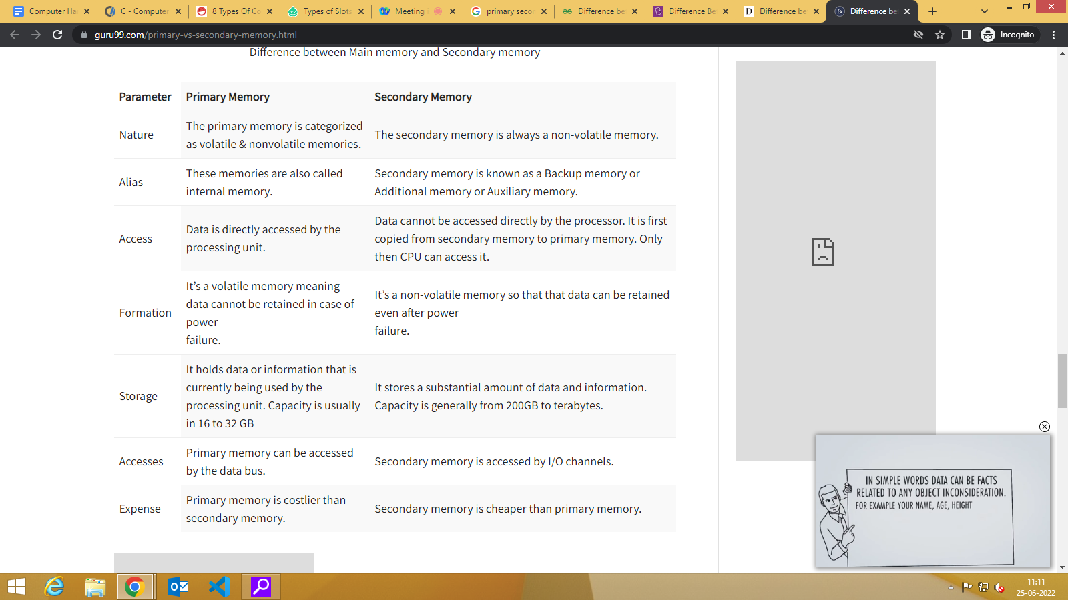

**Installing the primary memory module:**

If you are replacing a component, remove the existing component before performing the installation procedure.

The figure indicates the location of the primary memory module and provides a visual representation of the installation procedure.

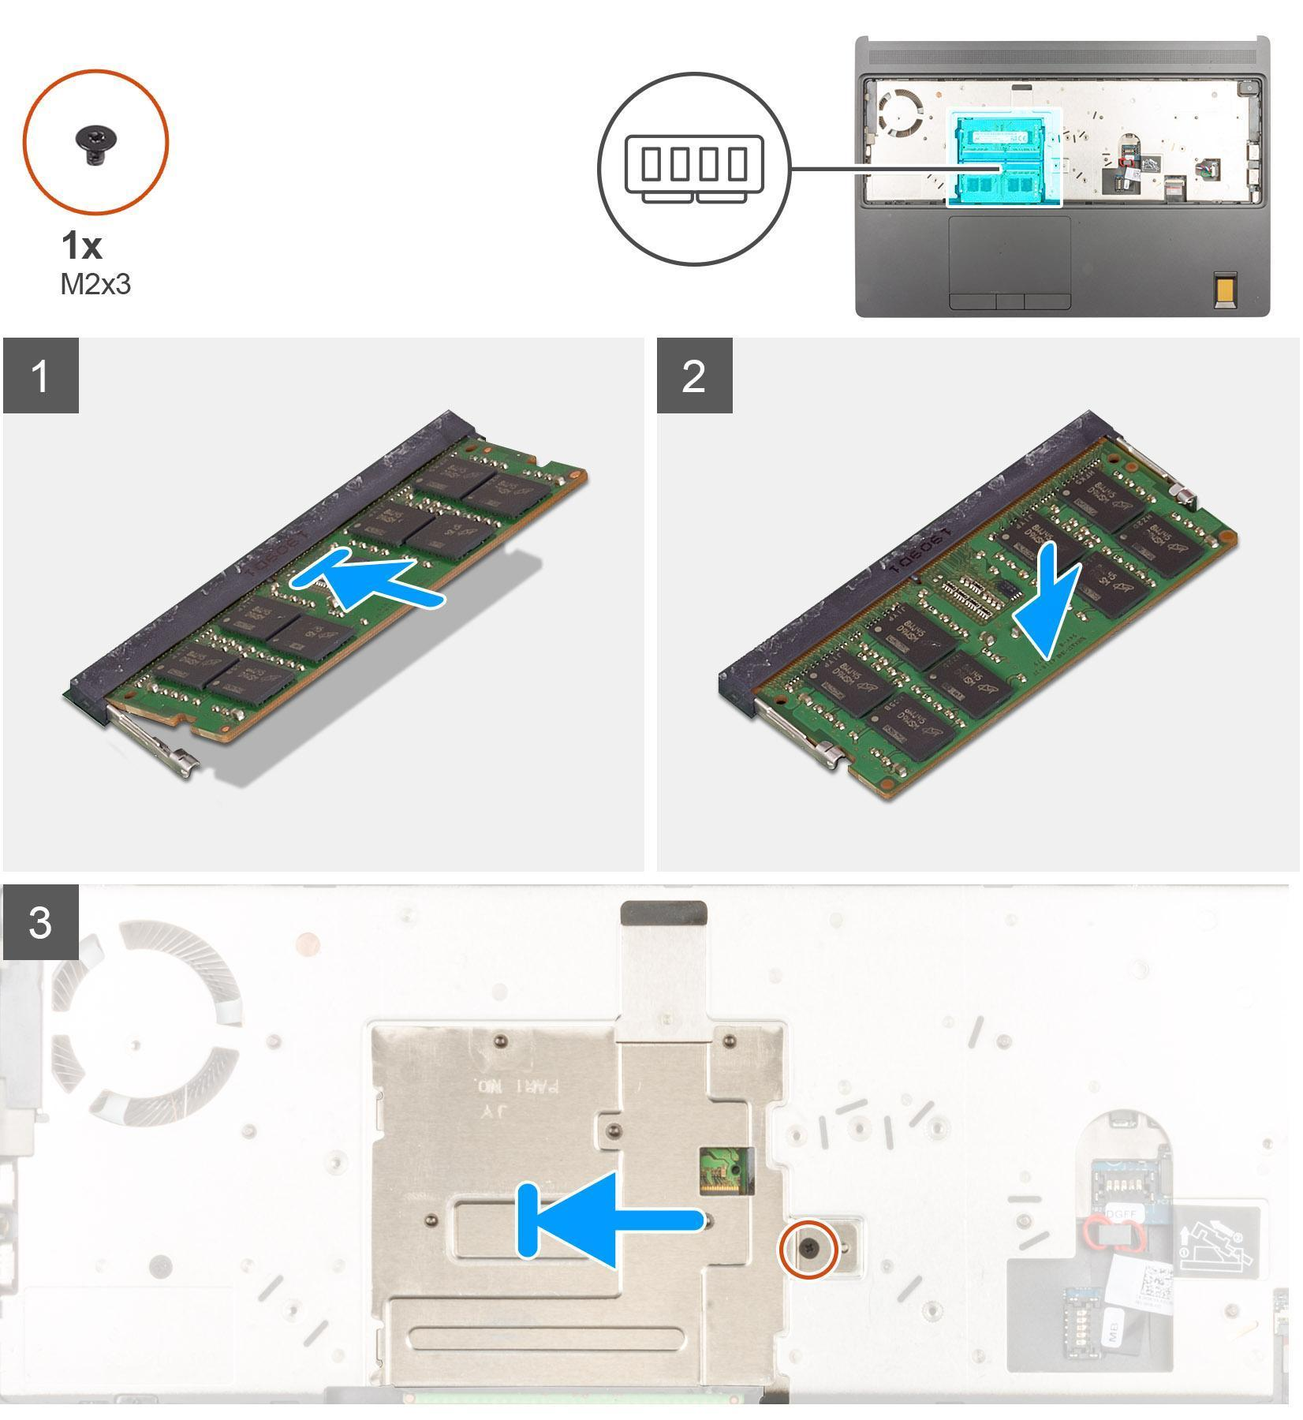

**Steps:**

1. Align the notch on the memory module with the tab on the memory-module slot.
2. Slide the memory module firmly into the slot at an angle and press the memory module down until it clicks into place.
3. Carefully align the two clips on the memory shield with the slots on the computer chassis and insert the clips under the chassis.
4. Place the memory shield above the memory module.
5. Replace the (M2x3) screw to secure the memory shield to the memory module.

**Cabinet Types:**

The computer cases are a visible part of our computers called PC towers and Computer towers. Its function is to serve as a protective structure for the rest of the internal components where they will be assembled.

There are many different types of cases. The main feature of each of them is its form and size factor. This is due to the motherboard, whose form factor must be compatible with that of the tower to fit perfectly. And yes, the [cooling system](https://en.wikipedia.org/wiki/Computer_cooling) is one of the main components of any PC case. There should be enough space inside for air circulation and large radiators that a powerful PC needs. It must be understood that a PC case is an essential component for protecting the internal equipment from external influences. Along with characteristics, it is necessary to highlight their size and type of execution, which can be either vertical or horizontal. The following are the computer case sizes and models available in the market.

**4 Different Types of Computer Case**

**1. Full tower**

Firstly, Full Tower is used to accommodate an E-ATX or CEB motherboard. This is very useful for high-performance servers that can use multiple components of all sizes of [motherboard from high end expensive](https://digitalworld839.com/why-are-motherboards-so-expensive/) to cheap including [RAM and ROM](https://digitalworld839.com/what-is-the-difference-between-ram-and-rom/) and other storage units at once.

The full tower ranges between 55- 75 cm tall and 22 – 32 cm in width. It can have from 4 to 9 5.25-inch bays (for additional optical drive). Allows you to install up to seven expansion cards, such as a sound card or a receiver.

This type of computer case comes with proper size and weight, which usually has better internal cooling. Of course, their prices are a little high. That’s why enthusiasts, administrators have always used full Tower cases, and hardcore streaming gamers.

If you want to build your separate uncompromising, powerful gaming PC and want to use three monitors and play in 4K togetherly? Then such a case will provide your future computer with the necessary space.

Such a case provides better cooling for two top-end [graphics cards, multiple RAM bars, and a processor](https://digitalworld839.com/processor-vs-graphic-card-vs-ram/) like the Intel Core i9-9900K and allows you to create a custom cooling system with 230mm fans.

Buying a Full Tower is worth it, but only if you need space for a large number of components or need a lot of airflows to cool the powerful processors and cards.

**2. Full Tower Gaming Chassis**

One big drawback to having a Full Tower is that it takes up a lot of space and is difficult to hide. But if you have free space available, then it is not essential for you, then Full Tower can be the best choice for your PC.

2. Mid Tower

Mid-tower or ATX format is the most popular and widely used computer case that allows you to use many drives and almost all types of motherboards with acceptable overall dimensions in it.

The average full tower ranges between 35- 55 cm tall and 15 – 25 cm in width.

Inside the mid-tower case, there is more enough space for installing full-size components, such as most extensive video cards over 300 mm long, and this case is capable of using 120, 140, or even 200 mm fans for a positive effect on cooling the air.

If you want to build a regular gaming PC, not as hardcore gaming, then Mid Tower is most likely your right choice. This case is about 31 cm long, which is easy to install a full-size video card and two to three [expansion slots](https://digitalworld839.com/motherboard-slots-types/) thick.

Besides, the components inside the Mid Tower will receive adequate cold airflow. With proper use of fans (and regular cleaning from dust), the video card and processor temperatures will never exceed 70-80 degrees Celsius, even in the most stressful conditions.

Using these types of computer cases, you can build a productive PC with a sound ventilation system. It is considered a universal option for desktop users because you can assemble a wide range of designs, a low-power office computer, a home media center, and a gaming computer.

This type of format includes both those developed for the mini ITX standard and those designed for the micro ATX standard. Therefore, you will find all the small computer cases in this segment, including many [cube-shaped chassis](https://digitalworld839.com/best-pc-cube-cases/) or oriented for HTPC.

* Recommended: [Full Tower vs. Mid Tower](https://digitalworld839.com/mid-tower-vs-full-tower/) – Which is Suitable? (Comparison)
* Related: [3 Pin vs. 4 Pin Fans](https://digitalworld839.com/3-pin-vs-4-pin-fan-difference-between/) [for PC Case](https://digitalworld839.com/3-pin-vs-4-pin-fan-difference-between/) – Which is Best? (Comparison)

**3. Mini Tower**

These types of computer cases are designed to take up as little physical space and without installing decent-sized graphics cards. The average mini-tower length ranges between 30 – 45 cm tall and 15 – 25 cm in width (they can sometimes be smaller).

Their thermal enclosures are not the best on the market, so it is more convenient for you to install low-consumption components rather than high-consumption ones.

The Mini Tower chassis is the smallest in size and not very popular among computer assemblers due to the limited volume, which does not allow assembly of a more or less productive computer and low airflow. A small body limits the choice of types of accessories too.

You can install only a microATX motherboard and a low power supply in these types of computer cases. Typically, Mini Tower computers are shipped in the most basic configuration for back-office machines or network terminals.

Mini Towers are an increasingly common choice for regular home PCs – both budget and enough for standard video games. Regarding their possible uses, given their limited size and expansion capabilities, their benefits are quite limited.

However, during assembly, only a specialist or experienced can beautifully arrange everything in its place as there is not much space inside.

**4. HTPC and SFF**

HTPC stands for ‘Home theater PC’ and SFF stands for ‘Small Form Factor‘. These types of cases were considered very niche, but in recent years they have gained popularity due to the miniaturization of powerful components that can fit in them.

HTPC is the perfect choice for the computer at your home multimedia entertainment. You can place it under the TV table, or even hang it on the wall. And the computing power of this is more than enough to play music and video in any modern format.

Also, such a PC will not make a sound – often, you can have passive cooling.

SFF takes little space. Due to their small size and lightweight, they can be an excellent alternative to laptops. Some SFFs are handy to come with handles or unique bags to make them easier to transport. Also, the SFF has a significant advantage over a laptop since it has more power at less cost.

Many SFFs come with motherboards by offering cooling options that differ from the standard fans found in other types of computer cases.

This happens because the video and sound on such motherboards are built-in, leading to generating heat in a very tiny amount. As a result, they do not need powerful cooling. Also, this arrangement reduces the size.

[SFF cases](https://en.wikipedia.org/wiki/Small_form_factor) with Mini-ITX motherboards suit perfectly the people who work or play in tight spaces. These are specially for small living rooms and small offices. It will also be much easier to repair and improve such a PC than a laptop with the feature of portability.

It has one drawback that they are most often limited to only one CD drive.

.

**Comparison of Different Computer Case Sizes**

| **Features** | **Full Tower** | **MidTower** | **Mini Tower** | **SFF/HTPC** |
| --- | --- | --- | --- | --- |
| **Size** | The full tower is the largest size for PC users than all types of computer cases. | It has the most common size for the average desktop user. | The size of the mini tower is smaller than the full and mid tower. | The SFF and HTPC are very small in size and light in weight compared to all the computer cases. |
| **Length in Inches** | The full tower ranges between 22 - 30 inches tall and 9 -13 inches in width. | The mid tower ranges between 15 - 22 inches tall and 6-10 inches in width. | The mini tower ranges between 12 - 18 inches tall and 6 -10 inches in width. | The HTPC and SFF range between 10 - 14 inches tall and 5 - 8 inches in width. |
| **Motherboard** | The full tower supports motherboards like ATX, Extended ATX, Micro ATX, Micro-ATX, XL-ATX, Mini ITX, SSI EEB. | The mid-tower supports motherboards like Mini-ITX, MicroATX, ATX, E-ATX, M-ATX. | It mainly supports Micro-ATX and Mini-ATX motherboards. | HTPC and SFF support Micro-ATX and Mini-ITX motherboards. |
| **Uses** | Full tower is best for hardcore and professional Gamers, so as to upgrade the PC later as it provides additional slots and space for optical bays, airflow units, etc. | It can be the best choice for casual users and even for regular gaming. Best choice for the newbie desktop users. | A mini tower case is best for basic tasks such as web browsing, accessing web-based applications, audio/video playback, and document processing. | It will be best to use as a home media center for streaming videos and audios via connecting TV or monitor. |
| **Drawback** | The enormous size tends to be very heavy, which occupies a great deal of room and is difficult to hide and transport. | If you try fitting additional graphics cards into the tower but then cooling becomes a hassle also there is not much ability for a custom cooling water system. | There are limitations for additional cards and slots for RAM and ROM. | It can be a lot of work customizing it to fit your wants/needs. Also, upscaling is not great |
| **Cost** | Very Expensive | Available at Mid and affordable range. | Inexpensive and affordable. | It can be Expensive or mid range cost depending on your needs. |

**Chapter 2: Diagnose & repair problems of Desktop and Laptop**

| **Contents:**   * General Troubleshooting rules * Preventive Maintenance * BIOS Features * BIOS & Boot Sequences * BIOS Shortcoming & Compatible Issues, Troubleshooting * POST * Error Code: Beep Code, Post Code * Preventive maintenance of latest gadgets | | | | | | |
| --- | --- | --- | --- | --- | --- | --- |

**General Troubleshooting rules:**

There are many different things that could cause a problem with your computer. No matter what's causing the issue, troubleshooting will always be a process of trial and error—in some cases, you may need to use several different approaches before you can find a solution; other problems may be easy to fix.

* **Write down your steps**: Once you start troubleshooting, you may want to write down each step you take. This way, you'll be able to remember exactly what you've done and can avoid repeating the same mistakes. If you end up asking other people for help, it will be much easier if they know exactly what you've tried already.
* **Take notes about error messages:** If your computer gives you an error message, be sure to write down as much information as possible. You may be able to use this information later to find out if other people are having the same error.
* **Always check the cables:** If you're having trouble with a specific piece of computer hardware, such as your monitor or keyboard, an easy first step is to check all related cables to make sure they're properly connected.   
  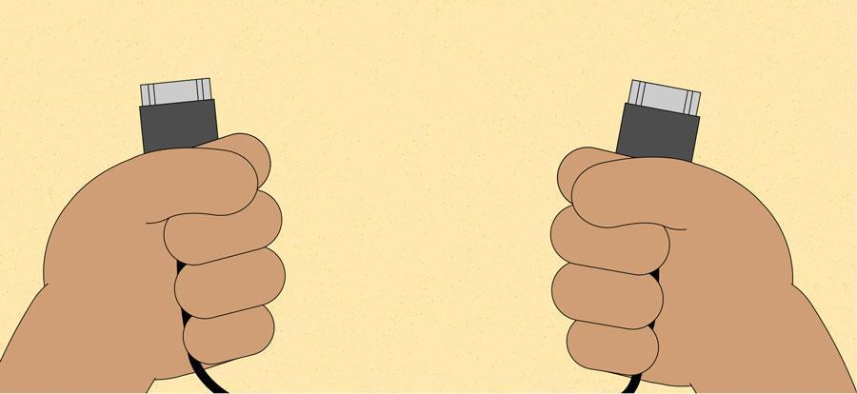
* **Restart the computer**: When all else fails, **restarting the computer** is a good thing to try. This can solve a lot of basic issues you may experience with your computer.
* **Using the process of elimination:** If you're having an issue with your computer, you may be able to find out what's wrong using **the** **process of elimination**. This means you'll make a list of things that could be causing the problem and then test them out one by one to eliminate them. Once you've identified the source of your computer issue, it will be easier to find a solution.

**Scenario:** Let's say you're trying to print out invitations for a birthday party, but the printer won't print. You have some ideas about what could be causing this, so you go through them one by one to see if you can **eliminate** any possible causes

First, you check the printer to see that it's turned on and plugged in to the **surge protector**. It is, so that's not the issue. Next, you check to make sure the printer's **ink cartridge** still has ink and that there is paper loaded in the **paper tray**. Things look good in both cases, so you know the issue has nothing to do with ink or paper.

Now you want to make sure the printer and computer are **communicating correctly**. If you recently downloaded an **update to your operating system**, it might interfere with the printer. But you know there haven't been any recent updates and the printer was working yesterday, so you'll have to look elsewhere.

You check the printer's **USB cord** and find that it's not plugged in. You must have unplugged it accidentally when you plugged something else into the computer earlier. Once you plug in the USB cord, the printer starts working again. It looks like this printer issue is solved!

This is just one example of an issue you might encounter while using a computer. In the rest of this lesson, we'll talk about other common computer problems and some ways to solve them.

**Problem: Power button will not start computer**

**Solution 1**: If your computer **does not start**, begin by checking the power cord to confirm that it is plugged securely into the back of the computer case and the power outlet.

**Solution 2**: If it is plugged into an outlet, make sure it is a **working outlet**. To check your outlet, you can plug in another **electrical device**, such as a lamp**.**

**Solution 3**: If the computer is plugged in to a **surge protector**, verify that it is turned on. You may have to **reset** the surge protector by turning it off and then back on. You can also plug a lamp or other device into the surge protector to verify that it's working correctly.   
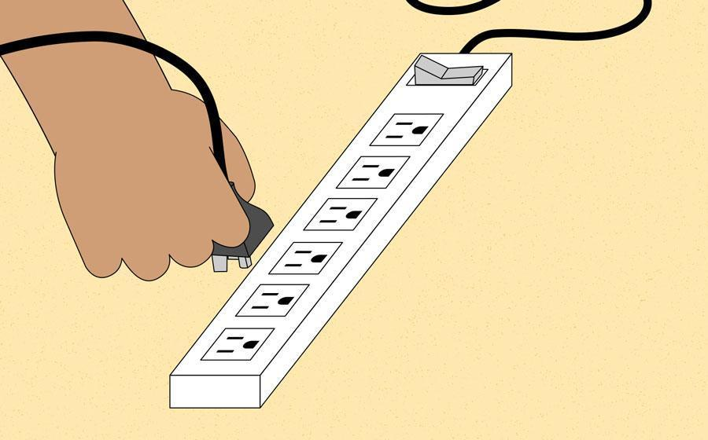

**Solution 4**: If you are using a **laptop**, the **battery** may not be charged. Plug the **AC adapter** into the wall, then try to turn on the laptop. If it still doesn't start up, you may need to wait a few minutes and try again.

**Problem: An application is running slowly**

**Solution 1**: Close and reopen the application.**Solution 2**: Update the application. To do this, click the **Help** menu and look for an option to check for **Updates**. If you don't find this option, another idea is to run an online search for application updates.  
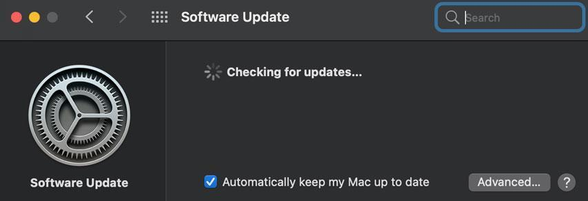

**Problem: An application is frozen**

Sometimes an application may become stuck, or **frozen**. When this happens, you won't be able to close the window or click any buttons within the application.

**Solution 1**: Force quit the application. On a PC, you can press (and hold) **Ctrl+Alt+Delete** (the Control, Alt, and Delete keys) on your keyboard to open the **Task Manager**. On a Mac, press and hold **Command+Option+Esc**. You can then select the unresponsive application and click **End task** (or **Force Quit** on a Mac) to close it.   
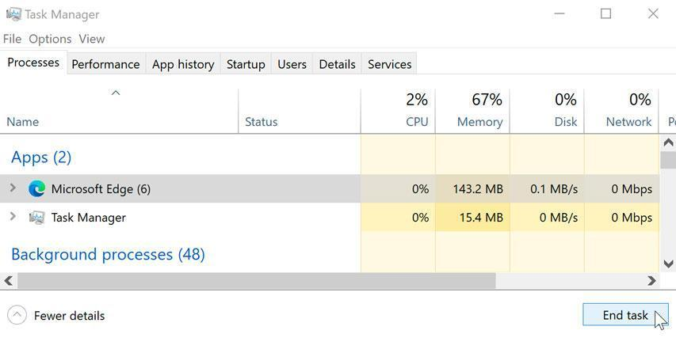

**Solution 2**: Restart the computer. If you are unable to force quit an application, **restarting** your computer will close all open apps.

**Problem: All programs on the computer run slowly**

**Solution 1**: Run a **virus scanner**. You may have **malware** running in the background that is slowing things down.  
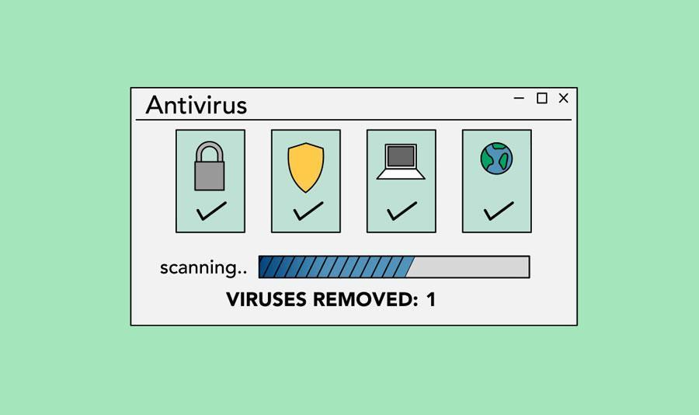

**Solution 2**: Your computer may be running out of hard drive space. Try **deleting** any files or programs you don't need.

**Solution 3**: If you're using a **PC**, you can run **Disk Defragmenter**. To learn more about **Disk Defragmenter**, check out our lesson on [**Protecting Your Computer**](http://www.gcflearnfree.org/computerbasics/protecting-your-computer/1/).

**Problem: The computer is frozen.**

Sometimes your computer may become completely unresponsive, or **frozen**. When this happens, you won't be able to click anywhere on the screen, open or close applications, or access shut-down options.

**Solution 1 (Windows only)**: Restart Windows Explorer. To do this, press and hold **Ctrl+Alt+Delete** on your keyboard to open the **Task Manager**. Next, locate and select **Windows Explorer** from the **Processes** tab and click **Restart**. You may need to click **More Details** at the bottom of the window to see the Processes tab.

**Solution 2 (Mac only):** Restart Finder. To do this, press and hold **Command+Option+Esc** on your keyboard to open the Force Quit Applications dialog box. Next, locate and select Finder, then click Relaunch.   
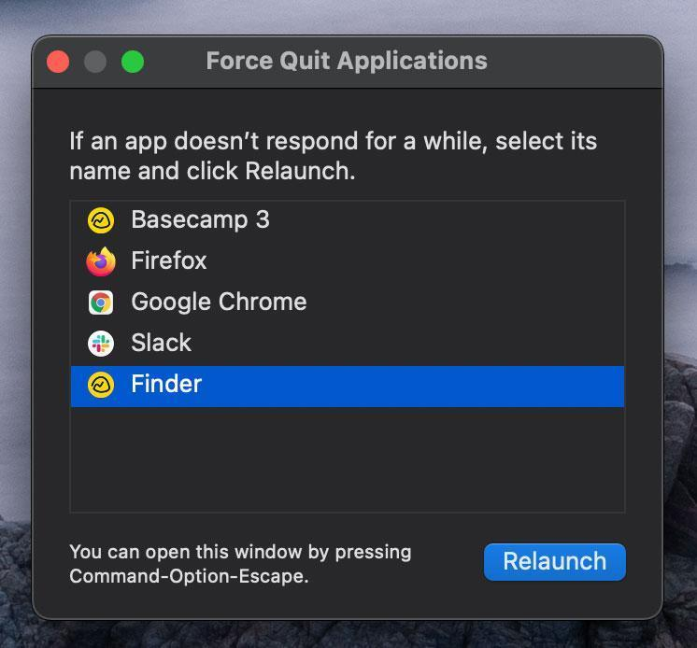

**Solution 3**: Press and hold the Power button. The Power button is usually located on the front or side of the computer, typically indicated by the **power** **symbol**. Press and hold the Power button for **5 to 10 seconds** to force the computer to shut down.

**Solution 4**: If the computer still won't shut down, you can **unplug the power cable** from the electrical outlet. If you're using a laptop, you may be able to remove the battery to force the computer to turn off. **Note**: This solution should be your **last resort** after trying the other suggestions above.

**Problem: The mouse or keyboard has stopped working**

**Solution 1**: If you're using a **wired** mouse or keyboard, make sure it's correctly plugged into the computer.   
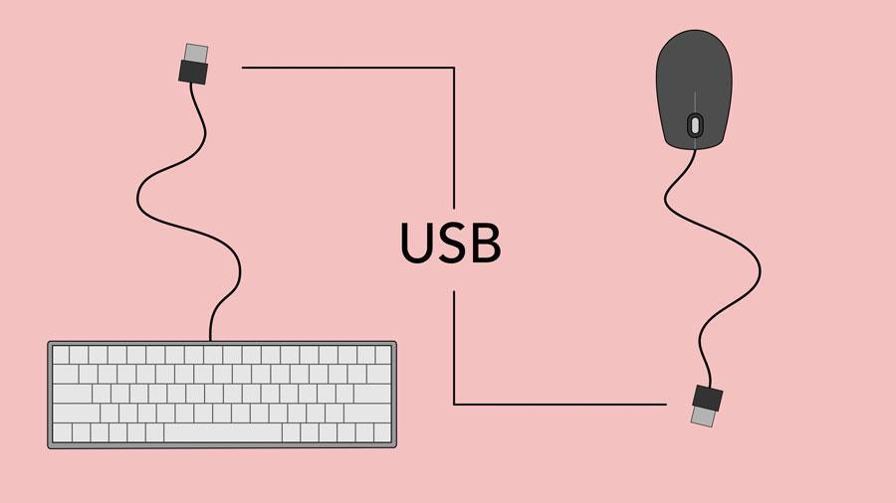

**Solution 2**: If you're using a **wireless** mouse or keyboard, make sure it's turned on and that its batteries are charged.

**Problem: The sound isn't working**

**Solution 1**: Check the volume level. Click the audio button in the top-right or bottom-right corner of the screen to make sure the sound is turned on and that the volume is up.

**Solution 2**: Check the audio player controls. Many audio and video players will have their own separate audio controls. Make sure the sound is turned on and that the volume is turned up in the player.

**Solution 3**: Check the cables. Make sure external speakers are plugged in, turned on, and connected to the correct audio port or a USB port. If your computer has **color-coded** ports, the audio output port will usually be **green**.

**Solution 4**: Connect headphones to the computer to find out if you can hear sound through the headphones.   
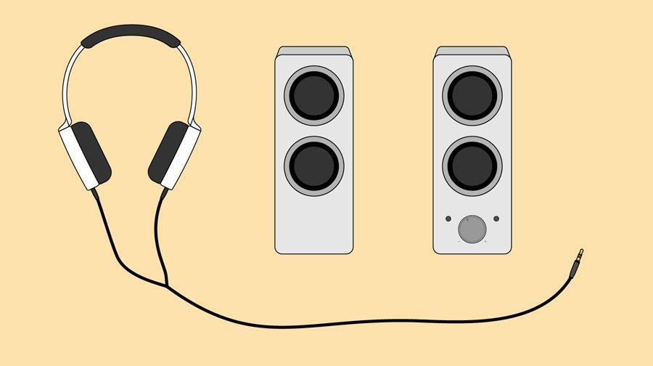

**Problem: The screen is blank**

**Solution 1:** The computer may be in Sleep mode. Click the mouse or press any key on the keyboard to wake it.

**Solution 2:** Make sure the monitor is plugged in and turned on.

**Solution 3:** Make sure the computer is plugged in and turned on.

**Solution 4:** If you're using a desktop, make sure the monitor cable is properly connected to the computer tower and the monitor.

**Preventive Maintenance**

Today’s computers come in many different shapes and sizes, and each keeps us connected to our digital world at any given time. Whether you depend on your collection of devices for work or play, keeping them in impeccable, unblemished condition is of the utmost importance. From their cosmetic appeal to their operational functionality, a well-maintained computer looks good, lasts longer, and performs reliably.

Keeping your PC in tip-top condition lengthens the life of your PC, both internally and externally. A glitchy operating system, overheating CPU, or fast-draining battery are avoidable computer woes that a bit of regular maintenance could defend against.

**Protect with padding**

Everyone has been there; drops, bumps, and slips result in unsightly cosmetic dings that leave your computer looking less-than-loved. If you’re like most [people who travel with their PC](https://www.hp.com/us-en/shop/tech-takes/5-best-hp-travel-laptops), safeguarding against accidents can feel next to impossible when packing your PC away into a carry-on. An exposed laptop is vulnerable to all of the elements of travel you likely want to protect it from.

Whether you’re traveling business-class or to a classroom across campus, shielding your PC against the elements [starts with a protective case](https://www.hp.com/us-en/shop/tech-takes/9-best-laptop-bags). There are a few different styles of protection that offer differing levels of armor and functionality. These include:

* Skins

Functioning as a full-body laptop sticker, laptop skins are best for protecting the chassis from light damage and scratches.

* Hardshell snap-on covers

Polycarbonate, plastic, or rubberized hard shell laptop covers protect your PC while still granting easy access to ports, buttons, lights, and fans.

* Sleeves

A simple, soft, envelope-style pouch typically made of gentle materials like nylon, polyester, suede, or microfiber, laptop sleeves are lightweight protection.

* Messenger bag

A shoulder bag specifically designed to accommodate your laptop and necessary peripherals, the dedicated [laptop messenger bag](https://www.hp.com/us-en/shop/cv/accessories-filters?cat=dBR0w) offers the most padded protection.

**Organize cords**

The only thing more frustrating than dealing with long, confusing cables is getting them all mixed up and tangled in the process. Keeping your digital world connected is a must, so nixing the cables isn’t a feasible option. Taking the time to declutter and organize the snake-like mass of wires spawning from your power strip and PC ports is a great first step for both desktop and laptop users. Try these wire organization tips:

* A rotating power strip

Traditional power strips offer a single line or panel of surge inputs. A rotating power strip gives you the freedom to modify the positioning of your many chargers, monitors, and docks.

* Color-coding cables

Computer cables tend to be two colors; black and white. Organizing your mess of wires may be as simple as color coding them with reds, blues, yellows, greens, and or using labels in distinguishable hues.

* Cable clips

Wire management is made simple when you attach cable clips to your desk, wall, or floor. These small clips are designed to hold cables of all different sizes.

* Organizer panel

Functioning as a panel of cable clips, a wire organizer panel accommodates multiple wires. Stick it in place with an adhesive or keep it desk-side when you use a weighted panel.

**Update your operating system**

If you’re looking for basic computer maintenance, keeping your operating system up to date is one of the easiest solutions. Regardless of whether you’re a Windows, Mac, or Linux loyalist, updating your PC when new patches are available ensures your PC stays at the cutting-edge of performance power.

Windows 10 is known for keeping users in-tune with once-a-day update checks. This automated scan occurs in the background and always notifies you if there are any important software or operating system patches that need to be made. The end goal is to optimize your PC performance, so when Windows suggests you update, you should do it.

**Unplug to avoid overcharging**

With heightened dependence on wireless devices, [optimizing battery power](https://www.hp.com/us-en/shop/tech-takes/best-battery-life-laptops) is a top priority for many. There are few things more dreadful than a draining battery when you’ve got hours of work and play left on your day’s schedule. However, it’s better to resist the temptation of plugging in the moment your PC falls under 50% battery life.

Unnecessary charging can lead to overcharging, which then leads to regenerative capability deterioration. This often looks like a laptop that can’t hold a charge as well as it could in its earlier days.

Being shackled to the weight of a charger defeats the purpose of a laptop’s wireless portability. To avoid a bad battery fate, unplug your device after it reaches 100% charge, and don’t plug in until power is actually low.

**Purge your system of junk files and programs**

Computers tend to show their age best in the number of unused files living on their hard drives. Useless programs and old junk files likely take up more space than you realize. From old versions of software to retired versions of your resume, your PC is sure to have its fair share of digital debris festering on your desktop or in your start menu. These programs and files can quickly turn into [performance hogs](https://www.hp.com/us-en/shop/tech-takes/7-ways-to-improve-computer-performance) if they continue to accumulate.

Before your computer gets to a point where it’s begging for more storage space, use these PC purge tips to relieve your system.

* Uninstall trialware
* Run [disk cleanup](https://www.hp.com/us-en/shop/tech-takes/how-to-use-disk-cleanup-windows-10) software
* Empty the recycle bin
* Delete temporary files
* Remove cache of offline web pages

**Run regular antivirus scans**

Malware attacks can sneak up on you at any given moment, and in the event one does, having a savvy antivirus living on your PC will protect you against the damage viruses bring. Weekly antivirus scans ensure your computer is always clear of malicious software infections. A basic scan will examine your computer for any glaring dangers or outstanding activity.

For those who are frequent web-users and download programs and files regularly, consider running a virus scan twice a week. It’s always better to err on the side of safety, especially when your personal data could be at risk.

Malware infections can compromise the performance of your computer and expose your confidential information to third-party cybercriminals. Depending on the [type of malware](https://www.hp.com/us-en/shop/tech-takes/most-common-types-of-cyber-attacks) installed on your system, a virus could also:

* Slow web browser speeds
* Disrupt network connections
* Freeze or crash your system
* Alter computer settings
* Allow unauthorized access to system resources

By running regular antivirus scans you can rest assured that nothing slips by. Be sure to choose an antivirus scan servicer that also scans all of your downloads, too.

**Clean the keyboard and case**

You’d be surprised to see just how much dust and debris lives underneath your keyboard’s keys. From food crumbs and dog hairs to dust and dirt, and everything else that can fit in between the keys, a number of dirty particles can clog your keyboard. This usually results in sticky or difficult-to-press buttons.

Clearing out these hard-to-reach parts of your laptop or desktop setup is most easily done with a compressed air canister, available from office supply stores, computer stores, and hardware stores.

For external keyboards

Unplug the keyboard from the USB port or power it off if it’s wireless. Tilt the keyboard upside down and shake any loose debris out first. Spray compressed air at an angle and approximately 1-inch away from the keys. Use a damp microfiber cloth to finish the job, removing any excess dust or grime.

For the laptop user

Power your laptop off and unplug any USB or power supply inputs. Tilt the laptop upside down and gently tap it to encourage any loose debris to come out. Set the laptop down in its natural position and spray between keys from about 1-inch away. Spray in short bursts moving from one side of the keyboard to the other.

If you find certain spots tougher to clean than others, use a cotton ball dipped in isopropyl alcohol as a great alternative. Alcohol evaporates more quickly than water which makes it the perfect solution for hardened debris.

**Update your passwords**

Believe it or not, updating your passwords is a task as crucial as backing up your data. Verizon’s 2017 Data Breach Investigations Report found that an alarming 81% of hacking-related breaches leveraged either stolen and/or weak passwords [1]. Poor password behavior encompasses everything from using the same password for every account to using simple, guessable passwords like “password” or “123456.”

When it comes to basic computer maintenance, protecting your digital world against cybercriminals should always be at the forefront of your task list. No security system is perfect, and more today than ever before, consumers are realizing this on a large scale.

If you’re overdue for a password update, consider using these strong password generation tips:

1. Use at least 10 characters
2. Use a combination of uppercase and lowercase letters
3. Include both numbers and special symbols
4. Add emoticons if possible (:O, :(, :D, :), T.T)

A strong password safeguards all of your data against potential third-party hackers which is precisely why it’s such an essential part of computer maintenance.

**Organize your data**

It’s easy to let your computer’s data organization run awry when your work and play lifestyle doesn’t leave much time for calculated file management. Whether it’s old music files from your garage band days or downloaded add-ons for your favorite simulation game, your PC’s many folders can grow crowded.

If you can’t remember the last time you took a look through your downloads folder, you’re likely overdue for a visit. The same applies to the rest of your default folders (documents, photos, etc.).

Dealing with a cluttered desktop or crowded computer folders may be a daunting task, but with these tips and tricks, you’ll be well on your way to a functioning system of files and folders.

* Create large, main folders

Everyone uses their computers for different primary purposes. A freelance writer will likely have completely different main folder assignments than a professional gamer or a business owner. It’s important to narrow down your digital world into easy folder divisions to make your first round of organization a breeze, and your future rounds even easier.

* Create small sub-folders

Within your larger primary folders, smaller sub-folders make your organization operation even smoother. Being able to categorize files by their functionality or content will help you access them whenever you need them. No search button necessary.

* Empty your downloads folder

Your downloads folder should function as a temporary cache for recently downloaded files. Get into the habit of placing recent downloads in their proper folders or deleting them once they’ve served their purpose.

* Clear your desktop

When you power on your computer and saddle up for your day’s work or some light social media browsing, you want to be able to do so without the stress of clutter. Clear your desktop of any files, folders, or programs you don’t need readily available at every power-on.

* Choose thoughtful filenames

If you’re frequently saving images, PDFs, and other common files, you know how easy it is to type in gibberish for a successful “Save As” operation. Instead of rushing through, take the time to come up with intentional file names so you always know what’s living on your hard drive and where it’s located.

**Back up your data**

Part of owning a modern computer is to prepare for the unexpected. Sudden crashes, untimely glitches, and random hardware failure all have the potential to damage the data living on your PC. Backing up files is one of the most vital computer maintenance procedures PC users can do for themselves. That’s why we’ve ranked it at our final spot. Your computer is replaceable, but without a backup, your information is not.

Full backups are usually done on storage-heavy external hard drives and on the cloud. By making duplicate copies of everything on your PC (actually having your data in 3 places is safest), all of your valuable data lives both on your computer and inside of the external drive or cloud.

**BIOS Features**

BIOS identifies, configures, tests and connects computer hardware to the OS immediately after a computer is turned on. The combination of these steps is called the *boot process*. These tasks are each carried out by BIOS' four main functions:

1. **Power-on self-test (**[**POST**](https://www.techtarget.com/whatis/definition/POST-Power-On-Self-Test)**).** This tests the hardware of the computer before loading the OS.
2. [**Bootstrap loader**](https://www.techtarget.com/searchdatacenter/definition/boot-loader-boot-manager)**.** This locates the OS.
3. **Software/drivers.** This locates the software and drivers that interface with the OS once running.
4. **Complementary metal-oxide semiconductor (CMOS) setup.** This is a configuration program that enable users to alter hardware and system settings. CMOS is the name of BIOS' non-volatile memory

**BIOS & Boot Sequences**

Alternatively referred to as boot options or boot order, the boot sequence defines which devices a computer should check for the operating system's boot files. It also specifies the order devices are checked. The list can be changed and re-ordered in the computer's BIOS, as shown in the example below.

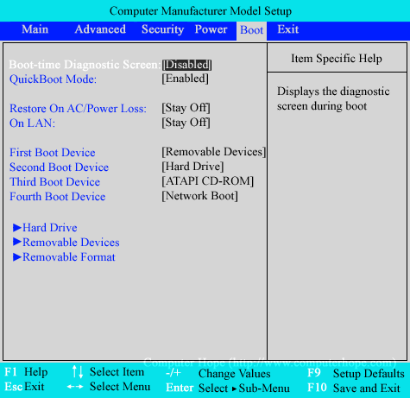

In the example above, the computer first looks at Removable Devices (e.g., [floppy diskette drive](https://www.computerhope.com/jargon/f/fdd.htm)). If nothing is in the drive or it wasn't bootable, the computer moves on to the [Hard Drive](https://www.computerhope.com/jargon/h/harddriv.htm). If an operating system such as Windows is installed, the computer loads the operating system from the hard drive. If nothing was installed on the hard drive or it was not found, the computer would boot from the [ATAPI](https://www.computerhope.com/jargon/a/atapi.htm) [CD-ROM](https://www.computerhope.com/jargon/c/cdrom.htm). Finally, if the computer could not boot from any of the earlier options, it would attempt to do a Network Boot. The most common devices to be listed in the boot sequence are the disc drive (CD or DVD), hard drive, [USB flash drive](https://www.computerhope.com/jargon/j/jumpdriv.htm), and [SSDs](https://www.computerhope.com/jargon/s/ssd.htm).

**How to change the boot sequence**

To change the boot sequence, use the [arrow keys](https://www.computerhope.com/jargon/a/arrowkey.htm) to select the device listed under First, Second, Third, or Fourth boot device, and then select something different. To key used to select something different varies depending on the BIOS setup. For example, in the above screenshot to change values, use the + ([plus](https://www.computerhope.com/jargon/p/plus.htm)) or - ([minus](https://www.computerhope.com/jargon/h/hyphen.htm)) key. Other setups may use the Enter or [spacebar](https://www.computerhope.com/jargon/s/spacebar.htm) to select from a list of available options.

**What should my boot sequence be?**

Your boot sequence should be set to how you want the computer to boot. For example, if you never plan on booting from a disc drive or a removable device, the hard drive should be the first boot device. If you're trying to fix a computer or reinstall its operating system, you may need to change the boot sequence. The most traditional first boot selections for these tasks are an [optical disc drive](https://www.computerhope.com/jargon/c/cdrom.htm) or a removable drive ([thumb drive](https://www.computerhope.com/jargon/j/jumpdriv.htm)).

**BIOS Shortcoming & Compatible Issues, Troubleshooting**

The Failed to Overclock error screen shows up whenever your BIOS settings have been cleared, and usually has nothing to do with actually overclocking your system, unless you just tried to overclock your system. Some common occurrences which cause this error to arise are:

* Your system has been physically moved
* Your CMOS battery is failing
* Your system is having power issues
* Overclocking your RAM or CPU (we do not overclock our parts)
* Adding a new device which is defective

We do not recommend overclocking any part in your Quiet PC. Overclocking the RAM or CPU is not something we support, because you are basically telling your PC to send more power to the CPU or RAM than the component was designed for in order to increase speed and performance. Overclocking diminishes the life expectancy of your PC, and can damage PC components (when done incorrectly). When using a silent PC, generally speaking, you are already dealing with higher temperatures than you would with a standard build. Overclocking exponentially increases those heat levels in your PC, putting more wear and tear on your components.

Failed Device is the second most common instance of a bios error screen (besides overclocking your PC). This happens when a new flash drive, USB device, or hard drive is connected to your PC. Most of the time adding a new flash drive or hard drive to your PC should not be an issue, since all of the ports in our PCs are tested thoroughly. Yet, we cannot test every component or piece of equipment customers choose to add to their machine, later on down the road.

Failed USB drives and USB devices, or bad hard drives commonly cause this type of error screen. If you encounter this BIOS error immediately after connecting a new device to your PC, simply disconnect the device and reboot to see if the error continues. If everything works well after the new device is removed, then you can assume that the new device was defective or unstable.

If you’ve added a new piece of equipment, first disconnect and reboot it, to see if the error continues to reoccur. If the error is not present when the new device is removed, then there could be an incompatibility issue between the new device and your system, or the new device may be defective. Connecting the device to another computer will help you know if the device is defective or not.

If you have purchased a PC from us and you run into this type of bios error screen without adding a new device to your PC, please feel free to contact us at support@silentpc.com since there could potentially be a bigger problem behind the BIOS error screen.

If your BIOS settings have been reset, or if you’ve attempted to overclock your PC and your PC failed, you may need to set the BIOS back to its optimized default settings. Setting your BIOS back to orginal settings is also referred to as restoring your BIOS settings. SilentPC.com (Cool Tech PC) saves all of our BIOS settingsunder the BIOS profiles tab, which most modern motherboards support. Simply load any of the pre-saved profiles under the profiles tab (unless you have altered one of those profiles) to reset everything back to the way it was when we sent the PC out.

Load BIOS defaults

Below is a quick guide on how to load your bios profiles:

* Login into the BIOS by hitting the Delete or F2 key (depending on your motherboard) during your computer's boot process (when you see the BIOS screen pop up).
* Navigate to the Tools Tab.
* You should see an item called Profile. Simply use one of the profiles to load the settings your machine initially had when you first received it.
* Hit the F10 key or select the "Save and Reset" option. Your Bios Settings should now revert back to how it was originally setup by us.

Boot Device Error

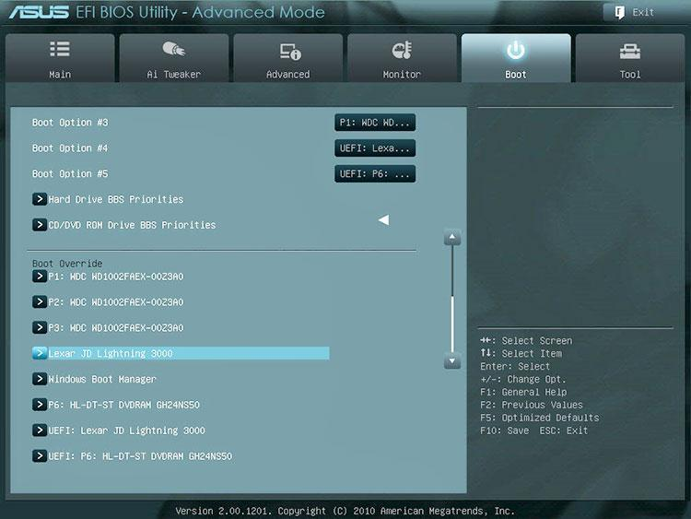

A Boot Device Error is a common occurrence among modern motherboards (which support UEFI). The DVD drive or hard drive may be set to boot as a UEFI (Unified Extensible Firmware Interface) and may not always work. UEFI utilizes the GPT partition scheme (globally unique identifiers partition table), and is far superior to that of the older MBR (master boot record). UEFI is almost always the default on modern motherboards, but this setting has been known to change when new devices are connected to the PC. Bottom line: booting off a DVD or hard drive may not always work when set to UEFI, and it is suggested to make sure that the primary boot device is either the DVD or hard drive, and not the UEFI DVD variant if you are having issues.

There are quite a few more options in the boot menu of a modern motherboard, than that of an old generation motherboard. Scrolling down on the boot page will list the primary DVD and hard drive boot options. Scrolling down even further will list the DVD boot options and the hard drive boot options. Simply select the DVD boot option, if you’re trying to boot off of the DVD drive, and make sure that UEFI is not at the top of the list. The same setting should be applied to the hard drive boot options. Once these setting are saved, you should be able to boot off of the DVD drive or hard drive, with no issues. You can almost always use the Quick Boot option (Typically the F8 key) which will allow you to quickly choose which device you would like to boot off of.

* Login into the BIOS by hitting the Delete key or F2 key (depending on your motherboard).
* Hit the F7 key to access the advanced view mode, if applicable.
* Navigate to the boot menu and scroll down until you see the boot options, as well as the primary hard drive and DVD drive options
* Make sure that the primary boot options are not the UEFI variants, as they will list twice
* Hit the F10 key or select the save and reset option

**POST**

What is POST(Power-On-Self-Test)?

A power-on self-test (POST) is a set of routines performed by firmware or software immediately after a computer is powered on, to determine if the hardware is working as expected. The process would proceed further only if the required hardware is working correctly, else the BIOS(Basic Input Output Software) would issue an error message. POST sequence is executed irrespective of the Operating System and is handled by the system BIOS. Once the tests are passed the POST would generally notify the OS with beeps while the number of beeps can vary from system to system. When POST is successfully finalized, bootstrapping is enabled. Bootstrapping starts the initialization of the OS.

The Role of POST in the Boot Sequence

The boot sequence is the process of starting a computer/system. The boot process is initiated when the power button is pressed, it sends power to the boot-loader in the cache memory. The Boot loader performs POST as a preboot sequence and if everything is working well without any errors the BIOS(Basic Input Output System) is activated which finds and loads the operating system.Finally the software has to interact with the hardware units to complete the process. To avoid any hardware errors while executing a software program, the pre-boot sequence would test the hardware and initiate the OS if and only if the basic hardware units are functioning as expected. he principal duties of the main BIOS during POST are as follows:

1. Find, size, and verify the system main memory.
2. Initialize BIOS.
3. Identify, organize, and select which devices are available for booting.
4. Verify CPU registers.
5. Verify the integrity of the BIOS code itself.
6. Verify some basic components like DMA, timer, interrupt controller.
7. Pass control to other specialized extensions BIOS (if installed).

The checks are performed majorly on:

* Hardware elements like processor, storage devices and memory.
* Basic System Devices like keyboard, and other peripheral devices.
* CPU Registers
* DMA (Direct Memory Access)
* Timer
* Interrupt controller

**Types of Errors encountered during POST**

If there are any errors in the POST the system would fail to proceed towards the next steps(boot process) as it would throw a fatal error. The POST sequence is executed irrespective of the Operating System. However, how the POST is handled and the types of errors thrown can be modified by the Vendor as per the system requirements.The error message could consist of text messages on the console or audio in the form of beeps. Irrespective of the vendor there would be a manual describing the types of errors and the error message mappings to help us troubleshoot. The error messages can vary from a parity error to a faulty motherboard.

**Error Code: Beep Code, Post Code**

**Example beep codes are:**

| Beeps | Meaning |
| --- | --- |
|  |  |
| 1 | No RAM installed/detected |
| 2 | Incompatible RAM types |
| 3 | No good banks |
| 4 | No good boot images in the boot ROM, or bad sys config block, or both |
| 5 | Processor is not usable |

The issues can be seen in different ways based on the hardware that is causing the issue. The system might turn on but could be struck before initiating the boot process without any hint/error message or an error message is being displayed on the screen. Follow the steps below to troubleshoot the issue:

1. Analyze when the issue began.
2. Check if any hardware was changed from the last time the system functioned properly.
3. If there was any new hardware try to remove and check to isolate the issue.
4. Remove/Disconnect any disks, USB’s and restart the system to check if anything changes.
5. Connect a known working power cable to see if the system is powering on successfully.
6. If you observe any overheating, check if all the fans are functioning well.
7. If you observe any error codes(beep codes, LED indication, Error message on screen) Follow the manual to resolve the issue.

**Beep Code**

* 1 Beep - Refresh Failure - Reseat/replace memory, troubleshoot motherboard.
* 2 Beeps - Parity Error - Reseat/replace memory, troubleshoot motherboard.
* 3 Beeps - Memory Error (first 64KB) - Reseat/replace memory.
* 4 Beeps - Timer Failure - Troubleshoot motherboard.
* 5 Beeps - Processor Failure- Troubleshoot CPU, motherboard.
* 6 Beeps - Keyboard Controller Failure - Troubleshoot keyboard, motherboard.
* 7 Beeps - Virtual Mode Exception Error - Troubleshoot CPU, motherboard.
* 8 Beeps - Display Memory Failure - Trouleshoot graphics card, motherboard.
* 9 Beeps - ROM BIOS Checksum Failure - Replace ROM BIOS, troubleshoot motherboard.
* 10 Beeps - CMOS Shutdown Register Failure - Troubleshoot motherboard.
* 11 Beeps - L2 Cache Failure - Troubleshoot L2 cache, motherboard.
* Continuous Beeps - Memory or Video Failure, Troubleshoot memory, graphics card, motherboard.

**Error: Post code**

| **Code** | **Error Message** | **Response** |
| --- | --- | --- |
| 0000 | Timer Error | Pause |
| 0003 | CMOS Battery Low | Pause |
| 0004 | CMOS Settings Wrong | Pause |
| 0005 | CMOS Checksum Bad | Pause |
| 000B | CMOS Memory Size Wrong | Pause |
| 000C | RAM R/W Test Failed | Pause |
| 000E | A: Drive Error | Pause |
| 000F | B: Drive Error | Pause |
| 0012 | CMOS Date/Time Not Set | Pause |
| 0040 | Refresh Timer Test Failed | Halt |
| 0041 | Display Memory Test Failed | Pause |
| 0042 | CMOS Display Type Wrong | Pause |
| 0043 | ~<INS> Pressed | Pause |
| 0044 | DMA Controller Error | Halt |
| 0045 | DMA-1 Error | Halt |
| 0046 | DMA-2 Error | Halt |
| 0047 | Unknown BIOS error. Error code = 0047 | Halt |
| 0048 | Password Check Failed | Halt |
| 0049 | Unknown BIOS error. Error code = 0049 | Halt |
| 004A | Unknown BIOS error. Error code = 004A | Pause |
| 004B | Unknown BIOS error. Error code = 004B | Pause |
| 004C | Keyboard/Interface Error |  |
| 005D | S.M.A.R.T. Command Failed |  |
| 005E | Password Check Failed | Pause |
| 0101 | Warning! This system board does not support the power requirements of the installed processor. The processor will be run at a reduced frequency, which will impact system performance. | Pause |
| 0102 | Error! The CPU Core to Bus ratio or VID configuration has failed! Please enter BIOS Setup and re-config it. | Pause |
| 0103 | ERROR! CPU MTRRs configuration failed!  Uncacheable memory hole or PCI space too complicated. |  |
| 0120 | Thermal Trip Failure | Pause |
| 0150 | Processor Failed BIST | Pause |
| 0160 | Processor missing microcode | Pause |
| 018F | BIOS does not support current stepping |  |
| 0192 | L2 cache size mismatch. |  |
| 0193 | CPUID, Processor stepping are different. |  |
| 0195 | Front side bus mismatch. System halted. |  |
| 0196 | CPUID, Processor Model are different. | Pause |
| 0197 | Processor speeds mismatched. | Pause |
| 5120 | CMOS cleared by jumper. | Pause |
| 5121 | Password cleared by jumper. | Pause |
| 5125 | Not enough conventional memory to copy PCI Option ROM. |  |
| 5180 | Unsupported Memory Vendor : DIMM_A0 | Warning |
| 51B7 | Unsupported AMB Vendor : DIMM_D5 |  |
| 51C0 | Memory Configuration Error. |  |
| 8101 | Warning! USB Host Controller not found at the specified address!!! |  |
| 8102 | Error! USB device failed to initialize!!! |  |
| 8104 | Warning! Port 60h/64h emulation is not supported by this USB Host Controller!!! |  |
| 8105 | Warning! EHCI controller disabled. It requires 64bit data support in the BIOS. |  |
| 8301 | Not enough space in runtime area. SMBIOS data will not be available. |  |
| 8302 | Not enough space in runtime area. SMBIOS data will not be available. |  |
| 8601 | Error: BMC Not Responding |  |
| 8701 | Insufficient Runtime space for MPS data.!.  System may operate in PIC or Non-MPS mode. |  |

**Preventive maintenance of latest gadgets:**

Before you begin, take a look at this pre-checklist that contains some basic information that should be core to any preventive maintenance plan:

* Assess and inventory the current state of your facility: Set benchmarks based on current performance for efficiency, quality, uptime, maintenance and more — and be sure you understand every aspect of your facility that will undergo preventive maintenance.
* Locate documentation: For machinery, much preventive maintenance can be done in accordance with manufacturer recommendations and specs.
* Create documentation of your own: A facility’s preventive maintenance checklist is a good start and quick reference, but be sure to comprehensively document your preventive maintenance plan and processes in a place where all employees can easily access and review it.

**1. Dust your keyboard using compressed air**

Did you know that researchers have found that the average desktop and keyboard is [dirtier than a toilet seat](http://www.center4research.org/bacteria-computer-keyboards-toilet-seats/)? That’s why dusting your keyboard off at least once a week can help maintain it (and reduce health risks). Wipe down your keyboard with a damp lint-free cloth, but be sure not to soak it in water.

For harder to reach areas such as in between the keyboard keys, use a compressed air canister.

**2. Wipe down your monitor**

Fingerprints and other stains can appear regularly on your monitor. In order to keep your screen view fresh and clean, wipe down your monitor once a week using a dry lint-free cloth. Gently wipe in long motions as pressing too hard can damage your device.

Oftentimes, your computer will come with a microfiber cleaning cloth upon purchase. Use this cloth or order a similar one for optimal cleaning.

**3. Get rid of your mouse’s dust and particles**

Like your keyboard, your mouse needs to be dusted regularly to work properly. To do this, unplug your mouse and turn it upside down. From there, you’ll want to remove the bottom panel and clean the ball with a lint-free cloth.

You can add rubbing alcohol to the cloth for a deeper clean. Let the ball dry before reassembling the mouse.

**4. Clean your system thoroughly**

Every three to six months you should do a thorough cleaning of your entire hardware system. You can do this in a number of ways, including with a computer vacuum. You’ll want to save and close any active files before you unplug your device to begin cleaning.

From there, you can open the casing by removing the screws. Don’t vacuum the inside of the computer. Instead, use the compressed air canister from step #1 on the inside to avoid damage.

If you have a laptop, disassembly will be different than with a traditional computer. Make sure to follow the instructions that came with your device before you begin taking it apart.

**5. Power down or reboot your device regularly**

While powering down your device every night isn’t a requirement with new computers, rebooting regularly does help refresh your system resources.

If you’re working off an older computer, you should power down your device properly every night to avoid overheating. If your device is newer, consider rebooting it once a day instead and turning it to sleep mode when it’s not in use.

**6. Defragment the hard drive**

Did you know that the disk is [the weakest link](https://condusiv.com/disk-defrag/defragmentation/) when it comes to computer performance? This is why defragging your hard drive once a month is so important.

Defragging is the process of reorganizing the data on your hard drive to speed up file access. It breaks up a file into smaller bits on your device. While every computer is different, you can usually find Defragment functions under the System and Security tab in the Control Panel.

**7. Backup data**

At least once a week you should backup your drive. If you’re working on an important project, you can do this daily to ensure your files are securely stored. Backing up your data saves important files in the event of a hard drive failure or system crash.

**8. Configure your startup**

You should periodically check in on the applications that automatically run at start-up. These applications can slow down your computer. From the Settings tab, you should be able to navigate to the Startup to control which applications run.

**9. Run disk cleanup**

You can free up disk space on your hard drive by running a disk cleanup. This will clean out temporary files and extra language files as well as delete big attachments and more.

**10. Install major computer updates**

To keep your applications running safely and efficiently you should check for major computer updates at least once a month. These updates can be critical for long-term health because they patch up critical security holes and remove unnecessary features. You may also be able to adjust your setting so updates happen automatically.

**11. Update antivirus software**

Whenever an antivirus software update is available, you should run it that day to [remove malware](https://us.norton.com/internetsecurity-malware-how-to-remove-malware.html). These updates introduce new software features or make improvements on current ones. Generally you can set your system up for automatic updates, but if you ever receive a notification from your current antivirus software, you should complete the update as soon as possible.

**12. Change your passwords regularly**

One of the easiest ways for hackers to gain access to your device is through a cyberattack where they steal your login credentials. Upon gaining access to your device, they can access sensitive information such as spam [emails](https://us.norton.com/internetsecurity-how-to-spam-spam-go-away.html), banking information, and more.

While experts used to recommend changing passwords every month, this frequency was causing new risks and inconveniences for users. Updating your password four times a year helps keep you more secure without much hassle.

**13. Check for firmware updates**

Firmware is a tiny piece of software in your computer that keeps the hardware functioning properly. Sometimes these updates are included in major computer updates, but you can check for firmware updates manually on many devices, as well.

**14. Complete signature updates**

To keep your antivirus software running properly, you’ll want to do signature updates in addition to software updates. This ensures that your device is protected from [new viruses](https://us.norton.com/internetsecurity-how-to-computer-virus-warning-signs.html). Many programs allow you to install these signature updates automatically, but if not you should update weekly.

**15. Consider parental controls**

If you have kids at home or have other people accessing your device, prevent software from being downloaded without your consent by setting up parental controls. These controls will require a password from an administrator to download certain files and software to your device.

**16. Move similar files into folders**

Keeping files on your desktop can slow down your machine. Instead, organize similar files into folders where you can easily find them. This will also help streamline the cleaning process when it comes time to delete unnecessary items.

**17. Delete unused programs**

Get more memory space by removing unnecessary programs from your device. If you filter your programs by size, you can see which ones take up the most memory and decide from there what you can remove.

**18. Clear out the Recycling Bin**

When you or another user deletes a file, it goes to the Recycling Bin. This gives you one last chance to salvage a file you’ve removed, but it can also clog up space on your hard drive if you don’t clear it out regularly. Once a month you should check the Recycling Bin for any files that may have accidentally been deleted and clear out the rest.

**19. Remove temporary internet files**

Speed up your system by removing temporary internet files and clearing your Cache. Every browser has a different method for clearing out these cookies. Find directions for your browser [here](https://us.norton.com/internetsecurity-privacy-how-to-clear-cookies.html).

**20. Transfer files to the cloud**

Cloud storage providers allow you to store gigabytes of space without running down your hard drive memory. Better yet, it allows you to share your files across multiple devices. As you download files throughout the day, transfer them to cloud storage to save space on your hard drive.

21. Avoid overheating your device

Set up your computer in an area of your office or home that gets good airflow, with two inches of empty space on either side. Giving your machine room to breathe helps prevent overheating, which extends the life of your device.

Stacks of paper and other items being placed on your computer can also make it overheat, so keep your desk area organized and free of clutter.

**22. Keep your cords organized**

Cable clutter can collect dust and become easily damaged. Cable stations and other cord organizers can help organize your area. It will also save you time and stress next time you go to unplug your computer.

**23. Don’t overcharge your device**

If you’re working off a laptop, it can be tempting to charge the battery all night. While doing so won’t damage the device, one of the best ways to maintain the battery over an extended period of time is to unplug it once it reaches 100%. You should also remove the battery altogether if you won’t be using the device for a month or more to help extend its shelf life.

**24. Keep food and drinks away**

It can only take one can of soda to destroy a device. As tempting as enjoying a glass of coffee as you check your morning emails may be, always avoid eating or drinking near your computer to reduce spillage risk.

**25. Avoid spam while browsing**

If a weird email shows up in your inbox or an unexpected popup [while browsing](https://us.norton.com/internetsecurity-online-scams-internet-scams.html), resist the urge to open it. Malware scams can greatly damage your device and put your files and privacy at risk.

Just like an automobile, your computer needs to be regularly maintained to run properly. Doing regular computer maintenance can greatly extend the lifespan of the device and may keep you safer [while browsing online](https://us.norton.com/internetsecurity-how-to-5-ways-you-can-help-yourself-stay-secure-online.html). Through completing just a few simple steps, you’ll get a faster and healthier operating system to work on.

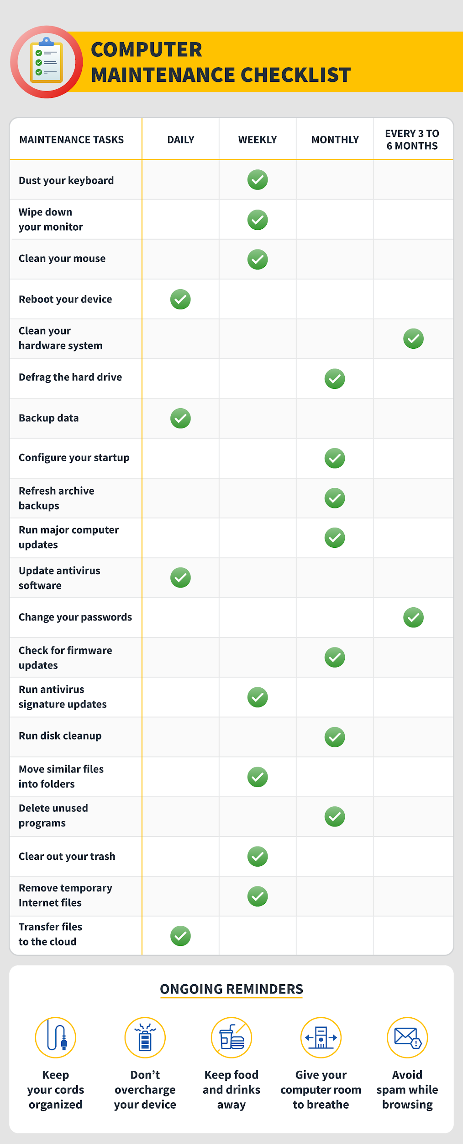

**Chapter 3: Input-Output devices and their troubleshooting**

| **Contents**  Troubleshoot Input-Output devices   * Keyboard * Switches * Mouse * Scanners * Webcam * Monitors * Printers * Speaker * Mike * LCD projector   I/O Cables: specification of I/O Cables, types of I/O cables, types of I/O ports  Internal and external modem | | | | | | |
| --- | --- | --- | --- | --- | --- | --- |

**Input-Output devices and their troubleshooting**

You can determine the cause of device problems.

Device software check

Correct a device software problem by:

* Checking the Error Log
* Listing All Devices
* Checking the State of a Device
* Checking the Attributes of a Device
* Changing the Attributes of a Device
* Using a Device with Another Application
* Defining a New Device

Error log check

Check the error log to see whether any errors are recorded for either the device, its adapter, or the application using the device. Go to [Error Logging Facility](https://www.ibm.com/docs/en/ssw_aix_72/generalprogramming/errlogfac.html) for information about performing this check. Return to this step after completing the procedures.

Because most hardware devices do not require input and output communication with the computer, most IO devices are [storage devices](https://www.computerhope.com/jargon/s/stordevi.htm). So, when you encounter an I/O error or I/O device error, it's an indication that the operating system cannot read or write to a device.

Reasons why you may get an IO device error

* [Write protection](https://www.computerhope.com/jargon/w/writprot.htm) is enabled. For example, if write-protection on an SD card.
* Trying to write to a disc that is not writable. For example, trying to [burn](https://www.computerhope.com/jargon/b/burn.htm) to a [CD](https://www.computerhope.com/jargon/c/compactd.htm) and not a [CD-R](https://www.computerhope.com/jargon/c/cdr.htm) disc.
* No more [disk space](https://www.computerhope.com/jargon/d/diskcapa.htm).
* The file is used by another user or computer program.
* Not enough [rights or permissions](https://www.computerhope.com/jargon/p/permissi.htm) to read or write.
* No physical or virtual connection.
* Bad or missing [drivers](https://www.computerhope.com/jargon/d/driver.htm) preventing the drive from being accessed.
* Failing or bad hardware.

Depending on what device is giving you the **I/O error** can change how to troubleshoot these errors. If you are not certain what device is giving you the error, follow the general troubleshooting steps. Otherwise, try following the specific steps for the device giving you the error.

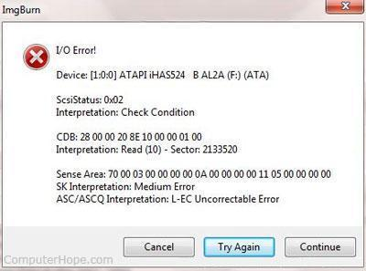

General troubleshooting for I/O errors

1. [Reboot](https://www.computerhope.com/jargon/r/reboot.htm) the computer.
2. Make sure you have all of the latest [drivers](https://www.computerhope.com/jargon/d/driver.htm) for your devices.
3. If you are using Microsoft Windows, make sure there are no errors in [Device Manager](https://www.computerhope.com/jargon/d/devicema.htm).
4. If you have recently moved the computer, open the computer and make sure the cables inside the computer are firmly connected.

* [How do I open my computer case?](https://www.computerhope.com/issues/ch000765.htm)

**Troubleshoot Keyboard:**

When you use a wired keyboard, you may experience one or more of the following problems:

* The keyboard is not detected.
* The keys on the keyboard do not work.
* Wrong characters are typed.

To work around these problems, use the following methods as appropriate for your situation.

The keyboard is not functioning

**Step 1: Verify the connection**

If the keyboard is not functioning at all, make sure that it is connected correctly to the computer. Check all the keyboard’s plugs to make sure that there are no loose connections. Connect the keyboard to your computer by using a different USB port.

Note Bypass any port replicator, USB hub, KVM switch, or similar component, and connect the keyboard directly to the USB port on the computer. If this resolves the problem, confirm that it is this additional connection device that is the source of the problem. Contact the manufacturer to see if they can provide a solution to allow you to use their device.

If an adapter (PS/2 to USB or PS/2 to AT) is being used, verify that it is the adapter that was included with the keyboard or that the keyboard supports adapting to a different port. For example, the Internet Keyboard does not adapt to a USB port, and a PS/2 to USB adapter will not work. It does not include an adapter.

To connect or to disconnect the keyboard to a PS/2 port, follow these steps:

1. Shut down the computer.
2. Plug your device into the correct port. Make sure that the plug is pushed securely into the connector on the computer.
3. Restart the computer. Microsoft Windows detects the change, and then installs the drivers on the new port automatically.

If the issue continues to occur, try connecting the keyboard to a different computer. If the keyboard functions correctly on a different computer, the port to which the keyboard was connected on the original computer may be damaged. If this is the case, contact your computer manufacturer to inquire about how to repair or replace the damaged port.

If the keyboard does not function correctly on another computer, the keyboard may be defective. If this is the case, and the warranty on the keyboard is still valid, you can exchange the defective keyboard for a new keyboard. For information about how to contact Microsoft Supplemental Parts, see the “References” section.

If the keyboard works on another computer, go to Step 2.

**Step 2: Download and install the latest keyboard software**

To download the latest drivers for the keyboard

**Step 3: Manually reinstall the drivers**

The keys do not strike correctly

If the keys do not strike correctly, make sure that the keyboard is free of dust, dirt, and foreign matter.

Turn the keyboard upside down to allow for any foreign debris, such as hair, food particles, or dust, to fall out.

We recommend that you periodically use compressed air to blow dust out of the hard-to-clean crevices in the keyboard.

If you spill a drink or some other liquid on the keyboard, immediately turn the keyboard upside down to let the liquid drain out, and then remove as much liquid as possible. Wait until the keyboard is completely dry before you use it again.

Do not take the keyboard apart. If you disassemble the keyboard, you may void the manufacturer warranty.

Note If you want to use a vacuum cleaner around the keyboard, make sure that the vacuum cleaner is a “static safe” vacuum cleaner.

The wrong characters are typed

If the wrong characters are typed when you use the keyboard, follow the steps in the “The Keys Do Not Strike Correctly” section to clean the keyboard that are described under “The Keys Do Not Strike Correctly” earlier to make sure that no obstructions under the keys are causing this issue.

If the issue continues to occur, connect the keyboard to a different computer. If the keyboard functions correctly on a different computer, the port to which the keyboard was connected on the original computer may be damaged. If this is the case, contact your computer manufacturer to ask about how to repair or replace the damaged port.

If the keyboard does not function correctly on another computer, the keyboard may be defective. If this is the case, and the warranty on the keyboard is still valid, you can exchange the defective keyboard for a new keyboard.

**Troubleshoot Mouse**

Cause of a Mouse Not Working

Mouse failures source from five sources:

* Irreparable hardware damage.
* Loss of power or connection.
* Interference between the mouse and the work surface.
* Outdated software.
* Operating system glitches or misconfigurations.

**How to Fix a PC or Laptop Mouse That's Not Working**

Since several factors could be at the root of a mouse failing to work properly, troubleshooting the problem is the best way to make it work once more. Try these steps, organized in order of most-common and easiest to most intensive.

* **Inspect the mouse for hardware damage.** A cracked housing, a missing ball, sticky or silent clicking of the finger switches, or a failure of the optical sensor to glow suggest that the device is damaged. Given how inexpensive most mice are, hardware damage usually suggests that replacement, rather than repair, is the optimal solution.
* **Clean the mouse.** If the pointer moves in jerking motions or is less responsive than usual, clean the mouse to see if it improves the performance. It's easy to [clean a wireless mouse](https://www.lifewire.com/clean-a-wireless-mouse-2640102) or clean a wired mouse with a rollerball.  
  While you're cleaning the mouse, make sure there is nothing covering the laser on the bottom of the mouse. Anything that obstructs the laser (like paper, tape, etc.) will interfere with the movement of the mouse/cursor.
* **Replace the batteries.** Swap the batteries out for a new set, especially if you're still using the batteries that came with the device. Likewise, verify the batteries are properly installed.  
  Similarly, plug the mouse into its charger for 30 minutes to let it get enough juice to connect. Mice with USB charger ports and non-rechargeable batteries sometimes appear to fail without warning when charge levels decline too much.
* **Try a different USB port.** There might be a problem with the one you're using, so unplug the mouse or the receiver and try an alternate USB port. Most desktop computers offer ports on the front and back of the computer, so try all of the ports before jumping to a different step. It could also be the case that the plug is partially unseated.
* **Connect the mouse directly to the USB port.** If you use a multi-card reader or an external USB hub, there may be a problem with that device instead of the mouse or [USB port](https://www.lifewire.com/what-is-a-usb-port-818166). Plug the mouse directly into the computer to see if the problem clears.
* **Use the mouse on an appropriate surface**. Some mice can be used on (almost) any kind of surface. Many can't. Study your device's limitations—it may require a mouse pad, especially if you're using an older mouse. Some [optical mice](https://www.lifewire.com/whats-the-difference-between-optical-and-laser-mice-2640209), for example, cannot track movement on shiny surfaces or surfaces with either very dark or very light colors.
* **Update the driver.** Check the manufacturer's website for available driver updates or use [driver-updater tools](https://www.lifewire.com/free-driver-updater-tools-2619206). If your mouse won't do something that the manufacturer promised it would do (side-to-side scrolling, for example), [find and download any required drivers from the manufacturer's website](https://www.lifewire.com/how-to-find-and-download-drivers-from-manufacturer-websites-2619220). These files are usually free.
* **Release and** [**re-pair a Bluetooth mouse**](https://www.lifewire.com/set-up-a-bluetooth-device-2640340)**.** It's not uncommon for Bluetooth devices to either lose pairing status or be forgotten if a different Bluetooth mouse is paired with the PC.
* **Disable an integrated trackpad**. If your laptop supports an internal trackpad, disable it through your operating system's settings utility. An internal trackpad may conflict with, or override, an external mouse.

**Troubleshoot Scanners**

**Verify cables connected properly to the back of the scanner**

If the scanner is a parallel port scanner, it has two available connections on the back of the scanner. Verify the cable coming from the computer connects to the IN, Computer IN, Computer, or similar connection.

If your scanner is not getting power, we recommend you check all the scanner's electrical connections. Make sure they are connected properly at the back of the computer, at the scanner, and at your wall outlet. If the scanner's power cable is plugged into a [power strip](https://www.computerhope.com/jargon/p/powestri.htm) or [surge protector](https://www.computerhope.com/jargon/s/surgprot.htm), connect the scanner directly to the [wall outlet](https://www.computerhope.com/jargon/o/outlet.htm), to verify it's not causing the problem.

If the computer scanner is getting power, you should notice the inside light come on when the power is first received by the scanner.

After checking the connections, if you still get no power to the scanner, we recommend you contact the [manufacturer](https://www.computerhope.com/support.htm) of the scanner.

**Parallel port scanner troubleshooting**

If another device connects between the scanner and computer, turn off the computer and temporally disconnect the devices connected to or from the scanner. If, after disconnecting these devices, the scanner works, it's likely that device has issues or cannot work with other parallel devices.

PC Windows users verify no TSRs are running in the background

Press [Ctrl+Alt+Del](https://www.computerhope.com/jargon/t/tfs.htm)and end task all currently running software, except explorer and Systray, and then scan again. If this resolves your issue, background applications (e.g., antivirus program) is preventing your scanner from working correctly.

**Verify the LPT port mode**

PC users should ensure the [LPT](https://www.computerhope.com/jargon/l/lpt.htm) port mode in the computer [BIOS](https://www.computerhope.com/jargon/b/bios.htm) is set to either EPP or bi-directional mode, or try alternating between these two modes.

**Update the drivers**

Verify the latest drivers are installed for the operating system are used on your computer. For a listing of computer scanner manufacturers and links to driver downloads, see our [scanner drivers](https://www.computerhope.com/drivers/scanner.htm) page.

**Troubleshoot Webcam**

A non-working webcam may be due to malfunctioning hardware, missing or outdated drivers, issues with your privacy settings, or problems with your antivirus software.

Windows usually installs device drivers automatically when it detects new hardware. Still, if you recently upgraded to Windows 10, you may need to update your hardware drivers manually. Some Windows Store apps only support newer webcam models, so your older device could be incompatible. Most desktop programs, however, still support older cameras.

Windows 10 offers a feature that disables the internal webcam. Keeping your webcam turned off when not using it is a great idea to protect your privacy. However, it can cause problems if you accidentally toggle this feature.

* Check your antivirus settings.

Antivirus software can occasionally interfere with webcams. Investigate the software settings to see if your antivirus prevents your camera from launching.

* Plug the webcam into a different computer. If you're using an external camera, plug it into another device to make sure it works. If you have problems with it on several computers, the problem is with the webcam.
* Check the device connection. Jiggling the cable or unplugging and plugging it back in can sometimes fix the problem.
* Check the USB port. Connection problems can occur on the computer's end. Plug something else into the USB port to rule out a faulty or mismapped port.
* Make sure the correct device is enabled. If you have a built-in camera and an external webcam plugged in, applications can get confused about which one to use. Check the application's settings and find the option to select your preferred device.
* Consult the manufacturer. For external webcams, check the user manual or the manufacturer's website for further guidance. Many manufacturers offer troubleshooting applications that scan device-specific settings.
* Update the webcam drivers. If the webcam driver is outdated, it may not work correctly.

**Troubleshoot Monitors**

**Verify display or video issue on a known-good monitor**

It is essential to verify if the problem is inherent with the monitor, video card (GPU) or video settings on your PC. A straightforward way to identify this is to connect the PC to a known-good external monitor or TV and ensure that the display (S-video, VGA, DVI, HDMI or DisplayPort) cables are firmly connected to the video ports on the PC and the monitor.

To learn more about connecting your PC to a monitor or TV, refer to the CyberPowerPC knowledge-base article [How do I Connect a Monitor or TV to a PC?](https://www.dell.com/support/article/us/en/19/sln128890/en).

If the issue persists on the other monitor it may be due to the video card (GPU) or video settings and not the monitor, proceed to the step [Verify display or video issue in Windows Safe Mode](https://www.dell.com/support/article/us/en/19/sln130763/how-to-troubleshoot-display-or-video-issues-on-a-dell-monitor?lang=en#Check_In_Safe_Mode). Else proceed to the next step.

**Check for physical damages**

Performance issues may occur if there is any type of damage caused to the display cables or the LCD screen. LCD screen may show symptoms like LCD screen stops working, work intermittently, color mismatch, flickering, display horizontal or vertical lines, etc. if there is a damage to the display cables or the LCD screen.

**Verify display or video issue in Windows Safe Mode**

Windows Safe Mode allows us to identify if the issue is related to the operating system, video settings, device drivers or a 3rd party software. To learn more about how to boot your CyberPowerPC system into Safe Mode, refer to the CyberPowerPC knowledge-base article [How to Boot to Safe Mode in Windows 10](https://support.cyberpowerpc.com/hc/en-us/articles/360014173613).

If the issue persists in Safe Mode, proceed to the next step. Else, proceed to [Perform a Windows System Restore](https://support.cyberpowerpc.com/hc/en-us/articles/360013979214-Reset-or-reinstall-Windows-10-on-your-CyberPowerPC-computer).

**Update the video card (GPU) driver, monitor driver, chipset driver & BIOS**

CyberPowerPC recommends updating the device drivers and BIOS as part of your scheduled update cycle. These device drivers and BIOS updates may contain feature enhancements or changes that will help keep your system software current and compatible with other system modules (hardware and software) as well as increased stability.

It is essential to update the following device drivers for optimal video performance and to resolve common video issues:

* BIOS
* Chipset driver
* Video Card (GPU) driver
* Monitor driver

These drivers will depend on the specific make and model of your video card (GPU) however, most modern video cards (GPU) offer universal drivers that are backwards compatible. This means the latest graphics drivers for your video card brand (NVIDIA or AMD) is likely to work for most previous generations.

1. First, you will need to identify the GPU brand of your graphics card, this refers to the GPU chip itself and not the manufacturer of the graphics card. This is likely either NVIDIA or AMD. If you are unsure, contact CyberPowerPC support and they can help you identify your GPU.
   1. If it is an NVIDIA GPU then you can download the latest graphics drivers here:  
      <https://www.geforce.com/drivers>
   2. If it is an AMD GPU you can download the latest drivers here:  
      [https://www.amd.com/en/suppor](https://www.amd.com/en/support)t

**Troubleshoot Printers**

**Printer does not have power indicator**

First, make sure that the printer is turned on. When a printer is on, it should have some light or [LED](https://www.computerhope.com/jargon/l/led.htm) (usually green) indicating it's receiving power.

If you do not have any indicator light, make sure the printer is connected to a working power outlet by verifying each end of the power cable. Next, press the printer power button.

If, after performing the above steps the printer still does not display a power status indicator light, your printer may have a serious internal hardware issue. We suggest contacting the [printer manufacturer](https://www.computerhope.com/network/printer.htm) for repair or replacement.

**Cables not connected properly**

Your printer should have two cables connected to it: the power cable and the data cable. Make sure the power and data cables ([parallel cable](https://www.computerhope.com/jargon/p/paraport.htm) or [USB](https://www.computerhope.com/jargon/u/usb.htm) cable) are connected to both the printer and computer.

**Printer error (orange or blinking light)**

After your printer has completed its initial startup, you'll see a solid colored light. If the indicator is orange or blinking, often this is an indication of a printer error. A paper jam or an issue with the ink or toner cartridge can cause the error.

As there are not standards for all printers, if you see a blinking light, visit the manufacturer's website or review the printer manual for specific error details.

**No paper or paper jam**

Without paper, your printer cannot print. Make sure there is paper loaded into the printer paper cartridge or tray. Next, verify that no printer paper is jammed or partially fed into the printer. If you suspect paper is stuck somewhere it shouldn't be, refer to our help page for paper jams.

* [How to fix a paper jam in a printer.](https://www.computerhope.com/issues/ch000980.htm)

**Inkjet printer ink related issues**

Often when you're encountering an ink related issue, your printer status indicator light (mentioned above) should be flashing. If this is not occurring, you may want to skip to the next section. However, if you've recently inserted a new ink cartridge, you may want to try the below suggestions.

**Printer self-tests**

Most printers have a way of printing a test page. A printer test page allows you to determine if the printer is working. The printer self-test is usually accomplished by holding down several keys. If you don't know to access and use the self-test feature on your printer, refer to the printer manual or visit the [printer manufacturer's website](https://www.computerhope.com/network/printer.htm).

You can also perform a software self-test to determine if the computer can see the printer and it's able to print. Follow the steps below to perform this test.

Microsoft Windows users

1. [Open the Control Panel.](https://www.computerhope.com/issues/control-panel.htm)
2. Click or double-click the Printers, Printers and Fax, or Devices and Printers icon.
3. Right-click the printer you want to test and select the Properties or Printer Properties option. If you do not see your printer listed, your printer is not installed.
4. In the printer's Properties window, click the Print Test Page [button](https://www.computerhope.com/jargon/p/pushbutt.htm).
5. If the printer can print a test page, your printer is installed and set up properly. However, if you cannot print in other programs, the program you are attempting to print from likely has issues.

**Older versions of Windows with older printers**

If you have an older printer and run [MS-DOS](https://www.computerhope.com/msdos.htm), [Windows 3.x](https://www.computerhope.com/jargon/w/win3x.htm), [Windows 95](https://www.computerhope.com/jargon/w/win95.htm), [Windows 98](https://www.computerhope.com/jargon/w/win98.htm), or [Windows NT](https://www.computerhope.com/jargon/w/winnt.htm), you can also attempt the following software test.

1. [Open the Windows command line.](https://www.computerhope.com/issues/chdos.htm)
2. Get to the root directory by typing cd\ and pressing [Enter](https://www.computerhope.com/jargon/e/enterkey.htm).
3. Reroute dir to printer by typing dir > lpt1 and pressing Enter.

The above should take the directory listing and print it to the printer. If this does not print, refer to your operating system troubleshooting section.

Note

The above command doesn't do a paper feed, so you need to press your FF or PP options on the printer, or you can try manually ejecting the paper.

**Printer drivers**

If your printer does not have any flashing lights and is connected properly, it's possible you may be encountering a [driver](https://www.computerhope.com/jargon/d/driver.htm) related issue. We suggest visiting our [printer driver listing](https://www.computerhope.com/drivers/printers.htm), which links to all major printer manufacturer driver pages, and download the latest drivers for your printer.

**Parallel (LPT) printers**

If the printer you're connecting to the computer is an [LPT](https://www.computerhope.com/jargon/l/lpt.htm) (parallel port) printer, we also suggest verifying the below settings if your printer is not working.

**Parallel port in CMOS**

1. Enter the computer's BIOS setup.

* [How to enter the BIOS or CMOS setup.](https://www.computerhope.com/issues/ch000192.htm)

1. Once in CMOS, verify that the parallel port is enabled or installed.
2. Next, verify the printer or parallel port mode. If your parallel port is set to ECP mode, we suggest trying a different mode.

**Other parallel device**

If you use a parallel printer with other parallel devices, such as a scanner, temporarily disconnect these devices to verify they are not causing issues with your printer.

**Troubleshoot Speakers:**

Most audio problems are a result of improper, defective, or misconnected cables; incorrect drivers; or resource conflicts. Audio problems that occur when you have made no changes to the system are usually caused by cable problems or operator error (such as accidentally turning the volume control down). Audio problems that occur when you install a new audio adapter (or when you add or reconfigure other system components) are usually caused by resource conflicts or driver problems.

To troubleshoot audio problems, always begin with the following steps:

1. Shut down and restart the system. Surprisingly often, this solves the problem.
2. Verify that all cables are connected, that the speakers have power and are switched on, that the volume control is set to an audible level, that you haven't muted audio in Windows, and so on.
3. Determine the scope of the problem. If the problem occurs with only one program, visit the web sites for Microsoft, the software company, and the audio adapter maker to determine if there is a known problem with that program and audio adapter combination. If the problem occurs globally, continue with the following steps.
4. Verify that the audio adapter is selected as the default playback device. If you have more than one audio adapter installed, verify that the default playback device is the audio adapter to which the speakers are connected.
5. If your audio adapter includes a testing utility, run it to verify that all components of the audio adapter are operating properly.
6. If you have another set of speakers and /or a spare audio cable, substitute them temporarily to eliminate the speakers as a possible cause. If you have a set of headphones, connect them directly to Line-out on the audio adapter to isolate the problem to the system itself. Alternatively, connect the questionable speakers to another system with a known good audio adapter, or even an MP3 player or portable CD player.

If the problem is occurring on a new system, or one in which you have just added or replaced an audio adapter, take the following steps in order:

1. Verify that the speakers are connected to the correct jacks. Connecting speakers to the wrong jacks is one of the most common causes of sound problems. We do it ourselves from time to time.
2. Check the troubleshooting sections of the Microsoft web site and the web sites for your motherboard and audio adapter manufacturer. Some audio adapters, for example, have problems with motherboards with certain Via chipsets, while other audio adapters have problems when used with certain AGP video cards.
3. Remove the drivers, restart the system, and reinstall the drivers from scratch.
4. Remove the drivers, shut down the system, and relocate the audio adapter to a different PCI slot. When the system restarts, reinstall the drivers from scratch.
5. If none of that works, suspect either a defective audio adapter or a fundamental incompatibility between your audio adapter and the rest of your system. Remove the drivers, shut down the system, remove the audio adapter, install a different audio adapter, and reinstall the drivers for it. If the replacement audio adapter is the same model and exhibits the same symptoms, try installing a different model of audio adapter.

If the problem occurs on a previously working system, take the following steps in order:

1. If you have recently added or changed any hardware, check Device Manager to verify that no resource conflicts exist.
2. If you have recently installed or uninstalled any software, it's possible that Setup installed DLLs that are incompatible with your audio adapter, or removed DLLs that your audio adapter or applications require. Remove the audio adapter drivers and reinstall them from scratch.
3. If the sound still does not function properly, suspect an audio adapter failure.

Here are some specific common sound problems and their solutions:

There's no sound.

This is probably the most common sound problem, and can have many causes. Following the troubleshooting steps just listed should resolve the problem.

Sound is scratchy or intermittent.

This problem can also have many causes. Perhaps the most common is the audio adapter itself. Older and inexpensive audio adapters often have poor audio quality. Other common causes include a defective or low-quality audio cable, speakers placed too close to the monitor or other source of electrical noise, and the placement of the audio adapter within the system. If you have a choice, locate an audio adapter as far as possible from other expansion cards. Another possible cause is that some video card drivers are optimized for benchmark tests by having them keep control of the bus. The result can be intermittent dropouts and scratchiness in the sound.

Computer sounds are audible but audio CDs are not.

Computer sound is digital, and is delivered directly to the audio adapter via the bus. Some old CD-ROM drives require a separate internal cable joining the audio-out connector on the back of the CD-ROM drive to the CD-audio connector on the audio adapter. If you do not have the necessary cable, you can temporarily fix the problem by connecting a standard stereo audio cable from the headphone jack on the front of the CD-ROM drive to the Line-in jack on the audio adapter. Note that modern motherboards and optical drives can deliver CD audio as a digital signal directly to the audio adapter, obviating the need for a separate CD audio cable.

A channel or channels are inaudible.

If you have another set of speakers or headphones, connect them directly to the audio adapter Line-out port to isolate the problem to either the audio adapter or the speakers. Roughly in order of decreasing probability, the most likely causes and solutions are:

* The Windows audio balance control is set fully in one direction. Double-click the speaker icon in the System Tray and verify balance settings in the Volume Control dialog (or the replacement applet installed with your audio adapter drivers).
  + The balance control on your speakers, if present, may be set fully in one direction. This happens commonly when someone blindly attempts to change volume or tone and turns the wrong knob. Center the speaker balance control.
  + The audio cable is defective. Many audio cables, particularly those supplied with inexpensive speakers, are constructed poorly. Replace it with a high-quality, shielded audio cable, available for a few dollars from computer stores, audio specialty stores, and big-box stores.
  + The audio cable is not fully seated in either the audio adapter jack or the speaker jack. Verify that the cable is fully seated at both ends.
  + You are using a mono rather than stereo audio cable to connect Line-out on the audio adapter to the speakers. Replace the cable.
  + The audio adapter driver is not installed, is installed improperly, or is the wrong driver. Some audio adapters may function partially under these conditions, and the most common symptom is single channel audio. Uninstall any driver currently installed, and then reinstall the proper driver.
  + Although it is rare, we once encountered a set of amplified speakers with one channel dead and the other working. Replace the speakers.

After installing an audio adapter, your PC speaker no longer works.

This is by design in some audio adapters. Installing the card and driver intentionally disables the PC speaker and routes sounds that would ordinarily go to the PC speaker to the audio adapter instead.

Windows suddenly loses sound.

On Windows systems with properly configured and functioning audio adapters, sound may disappear entirely for no apparent reason. This has happened to us on many different systems, under different versions of Windows, using different motherboards and audio adapters. The audio adapter still shows as installed, and everything appears perfectly normal, but the system simply stops sending audio to the speakers. This problem may or may not be accompanied by the speaker icon disappearing from the system tray. We have no idea what causes this, and we've never been able to get a satisfactory explanation from Microsoft. Restarting the system normally solves the problem, until next time. On systems where "next time" is all too frequent, we have occasionally had some success by removing and then reinstalling the sound drivers.

The system locks up when you boot or blue-screens immediately after booting.

This problem normally results from a severe resource conflict or an improperly installed card. Verify first that the card is seated fully. If so, boot the system in Safe Mode or using the Last Known Good Configuration. With the system booted, determine which devices and resources are conflicting, resolve the conflicts, and restart the system.

The system makes a ticking sound.

This is usually caused by an interrupt conflict, often with the keyboard. Remove the keyboard in Device Manager, shut down and power off, and restart with just the mouse connected. If that solves the problem, turn off the system, reconnect the keyboard, and restart. If the problem persists, try moving the audio card to a different PCI slot or using a USB keyboard.

**Troubleshoot Mike:**

If you are having trouble with your microphone features, the following information can help you troubleshoot and resolve issues.

Make sure apps have access to the microphone

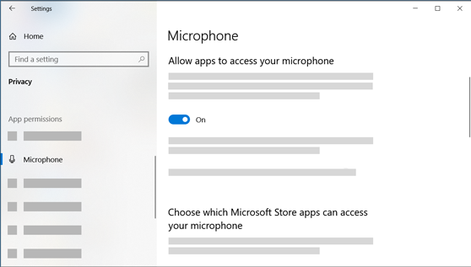

If your microphone isn't detected after updating Windows 11, you may need to give your apps permission to use it. Here's how:

1. Select Start > Settings > Privacy & security > Microphone and make sure Microphone access is turned on.
2. Make sure Let apps access your microphone is turned on, then choose which apps have access. Desktop apps won't appear in this list.

If you want to give access to desktop apps, make sure that Let desktop apps access your microphone is turned on. You can't turn off microphone access for individual apps.

Others can't hear me

Try the following solutions:

* If your headset has a Mute button, make sure it isn't active.
* Make sure that your microphone or headset is connected correctly to your computer.
* Make sure that your microphone or headset is the system default recording device. Here's how to do this in Windows 11:
  1. Select Start > Settings > System > Sound.
  2. In Input, go to Choose a device for speaking or recording, and select the device you want.
  3. To test your microphone, speak into it. In Volume, make sure the blue bar moves to make sure Windows hears you.

The microphone volume is too low or does not appear to be working at all

Try the following solutions:

* Make sure that the microphone or headset is connected correctly to your computer.
* Make sure that the microphone is positioned correctly.
* Increase the volume of your microphone. Here's how to do this in Windows 11:
  1. Select Start > Settings > System > Sound.
  2. In Input, select a microphone to see its properties.
  3. In Input volume, make sure the blue bar adjusts as you speak into the microphone.
  4. If it doesn't, go to Test your microphone and Start test. This will help you troubleshoot any issues with your microphone.

**Troubleshoot LCD Projectors:**

**Projector Not turning on:**

There are a number of reasons that a projector may not be turning on. If your projector doesn’t power on, try the following:

* Ensure the projector is properly plugged into a working outlet.
* Check the temperature lights to make sure the device hasn’t overheated and shut down.
* If you are using a remote control to turn on the projector, check the batteries.
* Be sure all of the projector latches are closed.
* Try resetting the lamp timer.
* Ensure the projector is not in standby mode.

If after trying all of the above tips the projector is still not turning on, the issue could be something more complex like damage to internal components.

**Projector is Overheating:**

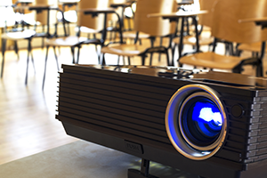

It is natural for projectors to become hot as they are in use, but sometimes projectors overheat when they need cleaning, maintenance or better air circulation. If your projector is randomly shutting down or displaying a warning message, utilize the following tips to resolve the overheating:

* Clear the area around the projector.
* Ensure there is nothing blocking the projector vents.
* Clean the filter and vent of any dust.

**Light on the projector is blinking:**

There are countless makes and models of projectors –all with different parts and pieces– so it’s generally best to refer to the owner’s manual to determine the meaning of a blinking projector light. However, these are the most common reasons and solutions to blinking lights on your projector:

* Power Light: If the power button light is green or flashing green, the projector is likely on or warming up. If the power light is orange or flashing orange, the projector might be in standby mode or turning off.
* Lamp Light: If the lamp light is flashing orange or red, this usually means the lamp light is going to burn out soon or needs to be replaced.
* Temperature Light: If the temperature light is flashing orange or red, this typically means your projector is overheating or in need of cleaning. Be sure to clear any clutter from around the projector and to remove any items that may be blocking its vents.

**Projector image is discoloured:**

Projector discoloration can occur for a number of reasons. Below are several of the most common reasons for discoloration and how to fix them.

* Inspect the condition of your VGA cable. If you notice any bent prongs, the VGA cable likely needs to be replaced.
* Optimize the display and color settings for the lighting in the classroom.
* Check if your projector is in need of a lamp replacement.

If none of the above suggestions help with the discoloration, the problem could be more serious. Contact a professional projector repair service to inspect the color wheel or polarizing plates.

**Projector lamp is burnt out:**

Although lamp life varies from projector to projector, all lamps need to be replaced at some point making this one of the most common projector issues. Signs of a burnt out lamp include:

* Inspect the lamp light. If the light is flashing red or orange, you need to replace the lamp.
* If the projector turns on, but the image doesn’t appear, your lamp may be burnt out.
* If the image being projected is discolored or dim, the lamp may burn out soon

**I/O Cables: specification of I/O Cables, types of I/O cables, types of I/O ports:**

(Input/Output port) An I/O port is a socket on a computer that a cable is plugged into. The port connects the CPU to a peripheral device via a hardware interface or to the network via a network interface. In a PC, an I/O port is an address used to transfer data.

**The table below lists the cable specifications.**

| **Characteristics** | **10/100Base-T (Shielded) Category 5** |
| --- | --- |
| Designator | Twisted pair |
| Segment Length - Recommended maximum | 100 m |
| Cable Type | 24 gauge 100-Ohm shielded twisted pair |
| Connector | 8-pin RJ-45 |

| **Characteristics** | **T1 (Shielded) Category 8** |
| --- | --- |
| Designator | Twisted pair |
| Segment Length - Recommended maximum | 100 meters |
| Cable Type | 24 gauge, 100-Ohm shielded twisted pair |
| Connector | 8-pin RJ-48 |

| **Characteristics** | **2 Conductor (Shielded Ring)** |
| --- | --- |
| Designator | Co-ax |
| Segment Length - Recommended maximum | 450 ft. |
| Cable Type | 75 ohm BNC Y |
| Connector | BNC |

**Here is the list of Types of Computer Cables**

**1. HDMI cable**

HDMI (High definition Media Interface) is a type of computer cable used to transmit high definition video and audio signals. Using the HDMI cables, the audio and video signal can be easily transmitted without compromising the quality of images and can send crystal clear images using this cable. The HDMI cables are used to connect cable boxes, TVs, DVD players, media streamers and other electronic devices. All types of Av devices can be connected to one standard cable, which is an HDMI cable. Also, one HDMI cable is capable of transmitting both audio and video signals at the same time.

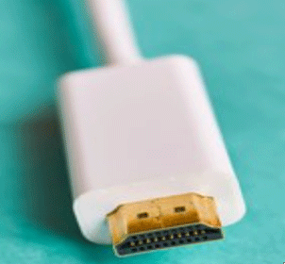

**2. VGA cable**

VGA (Video Graphics Ray) cable is another type of computer cable which is used for sending video signals and is used to link the monitor and the CPU of a computer. The VGA cable can also be used in HD televisions. All the information displayed on the monitor is coming from the VGA cable. There is a total of 15 pins in the plugin the cable, which have three rows containing 5 pins each. And the cable is easily fitted in the monitor and the other end is fixed in the CPU of a computer system.

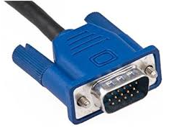

**3. DVI cable**

DVI cables are used to connect the LCD monitor and the video card. Using this cable, the user can see high image quality without having any disturbance. The DVI cable is mostly used in CRT monitors, which have a VGA connection. This cable transmits the digital and analog signals to the computer system. The DVI cable is capable enough of digital connections and analog connections. The DVI cable can be easily distinguished, whether it is analog or digital, by looking if there is any flat pin present on the cable. If the flat pin has four pins around, then it is a DVI analog, and there is only a flat pin, then it is DVI digital.

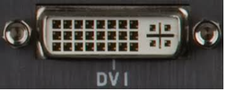

**4. Ethernet Cable**

The Ethernet cable is a type of computer network cable which is used for a wired network. The Ethernet cable is used to connect the switches, monitors, PCs to the LAN (Local Area Network). The length and durability of the Ethernet cable describe the quality of the connection. If the cable is too long and is not durable, it will contain a poor quality of the signal. And due to this factor, there are different types of Ethernet cables present in the market. The Ethernet cables are plugged into the Ethernet port present on the motherboard. The Ethernet cable looks like a phone cable but contains more wires than phone cables. There are eight wires in the Ethernet cable, and they can be available in different colors in the market.

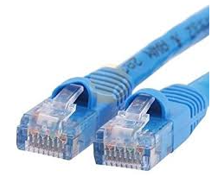

**5. PS/2 Cable**

The PS/2 cable is a standard cable to connect the mouse and keyboard to the computer system. The length of the PS/2 cable is long enough so that the user can easily connect the mouse and keyboard to the system and use the system. There are a total of 6 pins in PS/2 cables and have a round connector. There are majorly two sizes of PS/2 cable. The smaller size is the most common cable, but some adaptors can be used to convert it into a larger size. This cable is now replaced with USB cables as they are universal cables and can be easily plugged into any system.

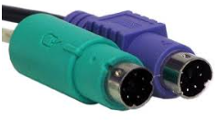

**6. 5mm Audio Cable**

The 3.5mm audio cables are a type of computer cables that are used in computer audio applications. This cable can be used for connecting a mini-stereo audio device, PC sound card or any portable CD player to any multimedia speaker. This cable can also be used to connect earphones and headphones to the system.

The green port is for headphones and computer speakers. Blue port is for DVD player, MP3 player and pink port Is used for connecting microphones.



**7. USB cables**

The USB (Universal Serial Bus) cable is a standard cable used to connect universal devices or personal computers. It is mainly used for short-distance digital communication. The digital data can be transferred using a USB cable. Nowadays, the USB cable is used to charge devices like smartphones, Bluetooth speakers, trimmers and many more. The USB cables can be used to connect two devices directly. The USB cable is connected to the USB port present in the computer system. The mouse and keyboard are also connected to a USB port as they have USB cables. As the device is connected through the USB cable, the unplugging of the USB cable when a device is running can cause damage to a device, so whenever there is a need of removing the USB cable, first it should be eject safely and then it should be removed from the system.

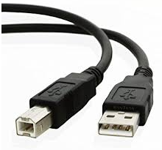

**There are two types of ports :**

1. Internal Port: It connects the system’s motherboard to internal devices like hard disk, CD drive, internal Bluetooth, etc.
2. External Port: It connects the system’s motherboard to external devices like a mouse, printer, USB, etc.

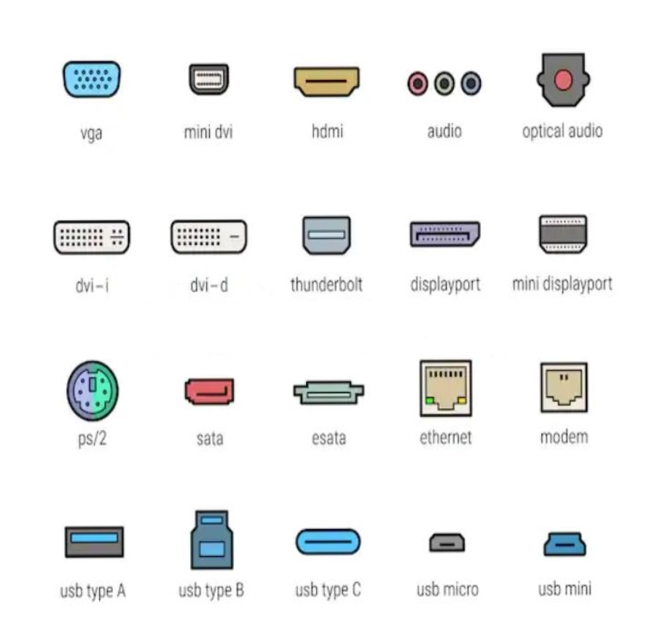

**Types of ports**

Some important types of ports are as per follows:

1. [Serial Port](https://www.geeksforgeeks.org/difference-between-serial-port-and-parallel-ports/) :

* Used for external modems and older computer mouse
* Two versions-9pin,25pin
* Data travels at 115 kilobits per second

2. [Parallel Port](https://www.geeksforgeeks.org/difference-between-serial-port-and-parallel-ports/) :

* Used for scanners and printers
* 25 pin model

3. [Universal Serial Bus (or USB)](https://www.geeksforgeeks.org/universal-serial-bus-usb-in-computer-network/) Port :

* It can connect all kinds of external USB devices such as external hard disks, printers, scanners, mouse, keyboards, etc.
* Data travels at 12 megabits per second.

4. Firewire Port :

* Transfers large amounts of data at a very fast speed.
* Connects camcorders and video equipment to the computer.
* Data travels at 400 to 800 megabits per second.

5. [Ethernet](https://www.geeksforgeeks.org/local-area-network-lan-technologies/) Port :

* Connects to a network and high-speed Internet.
* Data travels at 10 megabits to 1000 megabits per second depending upon the network bandwidth.

**Internal and External Modem:**

| S.No. | Internal Modem | External Modem |
| --- | --- | --- |
| 1. | It has built-in UART. | It doesn’t have built-in UART. They use the computer’s serial port as UART. |
| 2. | Its Price is low as compared to external modem. | It is comparatively high in price. |
| 3. | For internal modem, user doesn’t need to buy any external accessories. | In an external modem, RS232 interface cable has to be brought. |
| 4. | It is hard to transfer the internal modem to another computer. | The external modem can be moved easily. |
| 5. | The internal modem is powered by PC. | The external modem needs external power supply. |
| 6. | It is present inside the computer. | It is present outside the computer. |
| 7. | It can insert into a vacant expansion slot. | It cannot come into the expansion slot. |
| 8. | No holder case is required. | Holder case is required. |
| 9. | It is incompatible with different kind of PCs. | It is compatible for all kind of PCs. |
| 10. | The user is unable to see the status of the modem directly. | The user can check the status of the modem directly. |

**Chapter 4: Power Supply**

| **Contents**  Switched Mode Power supply block diagram, Working principles  Testing and troubleshooting  Power rating  Requirement of SMPS wattage depending parameters like type of processors and HDDs | | | | | | |
| --- | --- | --- | --- | --- | --- | --- |

**Switched Mode Power supply block diagram, Working Principles:**

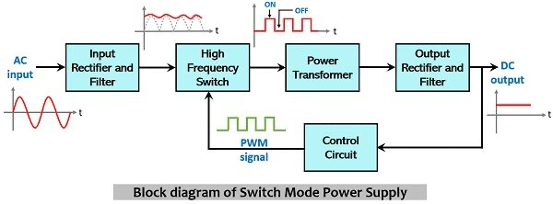

The major components that constitute SMPS are as follows:

1. Input rectifier and Filter (Diode rectifier and capacitor filter)
2. High-frequency switch (Power transistor or MOSFET)
3. Power transformer
4. Output rectifier and Filter (Diode rectifier and capacitor filter)
5. Control circuit (comparator and pulse width modulator)

The figure given below represents the functional block diagram of SMPS:

Initially, the unregulated ac input signal from the source is provided to the input rectifier and filter circuit. Here the ac input signal is rectified to generate a dc signal and further smoothened to remove high-frequency noise component from it. The dc output (still in unregulated form) is fed to the power transistor that acts as a high-frequency switch.

Here the dc signal undergoes chopping (switching). This circuit acts as an ideal switch i.e., when the power transistor (chopper circuit) is in on state, current passes through it with negligible voltage drop, and dc signal is obtained at the output terminal of the transistor. However, under the off state of the power transistor, no current passes through it and leading to cause maximal voltage drop within it. Thus, at the output side, no voltage will be present.

Hence, according to the switching action of the power transistor dc voltage will be obtained at its output side. The chopping frequency plays a crucial role in maintaining the desired dc voltage level.

The obtained dc signal at the output of the chopper circuit is then fed to the primary winding of the high-frequency power transformer. Here the step-down transformer converts the high voltage signal into a low voltage level which is further provided as input to the output rectifier and filter unit. This simply filters out the unwanted residuals from the signal in order to provide a regulated dc signal as the output.

The control circuitry present here acts as the feedback circuit for the complete unit. This involves a comparator along with a pulse width modulator (PWM). The dc output from the rectifier and filter is fed to the control circuit where the error amplifier which acts as a comparator, compares the obtained dc voltage with the reference value.

If the dc output is greater than the reference value then the chopping frequency is to be decreased. The decrease in chopping frequency will reduce the output power and so the dc output voltage. However, if the dc output is less than the reference value then the chopping frequency is increased. When chopping frequency is raised then the dc output voltage will get increased.

The pulse width modulator in the above circuit is responsible for generating a fixed frequency pulse width modulated waveform whose duty cycle controls the chopping frequency.

Basically, the duty ratio is the ratio of on-time to the overall cycle time (i.e., on + off) time. Hence, by making necessary adjustments in the width of the pulses, the chopping frequency gets adjusted hence, regulated dc output can be obtained.

tructure of a SMPS.

There is always a very clear separation between the high and low voltage sides (primary and secondary sides). You can observe it on the bottom (copper) side of the PCB as a larger spacing in the tracks. Some times the solder mask varnish is removed in this area or there are holes and slots to increase insulations. On the pictures in this page, this separation is often marked with a dashed red line.’

**SMPS Testing and troubleshooting:**

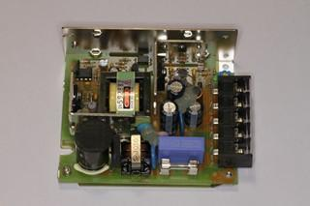 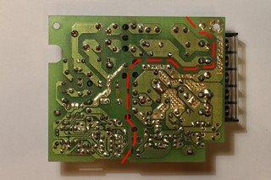

This SMPS uses classic-style (through hole) components. The high voltage side is on the left of the dashed red line.

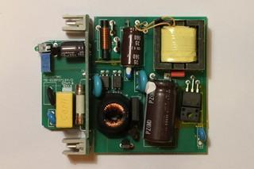 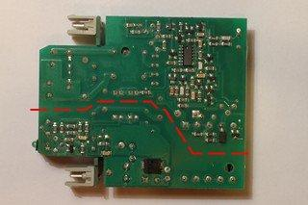

This SMPS uses modern surface mount (SMD) components. Here, the controller uses SMD technology and is mounted on the bottom side. The large SMD diode is the low voltage rectifier. The high voltage side is above the dashed red line.

The primary and secondary side are fully DC isolated by the transformer. Very often, if the ground of the output is not connected to the mains ground, a small high voltage capacitor connects these two grounds at high frequency.

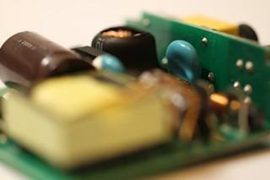

The light blue capacitor in this picture is the high voltage capacitor connecting the low voltage ground with the mains ground. Of course, there is DC insulation.

**Safety first**

Before starting, I just want to remind that SMPS are dangerous circuits: half of the components are directly connected to the mains voltage. A large storage capacitor is charged at high voltage and can be dangerous even when the mains supply is disconnected. Not all SMPS include bleeding resistors (or they could be broken) so the capacitors could stay charged for a long time. Always make sure all capacitor are completely discharged before touching the circuit. To discharge the capacitors, don't short them with the screwdriver, use a suitable resistor instead (a few kΩ and a few Watts) connected to two insulated probes like the one of a multimeter. Then, measure the voltage and make sure it's zero before proceeding. Keep also in mind that heat sinks very often are not grounded and they can very well be at mains voltage. Beware of taking measures with an oscilloscope: oscilloscopes are grounded to the mains supply (and it's a bad idea to float them) and you could make a short with your ground lead (this would be dangerous also for your oscilloscope). In summary, SMPS repair is for experienced and skilled technicians; if you don't know exactly what you're doing, stay away from SMPSs.

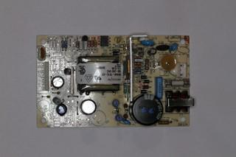 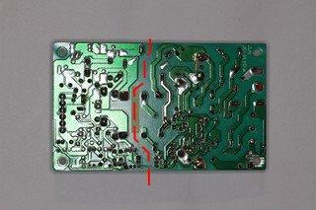

This SMPS has no bleeder resistor on the high voltage filter capacitor. Please remark the 330 kΩ resistor tack soldered on the bottom side of the PCB during the repair operation to automatically discharge the capacitor in a reasonable time and avoid potential shocks. The high voltage side is on the right of the dashed red line.

**Visual Inspection:**

I usually start with a visual inspection to get an idea. Of course, first I disconnect the SMPS and I make sure all capacitor are discharged. Many faulty electrolytic capacitors, when not exploded, can easily be spotted because they "inflate" and their top (or bottom) side becomes dome-shaped Burned resistor can also be spotted by their black colour and bad smell. A look to the ferrite transformer is very important: if it looks burned out and smells badly, I generally give up because it may have shorted turns and it's a nightmare to repair or find a replacement part. If the transformer is faulty, I prefer to replace the whole SMPS and save a lot of time. Some components are warm and as time goes by they tend to get a little brownish (the same is true for the board near them): this is not necessarily a problem; a little brown is ok, black and smelly is not.

If your SMPS has a regulator IC, try to find it's datasheet on the internet: many SMPS have a schematic diagram very similar to the examples reported in the datasheets. If it does, you'll save a lot of time.

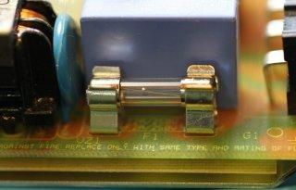

**Start by looking at the SMPS mains line fuse (this one is good).**

Start by looking at the mains fuse: this will give you good clues on the origin of the failure. A blown fuse usually means many faulty semiconductors; a healthy one is probably just a single component.

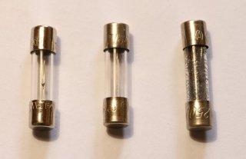

Three Ø5 × 20 mm fuses: the one on the left is good, the one in the middle blew up with a moderate current and the one on the right blew up with a large current.

Also look at how the fuse looks like: if it only slowly burned the failure was not catastrophic, but if the fuse almost "exploded", there was a big current when it blew up and you can expect a lot of damaged components (especially semiconductors). It doesn't mean you can't fix it, but just that you'll have many components to replace: if you find just a faulty one, you should check again. Unfortunately some fuses are filled with sand and you cannot see what happened.

**No output, good fuse**

SMPS can fail in many different ways, the most common being no output power at all. In this case, I start by checking the input fuse. If the fuse is good but there is no output, probably all the semiconductors are good and it could be easy to fix. Keep in mind that usually semiconductors blow up shorted and resistors (and often capacitors) blow up open.

A good candidate is the inrush current limiter (an NTC). Than I check for high power rating resistors, particularly on the primary side: I measure their resistance one by one, in circuit. If the value doesn't match what written (or colour coded) on the component, I unsolder one terminal and measure again: if the value is wrong, I replace it with a new one.

The first resistors to check are the one in series with the power transistors, usually less than one Ohm. Sometimes the regulator is powered by a high value high wattage resistor in series with a Zener diode: if the resistor is good, maybe the Zener is shorted, so I check all diode junctions with the diode function of the multimeter (most of the times, you can do this in circuit). Than I check the capacitors Faulty regulators IC can happen but it's not very common.

**No output, blown fuse**

On the other hand, if the fuse is open, than something went really wrong in the circuit. Don't replace the fuse yet, it would just blow again: there is a short circuit somewhere that you have to fix first. Typical problems are blown up power transistors or rectifier diodes, especially on the primary side. Just use the diode function of a multi-meter and check the junctions: shorts are easy to spot. More components can be faulty at the same time and if you don't replace them all, they may blow again, so be careful. Than, I also check for faulty resistors as above and faulty capacitors

If the power transistor (or one of them) is dead, chances are that many other components are dead too. Often SMPS include protection components such as additional resistor or Zener diodes to reduce damages in case of failure, but not always. Before going to far in replacing, make sure you check all the parts. For example, check if the controller IC still works. Powering it off-line with a small external DC power supply and checking for pulses on the transistor base (or gate) is a good idea. But some IC won't work if there is no high voltage to switch: check the datasheet first. If too many components are dead, it’s probably easier to replace the whole SMPS.

When replacing semiconductors I first try to source the exact same part. If it's unavailable (or too expensive) I look for alternatives. Of course the new semiconductor must show at least the same voltage, current and power characteristics, or be even better. For diodes also check the switching time: you want a diode that is at least as fast as the old one, or faster. For transistor, check the gain and the cut-off frequency: you want a similar gain (not too low and not too high) and a cut-off frequency at least ten times higher than the switching frequency. For MOSFETs check the gate capacitance that should not exceed the one of the old component and the gate threshold voltage that has to be similar to the old device.

After replacing the faulty components, it's a very good idea to use the light bulb trickfor the very first power on test: this will limit the damages in case the problem isn't completely fixed.

**SMPS partially working**

Sometimes the SMPS is only partially working: it may start for a fraction of a second and than shut down, or it may pulsate trying to start every few seconds and shutting down after a fraction of a second, or it may produce a wrong output voltage. Here, probably all power semiconductors are good, so the first thing to check are the capacitors

Than, there may be something wrong with the feedback circuit: a good trick is to apply an external adjustable DC voltage to the SMPS output (the SMPS being not connected to the mains). When gradually increasing the DC voltage, you should see the feedback circuit working when you cross a threshold near the nominal output voltage. Since, while doing this test there are no dangerous voltages involved, you can easily use an oscilloscope to diagnose the feedback circuit. You may also have to supply the controller IC (on primary side) with the same low voltage source to see what happens on the other side of the optocoupler.

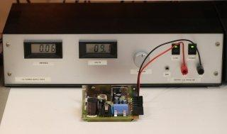

A SMPS being powered on its output by an external laboratory DC power supply to check the feedback circuit.

**Capacitor check**

Electrolytic capacitors are very often the cause of SMPS problems. In cheap designs, where thermal dissipation is a bit too close to the limit, and a choice of components a bit too cost-oriented, electrolytic capacitors are real time-bombs that will eventually fail (sometimes by literally exploding)... The liquid electrolyte inside these components tends to evaporate and dry out completely altering the characteristics.

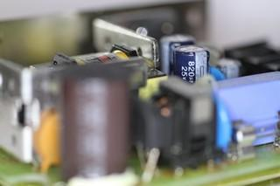

The two blue electrolytic capacitors in this picture are the low voltage filter capacitors. These ones are in good shape.

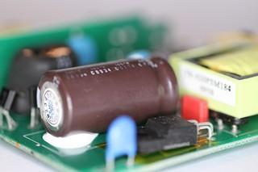

The big brown electrolytic capacitor in this picture is the high voltage filter capacitor. This one is in good shape.

When electrolytic capacitors explode, they throw out corrosive (and bad smelling) projections. The exploded components are easy to spot, but before going any further, one should check the status of the rest of the circuit: if it cannot be cleaned or is already too corroded, replacing the whole SMPS is the best option since corroded components or copper PCB tracks will eventually fail.

Fortunately, only very few electrolytic capacitors explode, the majority of them just fail silently. Look at all the capacitors, their shape and their neighbourhood. If they are not cylindrical anymore, are "inflated", have a dome-shaped top or bottom side (instead of being flat) or have leaked they're faulty. Don't bother measuring them: if it's visually bad it's 100% faulty and needs replacement.

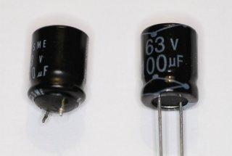

Two electrolytic capacitors: the one on the left is "inflated" compared to a new one on the right. No need to measure: an inflated capacitor must be replaced.

But some electrolytic capacitors can be bad and still look decent. The only way of finding the faulty ones is by measuring them. Just measuring the capacitance may help, but it's not enough. It's much better to measure the equivalent series resistance (ESR) and compare it with the one of a known good capacitor. The bad news is that you need an ESR meter (or an RLC bridge); the good news is that it works most of the times in the circuit without removing the capacitors (unless you have several in parallel).

For replacement, use only new capacitors. Choose a good brand and keep in mind that good capacitors are expensive, but fixing a SMPS is hard enough and completely justifies the extra cost. Electrolytic capacitors exist in two flavours: 85 °C and 105 °C. I always choose the higher temperature because they last longer.

**The light bulb trick**

After replacing all the faulty parts, there is still a reasonable risk of blowing them again, especially if the fuse was initially blown. So, for the first test, I replace the fuse with a 100 W or so light bulb (or I put the bulb in series with the mains line). About the same bulb power of the SMPS is a good starting point, but it's not critical at all. This limits the power in case the short isn't fixed yet, prevents more catastrophic failures, and don't make me nervous in replacing fuses again and again. Wearing safety glasses is also a very good idea.

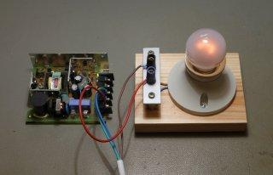

Put a light bulb in series with the AC mains line to prevent damage when first powering up a SMPS.

When you switch the power on (with no load) you'll see the bulb flash for a fraction of a second and than goes off (or glows slightly). If you still have a short circuit the bulb will glow bright and steady: just switch quickly the power off, discharge all the capacitors and start to look for the problem again.

**Power rating:**

A system manufacturer should be able to provide you the technical specifications of the power supplies it uses in its systems. This type of information can be found in the system's technical-reference manual, as well as on stickers attached directly to the power supply. Power supply manufacturers can also supply this data, which is preferable if you can identify the manufacturer and contact them directly or via the Web.

The input specifications are listed as voltages, and the output specifications are listed as amps at several voltage levels. IBM reports output wattage level as "specified output wattage." If your manufacturer does not list the total wattage, you can convert amperage to wattage by using the following simple formula:

watts = volts x amps

For example, if a motherboard is listed as drawing 6 amps of +5v current, that would be 30 watts of power, according to the formula.

By multiplying the voltage by the amperage available at each output and then adding the results, you can calculate the total capable output wattage of the supply.

Table 3.12 shows the rated outputs at each of the voltage levels for supplies with different manufacturer-specified output ratings. To compile the table, I referred to the specification sheets for supplies from Astec Standard Power and PC Power and Cooling. Although most of the ratings are accurate, they are somewhat misleading for the higher wattage units.

Table 3.12 Typical Non-ATX Power Supply Output Ratings

| Rated Output (Watts) | 100W | 150W | 200W | 250W | 300W | 375W | 450W |
| --- | --- | --- | --- | --- | --- | --- | --- |
| Output current (amps): | | | | | | | |
| +5V | 10.0 | 15.0 | 20.0 | 25.0 | 32.0 | 35.0 | 45.0 |
| +12V | 3.5 | 5.5 | 8.0 | 10.0 | 10.0 | 13.0 | 15.0 |
| –5V | 0.3 | 0.3 | 0.3 | 0.5 | 1.0 | 0.5 | 0.5 |
| –12V | 0.3 | 0.3 | 0.3 | 0.5 | 1.0 | 0.5 | 1.0 |
| Calc. output (watts) | 97.1 | 146.1 | 201.1 | 253.5 | 297.0 | 339.5 | 419.5 |

Adding a +3.3v output to the power supply modifies the equation significantly. Table 3.13 contains data for various ATX power supplies from PC Power and Cooling that include a +3.3v output.

Table 3.13 PC Power and Cooling ATX Power Supply Output Ratings

| Rated Output | 235W | 275W | 300W | 350W | 400W | 425W |
| --- | --- | --- | --- | --- | --- | --- |
| Output current (amps): | | | | | | |
| +5V | 22.0 | 30.0 | 30.0 | 32.0 | 30.0 | 50.0 |
| +3.3V | 14.0 | 14.0 | 14.0 | 28.0 | 28.0 | 40.0 |
| Max watts +5V and +3.3V: | 125W | 150W | 150W | 215W | 215W | 300W |
| +12V | 8.0 | 10.0 | 12.0 | 10.0 | 14.0 | 15.0 |
| –5V | 0.5 | 0.5 | 0.5 | 0.3 | 1.0 | 0.3 |
| –12V | 1.0 | 1.0 | 1.0 | 0.8 | 1.0 | 1.0 |

If you compute the total output using the formula described earlier, these power supplies seem to produce outputs that are much higher than their ratings. The 300W model, for example, comes out at 354.7 watts. However, notice that the supply also has a maximum combined output for the +3.3v and +5v of 150 watts. This means you cannot draw the maximum rating on both the 5v and 3.3v lines simultaneously but must keep the total combined draw between them at 150W. This brings the total output to a more logical 308.5 watts.

Most PC power supplies have ratings between 150 and 300 watts. Although lesser ratings are not usually desirable, you can purchase heavy-duty power supplies for most systems that have outputs as high as 600 watts or more.

The 300-watt and larger units are recommended for fully optioned desktops or tower systems. These supplies run any combination of motherboard and expansion card, as well as a large number of disk drives and other peripherals. In most cases, you cannot exceed the ratings on these power supplies—the system will be out of room for additional items first!

Most power supplies are considered to be universal, or worldwide. That is, they also can run on the 220v, 50-cycle current used in Europe and many other parts of the world. Many power supplies that can switch from 110v to 220v input do so automatically, but a few require you to set a switch on the back of the power supply to indicate which type of power you will access.

**Requirement of SMPS wattage depending parameters like type of processors and HDDs:**

SMPS or PSU is one of the most important parts of your desktop PC. A good and proper capacity power supply is required for providing sufficient power to all your computer components so that they function properly even at full load.

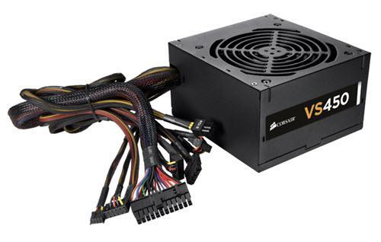

SMPS or PSU comes in different wattage (W) and with different amount of current listed on 12V Rail. The amount of current on 12V Rail is the most important and deciding factor when choosing a SMPS. It is so because all the major components like CPU, Graphics Card, Hard Disk, Fans etc. draw their power from 12V Rail. Every SMPS has different amount current listed on 12V rail but you should note that this current must be sufficient enough for a SMPS or PSU of certain Wattage. This means that a 400W SMPS should have at least 30A listed on its 12V rail, a 500W should have 40A or more and so on.

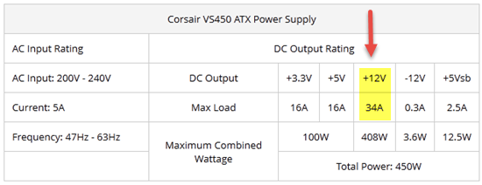

12V Rail and Current Listed on it

The 12V Rail in a SMPS may or may not be divided into smaller units and if it is divided then these types of PSUs are known as multiple 12 rail power supplies.

**Finding out your Power Supply Requirement**

You must know that every PC has its own power requirements and for that power supplies of different capacities are available in the market. So for different PC configuration, power supply having a particular capacity is generally used. For example a PC requiring up to 400 Watt, you can use a PSU of 400W – 450 Watt but if you use a PSU of 300 Watt for that then you should face many problems like restarting, reduced performance and also you will be at a greater risk of damaging your computer components. So it is safer to use the higher capacity PSU rather than using the lower capacity one for the given power requirements of your PC. So here in this post I will show you on how to select the proper capacity SMPS for your PC.

Components that Draws Major Power in your PC

Below are the components that draws or uses major amount of power from your SMPS.

* Processor
* Graphics Card
* Hard Disk
* Fans

From the above components, Graphics Card consumes or draws the maximum amount of power when playing games or running graphics intensive applications.

SMPS / PSU Power Requirement Table

Here is a useful table to find out a rough estimate on your SMPS requirement.

|  | **CPU / Processor** | **Graphics Card** | **Number of Hard disks** | **RAM** | **Number of Cabinet Fans** | **SMPS Requirement** |
| --- | --- | --- | --- | --- | --- | --- |
| **PC1** | Dual Core | None | 1 | 2 GB – 4 GB | 1 | 350W – 400W |
| **PC2** | Dual Core / Quad Core | Entry Level to Mainstream Graphics Card | 2 | 4 GB or more | 2 | 400W – 450W |
| **PC3** | Mid-range Dual Core / Quad Core / Multi Core | Mid-Range Graphics Card | 2 | 4 GB or more | 3 | 500W – 600W |
| **PC4** | High-end Quad Core / Multi Core | High End Graphics Card | 3 | 8 GB or more | 3 – 4 | 650W – 700W or more |

**Chapter 5: Transmission Media and Networking Connectivity Hardware**

| **Contents**  Network interface cards–Ethernet  Cabling Concepts   * Designing * Installing * Maintaining modern communications infrastructures * Electronic physical security systems * Fiber optics * Wireless networks   Various networking devices like:   * Routers * Repeaters * Switches * Bridges | | | | | | |
| --- | --- | --- | --- | --- | --- | --- |

**Network interface cards–Ethernet**

A network interface card (NIC) is a hardware component without which a computer cannot be connected over a network. It is a circuit board installed in a computer that provides a dedicated network connection to the computer. It is also called network interface controller, network adapter or LAN adapter.

Purpose

* NIC allows both wired and wireless communications.
* NIC allows communications between computers connected via local area network (LAN) as well as communications over large-scale network through Internet Protocol (IP).
* NIC is both a physical layer and a data link layer device, i.e. it provides the necessary hardware circuitry so that the physical layer processes and some data link layer processes can run on it.

**Types of NIC Cards**

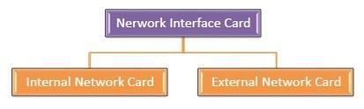

**Internal Network Cards**

In internal networks cards, motherboard has a slot for the network card where it can be inserted. It requires network cables to provide network access. Internal network cards are of two types. The first type uses Peripheral Component Interconnect (PCI) connection, while the second type uses Industry Standard Architecture (ISA).

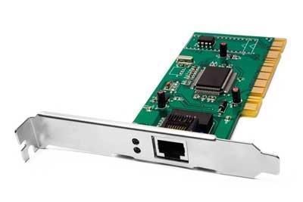

**External Network Cards**

In desktops and laptops that do not have an internal NIC, external NICs are used. External network cards are of two types: Wireless and USB based. Wireless network card needs to be inserted into the motherboard, however no network cable is required to connect to the network. They are useful while traveling or accessing a wireless signal.

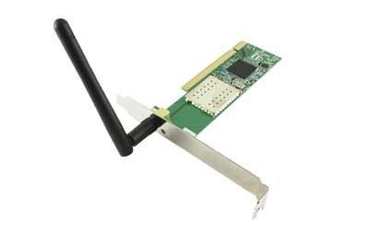

**Cabling Concepts - Electronic physical security systems:**

Electronic Security Systems (ESS) are physical security systems deployed to integrate into a facility's necessary level of protection (LOP). Types of ESS:

* Physical Access Control Systems (PACS)
* Video Surveillance Systems (VSS) (sometimes known as CCTV)
* Intrusion Detection Systems (IDS)

**Physical Access Control Systems (PACS)**

PACS are intelligence systems (stand-alone or enterprise) of hardware and software deployed to control accesses through perimeter entries, internal control points and protected spaces. At a high level, a PACS is a collection of technologies that control physical access at one or more federal agency sites by electronically authenticating employees, contractors, and visitors. PACS components include, but are not limited to, PIV card readers, door controllers, turnstiles, request to exit (REX) devices, door position switches/sensors, electric door strikes, CAT5/CAT6/Fiber Optic cabling infrastructure, middleware, switches, servers, PACS software and computing hardware.

All Department of Commerce PACS procurements are to meet requirements set forth by the [GSA Approved Products List (APL) for PACS](https://www.idmanagement.gov/approved-products-list-pacs-products/). The APL provides federal agencies with products and services that have been approved for Federal Identity, Credentialing and Access Management (FICAM) implementation based on rigorous security vulnerability and interoperability testing performed by the [FIPS 201 Evaluation Program](https://www.idmanagement.gov/fips201).

The [PACS Guide](https://pacs.idmanagement.gov/) provided via the GSA's idmanagement.gov site serves as a "playbook" to help Security Specialists, IT staff, procurement specialists, and Facility Project Managers understand concepts related to FICAM-compliant PACSs. The guide provides a compliant path to PACS planning, programming, procurements, training and understanding of standards, policies and guidance.

**Video Surveillance Systems (VSS)**

VSS are intelligent systems of surveillance hardware and software deployed to surveil required points of facilities according to ISC standards and/or as designated by the security organization, Facility Security Committee (FSC), or facility Designated Official (DO).

**Intrusion Detection Systems (IDS)**

IDS are alarm signaling deployed devices programmed to detect intrusion into certain protected spaces, such as facility perimeter spaces (perimeter access locations like doors, windows, roof hatches, etc) and controlled areas (weapons/ammunition storage rooms, classified spaces). IDS communicate alarms to monitoring stations to signal for the appropriate response to the alarmed location.

**Cabling Concepts - Fiber Optics:**

When we speak into a landline [telephone](https://www.explainthatstuff.com/telephone.html), a wire cable carries the sounds from our voice into a socket in the wall, where another cable takes it to the local telephone exchange. [Cellphones](https://www.explainthatstuff.com/cellphones.html) work a different way: they send and receive information using invisible [radio](https://www.explainthatstuff.com/radio.html) waves—a technology called wireless because it uses no cables. Fiber optics works a third way. It sends information coded in a beam of [light](https://www.explainthatstuff.com/light.html) down a [glass](https://www.explainthatstuff.com/glass.html) or [plastic](https://www.explainthatstuff.com/plastics.html) pipe. It was originally developed for endoscopes in the 1950s to help doctors see inside the human body without having to cut it open first. In the 1960s, engineers found a way of using the same technology to transmit telephone calls at the speed of light (normally that's 186,000 miles or 300,000 km per second in a vacuum, but slows to about two thirds this speed in a fiber-optic cable).

A fiber-optic cable is made up of incredibly thin strands of glass or plastic known as optical fibers; one cable can have as few as two strands or as many as several hundred. Each strand is less than a tenth as thick as a human hair and can carry something like 25,000 telephone calls, so an entire fiber-optic cable can easily carry several million calls. The current record for a "single-mode" fiber (that's explained below) is 178 terabits (trillion bits) per second—enough for 100 million Zoom sessions ([according to fiber expert Jeff Hecht](https://spectrum.ieee.org/tech-talk/telecom/internet/single-optical-fibers-100-million-zoom))!

Fiber-optic cables carry information between two places using entirely optical (light-based) technology. Suppose you wanted to send information from your [computer](https://www.explainthatstuff.com/howcomputerswork.html) to a friend's house down the street using fiber optics. You could hook your computer up to a [laser](https://www.explainthatstuff.com/lasers.html), which would convert electrical information from the computer into a series of light pulses. Then you'd fire the laser down the fiber-optic cable. After traveling down the cable, the light beams would emerge at the other end. Your friend would need a [photoelectric cell](https://www.explainthatstuff.com/how-photoelectric-cells-work.html)(light-detecting component) to turn the pulses of light back into electrical information his or her computer could understand. So the whole apparatus would be like a really neat, hi-tech version of the kind of telephone you can make out of two baked-bean cans and a length of string!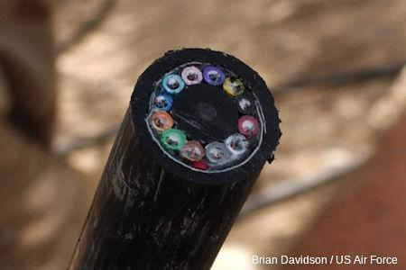

***Photo:*** *A section of 144-strand fiber-optic cable. Each strand is made of optically pure glass and is thinner than a human hair. Picture by Tech. Sgt. Brian Davidson, courtesy of* [*US Air Force*](https://www.af.mil/News/Photos/igphoto/2000581794/)*.*

**How fiber-optics works**

Light travels down a fiber-optic cable by bouncing repeatedly off the walls. Each tiny **photon** (particle of light) bounces down the pipe like a bobsleigh going down an ice run. Now you might expect a beam of light, traveling in a clear glass pipe, simply to leak out of the edges. But if light hits glass at a really shallow angle (less than 42 degrees), it reflects back in again—as though the glass were really a [mirror](https://www.explainthatstuff.com/howmirrorswork.html). This phenomenon is called [total internal reflection](http://hyperphysics.phy-astr.gsu.edu/hbase/phyopt/totint.html). It's one of the things that keeps light inside the pipe.

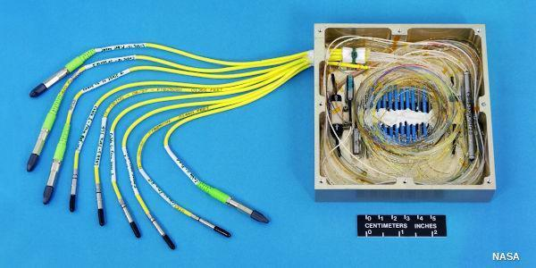

*Photo: Fiber-optic cables are thin enough to bend, taking the light signals inside in curved paths too. Picture courtesy of NASA Glenn Research Center (NASA-GRC) and* [*Internet Archive*](https://archive.org/details/NIX_EL-1998-00255)*.*

The other thing that keeps light in the pipe is the structure of the cable, which is made up of two separate parts. The main part of the cable—in the middle—is called the **core** and that's the bit the light travels through. Wrapped around the outside of the core is another layer of glass called the **cladding**. The cladding's job is to keep the light signals inside the core. It can do this because it is made of a different type of glass to the core.



*Artwork: Total internal reflection keeps light rays bouncing down the inside of a fiber-optic cable.*

**Types of fiber-optic cables**

Optical fibers carry light signals down them in what are called **modes**. That sounds technical but it just means different ways of traveling: a mode is simply the path that a light beam follows down the fiber. One mode is to go straight down the middle of the fiber. Another is to bounce down the fiber at a shallow angle. Other modes involve bouncing down the fiber at other angles, more or less steep.

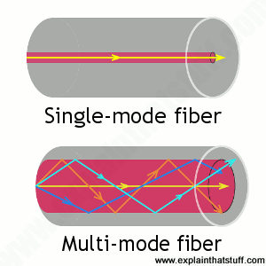

*Artworks: Above: Light travels in different ways in single-mode and multi-mode fibers. Below: Inside a typical single-mode fiber cable (not drawn to scale). The thin core is surrounded by cladding roughly ten times bigger in diameter, a plastic outer coating (about twice the diameter of the cladding), some strengthening fibers made of a tough material such as* [*Kevlar®*](https://www.explainthatstuff.com/kevlar.html)*, with a protective outer jacket on the outside.*

**

The simplest type of optical fiber is called **single-mode**. It has a very thin core about 5-10 microns (millionths of a meter) in diameter. In a single-mode fiber, all signals travel straight down the middle without bouncing off the edges (yellow line in diagram). Cable TV, Internet, and telephone signals are generally carried by single-mode fibers, wrapped together into a huge bundle. Cables like this can send information over 100 km (60 miles). Another type of fiber-optic cable is called **multi-mode**. Each optical fiber in a multi-mode cable is about 10 times bigger than one in a single-mode cable. This means light beams can travel through the core by following a variety of different paths (yellow, orange, blue, and cyan lines)—in other words, in multiple different modes. Multi-mode cables can send information only over relatively short distances and are used (among other things) to link [computer networks](https://www.explainthatstuff.com/howcomputernetworkswork.html) together.

Even thicker fibers are used in a medical tool called a **gastroscope** (a type of endoscope), which doctors poke down someone's throat for detecting illnesses inside their stomach. A gastroscope is a thick fiber-optic cable consisting of many optical fibers. At the top end of a gastroscope, there is an eyepiece and a lamp. The lamp shines its light down one part of the cable into the patient's stomach. When the light reaches the stomach, it reflects off the stomach walls into a [lens](https://www.explainthatstuff.com/lenses.html) at the bottom of the cable. Then it travels back up another part of the cable into the doctor's eyepiece. Other types of endoscopes work the same way and can be used to inspect different parts of the body. There is also an industrial version of the tool, called a fiberscope, which can be used to examine things like inaccessible pieces of machinery in [airplane](https://www.explainthatstuff.com/howplaneswork.html) engines.

**Uses for fiber optics**

Shooting light down a pipe seems like a neat scientific party trick, and you might not think there'd be many practical applications for something like that. But just as [electricity](https://www.explainthatstuff.com/electricity.html) can power many types of machines, beams of light can carry many types of information—so they can help us in many ways. We don't notice just how commonplace fiber-optic cables have become because the laser-powered signals they carry flicker far beneath our feet, deep under office floors and city streets. The technologies that use it—computer networking, broadcasting, medical scanning, and military equipment (to name just four)—do so quite invisibly.

**Cabling Concepts - Wireless Networks:**

Computer networks that are not connected by cables are called wireless networks. They generally use radio waves for communication between the network nodes. They allow devices to be connected to the network while roaming around within the network coverage.

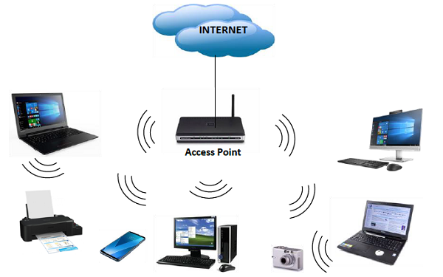

**Types of Wireless Networks**

* Wireless LANs − Connects two or more network devices using wireless distribution techniques.
* Wireless MANs − Connects two or more wireless LANs spreading over a metropolitan area.
* Wireless WANs − Connects large areas comprising LANs, MANs and personal networks.

**Advantages of Wireless Networks**

* It provides clutter-free desks due to the absence of wires and cables.
* It increases the mobility of network devices connected to the system since the devices need not be connected to each other.
* Accessing network devices from any location within the network coverage or Wi-Fi hotspot becomes convenient since laying out cables is not needed.
* Installation and setup of wireless networks are easier.
* New devices can be easily connected to the existing setup since they needn’t be wired to the present equipment. Also, the number of equipment that can be added or removed to the system can vary considerably since they are not limited by the cable capacity. This makes wireless networks very scalable.
* Wireless networks require very limited or no wires. Thus, it reduces the equipment and setup costs.

**Examples of wireless networks**

* Mobile phone networks
* Wireless sensor networks
* Satellite communication networks
* Terrestrial microwave networks

**Various networking devices like routers, repeaters, switches, bridges:**

**Routers**

A Router is a networking device that forwards data packets between computer networks.

Let us understand this by a very general example, suppose you search for www.google.com in your web browser then this will be a request which will be sent from your system to the google`s server to serve that webpage, now your request which is nothing but a stream of packets don`t just go the google`s server straightaway they go through a series of networking devices known as a router which accepts this packets and forwards them to correct path and hence it reaches to the destination server.

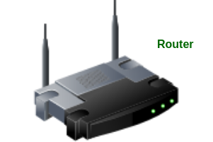

A router has a number of interfaces by which it can connect to a number of host systems.

**Functions of a Router:**

The router basically performs two major functions:

1. Forwarding –   
   The router receives the packets from its input ports, checks its header, performs some basic functions like checking checksum, and then looks up to the routing table to find the appropriate output port to dump the packets onto, and forwards the packets onto that output port.
2. Routing –   
   Routing is the process by which the router ascertains what is the best path for the packet to reach the destination, It maintains a routing table which is made using different algorithms by the router only.

**The architecture of a Router:**

A Generic router consist of the following components:

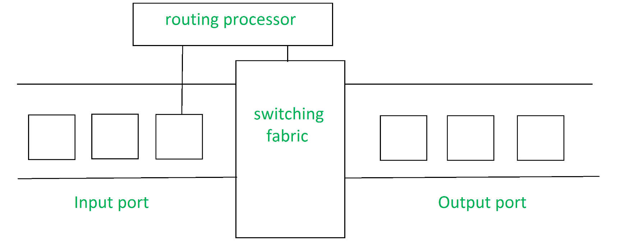

1. Input Port –   
   This is the interface by which packets are admitted into the router, it performs several key functions as terminating the physical link at the router, this is done by the leftmost part in the below diagram, the middle part does the work of interoperating with the link-layer like decapsulation, in the last part of the input port the forwarding table is looked up and is used to determine the appropriate output port based on the destination address.
2. Switching Fabric –   
   This is the heart of the Router, It connects the input ports with the output ports. It is kind of a network inside a networking device. The switching fabric can be implemented in a number of ways some of the prominent ones are:
   * Switching via memory: In this, we have a processor which copies the packet from input ports and sends it to the appropriate output port. It works as a traditional CPU with input and output ports acting as input and output devices
   * Switching via bus: In this implementation, we have a bus that connects all the input ports to all the output ports. On receiving a packet and determining which output port it must be delivered to, the input port puts a particular token on the packet and transfers it to the bus. All output ports are able to see the packets but it will be delivered to the output port whose token has been put in, the token is then scraped off by that output port and the packet is forwarded
   * Switching via interconnection network: This is a more sophisticated network, here instead of a single bus we use a 2N bus to connect n input ports to n output ports.
3. Output Port –   
   This is the segment from which packets are transmitted out of the router. The output port looks at its queuing buffers (when more than one packets have to be transmitted through the same output port queuing buffers are formed) and takes packets, does link layer functions, and finally transmits the packets to an outgoing link
4. Routing Processor –   
   It executes the routing protocols, it works like a traditional CPU. It employs various routing algorithms like link-state algorithm, distance-vector algorithm, etc. to prepare the forwarding table, which is looked up to determine the route and the output port.

**Repeaters**

A repeater operates at the physical layer. Its job is to regenerate the signal over the same network before the signal becomes too weak or corrupted so as to extend the length to which the signal can be transmitted over the same network. An important point to be noted about repeaters is that they do not amplify the signal. When the signal becomes weak, they copy the signal bit by bit and regenerate it at the original strength. It is a 2 port device.

Repeaters are network devices operating at physical layer of the OSI model that amplify or regenerate an incoming signal before retransmitting it. They are incorporated in networks to expand its coverage area. They are also known as signal boosters.

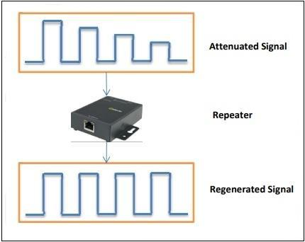

**Why are Repeaters needed?**

When an electrical signal is transmitted via a channel, it gets attenuated depending upon the nature of the channel or the technology. This poses a limitation upon the length of the LAN or coverage area of cellular networks. This problem is alleviated by installing repeaters at certain intervals.

Repeaters amplifies the attenuated signal and then retransmits it. Digital repeaters can even reconstruct signals distorted by transmission loss.So, repeaters are popularly incorporated to connect between two LANs thus forming a large single LAN. This is shown in the following diagram −

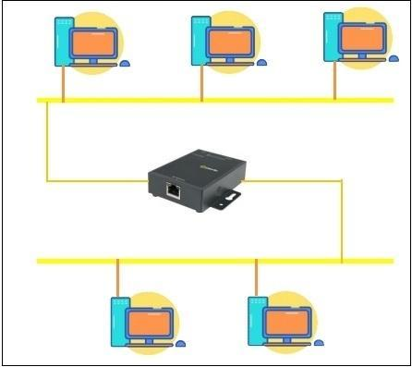

**Types of Repeaters**

According to the types of signals that they regenerate, repeaters can be classified into two categories −

* Analog Repeaters − They can only amplify the analog signal.
* Digital Repeaters − They can reconstruct a distorted signal.

According to the types of networks that they connect, repeaters can be categorized into two types −

* Wired Repeaters − They are used in wired LANs.
* Wireless Repeaters − They are used in wireless LANs and cellular networks.

According to the domain of LANs they connect, repeaters can be divided into two categories −

* Local Repeaters − They connect LAN segments separated by small distance.
* Remote Repeaters − They connect LANs that are far from each other.

Advantages of Repeaters

* Repeaters are simple to install and can easily extend the length or the coverage area of networks.
* They are cost effective.
* Repeaters don’t require any processing overhead. The only time they need to be investigated is in case of degradation of performance.
* They can connect signals using different types of cables.

Disadvantages of Repeaters

* Repeaters cannot connect dissimilar networks.
* They cannot differentiate between actual signal and noise.
* They cannot reduce network traffic or congestion.
* Most networks have limitations upon the number of repeaters that can be deployed.

**Switches**

Switches are networking devices operating at layer 2 or a data link layer of the OSI model. They connect devices in a network and use packet switching to send, receive or forward data packets or data frames over the network.

A switch has many ports, to which computers are plugged in. When a data frame arrives at any port of a network switch, it examines the destination address, performs necessary checks and sends the frame to the corresponding device(s).It supports unicast, multicast as well as broadcast communications.

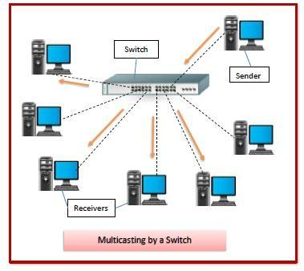

**Features of Switches**

* A switch operates in the layer 2, i.e. data link layer of the OSI model.
* It is an intelligent network device that can be conceived as a multiport network bridge.
* It uses MAC addresses (addresses of medium access control sublayer) to send data packets to selected destination ports.
* It uses packet switching technique to receive and forward data packets from the source to the destination device.
* It is supports unicast (one-to-one), multicast (one-to-many) and broadcast (one-to-all) communications.
* Transmission mode is full duplex, i.e. communication in the channel occurs in both the directions at the same time. Due to this, collisions do not occur.
* Switches are active devices, equipped with network software and network management capabilities.
* Switches can perform some error checking before forwarding data to the destined port.
* The number of ports is higher – 24/48.

**Types of Switches**

There are variety of switches that can be broadly categorised into 4 types −

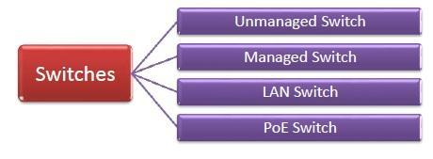

* Unmanaged Switch − These are inexpensive switches commonly used in home networks and small businesses. They can be set up by simply plugging in to the network, after which they instantly start operating. When more devices needs to be added, more switches are simply added by this plug and play method. They are referred to as u managed since they do not require to be configured or monitored.
* Managed Switch − These are costly switches that are used in organisations with large and complex networks, since they can be customized to augment the functionalities of a standard switch. The augmented features may be QoS (Quality of Service) like higher security levels, better precision control and complete network management. Despite their cost, they are preferred in growing organizations due to their scalability and flexibility. Simple Network Management Protocol (SNMP) is used for configuring managed switches.
* LAN Switch − Local Area Network (LAN) switches connects devices in the internal LAN of an organization. They are also referred as Ethernet switches or data switches. These switches are particularly helpful in reducing network congestion or bottlenecks. They allocate bandwidth in a manner so that there is no overlapping of data packets in a network.
* PoE Switch − Power over Ethernet (PoE) switches are used in PoE Gogabit Ethernets. PoE technology combine data and power transmission over the same cable so that devices connected to it can receive both electricity as well as data over the same line. PoE switches offer greater flexibility and simplifies the cabling connections

**Bridges**

Bridges are used to connect two subnetworks that use interchangeable protocols. It combines two LANs to form an extended LAN. The main difference between the bridge and repeater is that the bridge has a penetrating efficiency.

**Working of Bridges**

A bridge accepts all the packets and amplifies all of them to the other side. The bridges are intelligent devices that allow the passing of only selective packets from them. A bridge only passes those packets addressed from a node in one network to another node in the other network.

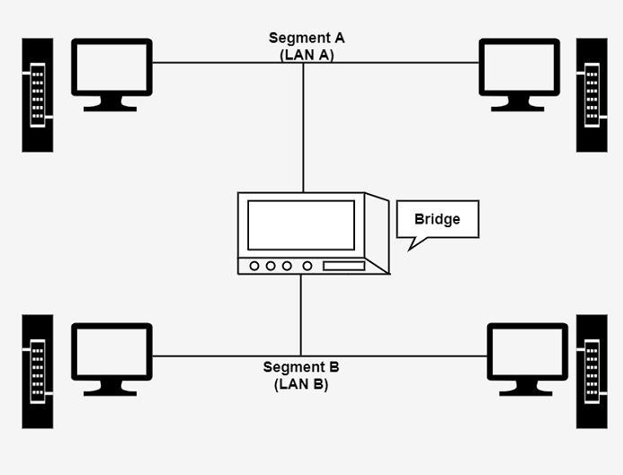

A bridge performs in the following aspect −

* A bridge receives all the packets or frame from both LAN (segment) A and B.
* A bridge builds a table of addresses from which it can identify that the packets are sent from which LAN (or segment) to which LAN.
* The bridge reads the send and discards all packets from LAN A sent to a computer on LAN A and that packets from LAN A send to a computer on LAN B are retransmitted to LAN B.
* The packets from LAN B are considered in the same method.

**Types of Bridges**

There are generally two types of bridges which are as follows −

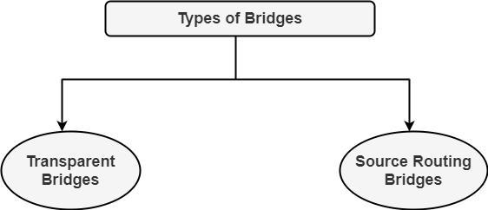

**Transparent Bridges**

It is also called learning bridges. Bridge construct its table of terminal addresses on its own as it implements connecting two LANs. It facilitates the source location to create its table. It is self-updating. It is a plug and plays bridge.

**Source Routing Bridge**

This sending terminal means the bridges that the frames should stay. This type of bridge is used to prevent looping problem.

**Uses of Bridges**

The main uses of bridges are −

* Bridges are used to divide large busy networks into multiple smaller and interconnected networks to improve performance.
* Bridges also can increase the physical size of a network.
* Bridges are also used to connect a LAN segment through a synchronous modem relation to another LAN segment at a remote area.

**References:**

<https://turbofuture.com/computers/Computer-Basics-Examples-of-Hardware>

<https://www.thomasnet.com/articles/top-suppliers/computer-hardware-companies/>

<https://www.businessinsider.in/tech/how-to/what-is-a-cpu-a-guide-to-the-brain-of-your-computer-or-phone-including-how-it-works/articleshow/81340449.cms>

<https://www.easypc.io/pc-cases/>

<https://edu.gcfglobal.org/en/computerbasics/basic-troubleshooting-techniques/1/>

<https://www.geeksforgeeks.org/what-is-postpower-on-self-test/>

<https://www.ibm.com/docs/en/aix/7.2?topic=io-troubleshooting-devices>

<https://www.geeksforgeeks.org/difference-between-internal-and-external-modem/>

<https://www.giangrandi.ch/electronics/smpsfix/smpsfix.shtml>

<https://www.tutorialspoint.com/what-is-network-interface-card-nic>

<https://www.explainthatstuff.com/fiberoptics.html>

<https://www.geeksforgeeks.org/network-devices-hub-repeater-bridge-switch-router-gateways/>

<https://blog.netwrix.com/2019/01/08/network-devices-explained/>

<https://www.computerhope.com/jargon/m/mothboar.htm>

<https://informationq.com/computer-hardware-basics-and-its-components/>

<https://www.computerhope.com/jargon/p/port.htm>

<https://www.addoncards.com/>

<https://red-dot-geek.com/types-of-computer-expansion-cards/>

<https://www.guru99.com/primary-vs-secondary-memory.html>

<https://us.norton.com/internetsecurity-how-to-computer-maintenance.html>

<https://www.informit.com/articles/article.aspx?p=31105&seqNum=7>

<https://www.tutorialspoint.com/Wireless-Networks>

<https://www.tutorialspoint.com/what-are-switches-in-computer-network>